Helsinki city package private sightseeing
4 days/3 nights
City packages to be booked on request through e-mail bonniebraga@msn.com Rate and availability confirmed upon confirming reservation.
Day 1  Helsinki  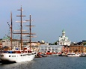 | Arrival and transfer from Helsinki International Airport to your hotel. Private car and English speaking driver. Overnight.
Day 2  Helsinki  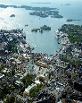 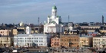 | Buffet breakfast at hotel. At 0930 AM panoramic sightseeing tour of Helsinki, private car and guide in English/Spanish/Portuguese or other; view of Market square, Senate square and Sibelius monument. Entrance to Church in the Rock if opened to the public. PM free for independent activities. Overnight.
Day 3  Helsinki  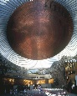 | Buffet breakfast. Entire day free for independent activities. Or optional tour to Medieval Talinn. Or to Soumenlinna fortress Overnight.
Day 4  Helsinki  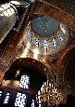 | Buffet breakfast. Pick up at Hotel for departure transfer from your hotel to Airport/ railway station.

Included hotels: | Tourist class | First class
Copenhagen | Sokos Helsinki/ Holiday Inn Helsinki/ Hotel Seurahuone/ Helsinki Best Western Haaga/ Cumulus Olympia | Scandic Grand Marina/ Scandic Simonkentää/ Radisson Blu Seaside/Holiday Inn Helsinki City Centre/ GLO hotels
Rates in EUR valid 1 Jan -31 December: | - From 1236 per person in triple*  - From 1236 per person in double  - From 1890 per person in single | - From 1468 per person in triple*  - From 1468 per person in double  - From 2190 per person in single
IMPORTANT NOTICE: | Porterage service is not included on this tour. DT is not responsible or liable for loss, damage or theft of luggage and/or personal belongings. It is of the utmost importance that passengers have adequate travel insurance to cover last minute cancellations, medical emergencies, loss, damage and/or theft.
* Please note that in Scandinavia we do not have triple rooms with 3 equal beds. It will be a double or twin room with extra bed, very often a simple folding bed.

