Oslo city package private sightseeing
4 days/3 nights
City packages to be booked on request through e-mail at bonniebraga@msn.com Rate and availability confirmed upon confirming reservation.
Day 1 Oslo  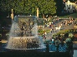 | Arrival to Oslo. Transfer with private car and English speaking driver to Hotel. Overnight.
Day 2 Oslo  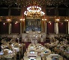 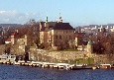 | Buffet breakfast. At 0930 AM sightseeing tour of Oslo including the Vigeland Sculpture Park, the Opera, Akersbrygge etc. Private car and guide in English/Spanish/Portuguese or other. Afternoon at leisure. Overnight.
Day 3 Oslo  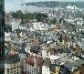 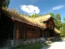 | Buffet breakfast. Full day at leisure Overnight.
Day 4 Oslo  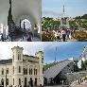 | Buffet breakfast. Departure transfer by private car and English speaking driver. Pick up at Hotel, drop off at Airport/stn/pier.

Included hotels: | Tourist class | First class
Oslo | Scandic Solli/ Thon Opera/ Clarion Collection Bastion/Best Western Bondeheimen | Thon Stefan/ Clarion Royal Christiania/ Scandic Victoria/ Scandic Holberg/ First Millennium/ Grand Hotel/ Thon Bristol
Rates in EUR valid 1 Jan -31 December: | - From 1586 per person in triple*  - From 1586 per person in double  - From 2550 per person in single | - From 1660 per person in triple*  - From 1660 per person in double  - From 2690 per person in single
IMPORTANT NOTICE: | Porterage service is not included on this tour. DT is not responsible or liable for loss, damage or theft of luggage and/or personal belongings. It is of the utmost importance that passengers have adequate travel insurance to cover last minute cancellations, medical emergencies, loss, damage and/or theft.
* Please note that in Scandinavia we do not have triple rooms with 3 equal beds. It will be a double or twin room with extra bed, very often a simple folding bed.

