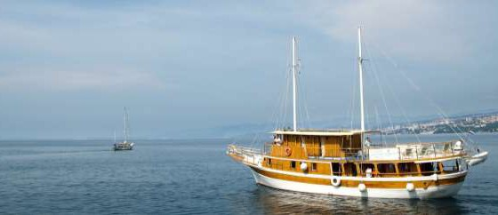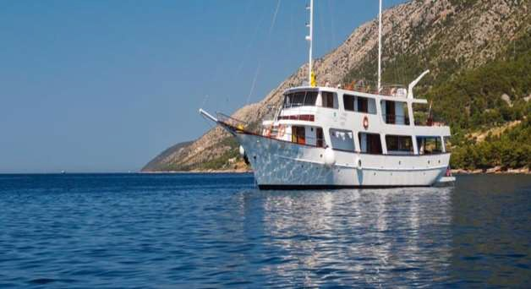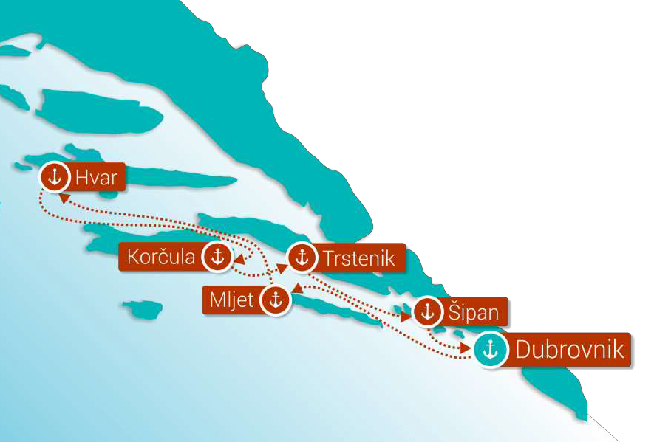
FEATURED SHIPS
A+ category
MV PAPE PRVI
or similar
A category
MV DALMATINKA
or similar

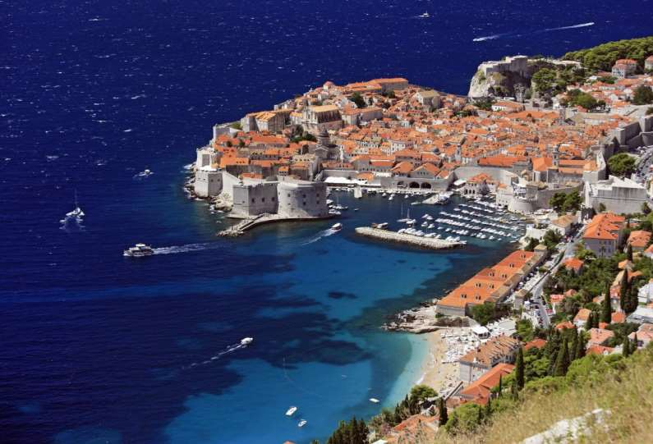Dubrovnik Discovery 2017
Departure from Dubrovnik Guaranteed departures

Cruising with motor ships along the magnificent Dalmatian coastline & islands on the route KL5: DUBROVNIK – MLJET – HVAR – KORČULA – TRSTENIK – ŠIPAN – DUBROVNIK

For this trip all you will need is a few T-shirts and a swimming costume to spend seven unforgettable days sailing on the southern Adriatic Sea from one island to another. Relax and let the captain and his crew (especially the cook) take care of you. During the day you can swim, snorkel, sunbathe, and explore the underworld of the Adriatic Sea. The evenings you have free to find a good restaurant or discover old churches or other historical monuments…

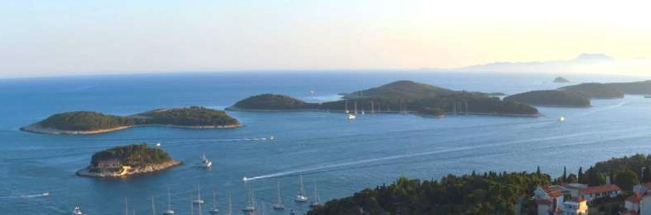

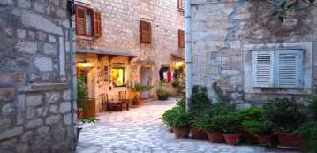
SUNDAY DUBROVNIK
ITINERARY:
Check in from 13.00h onwards (GRUŽ harbour) with dinner as your first meal. Due to the many different flight arrivals the first overnight is planned in Dubrovnik - a unique town on the Adriatic. The special charm of this old town are the buildings that have remained from the time of the old Dubrovnik Republic. A larger part of the monuments of history and culture belong to the fine but modest Renaissance architecture with some traces of the Gothic style. Use the afternoon to explore the city walls and plan what to do on your last night of the cruise when we return to this wonderful city. Overnight in Dubrovnik.

MONDAY DUBROVNIK – MLJET
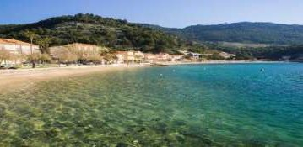
After breakfast we continue our journey towards the island and national park Mljet. Lunch on board. The whole afternoon is free to enjoy the salt lakes in the National Park and enjoy the sun and sea on this peaceful island. In the middle of the large lake, inside the National park, one can visit an old abbey and church, or just use a small boat to roam around the National park. Bicycles can also be rented to cycle around the paths that surround the lakes or cars for those wanting to go further. Overnight in port Polača/Pomena.

TUESDAY MLJET – HVAR
Early in the morning we depart towards the little island Šćedro where we will have enough time to relax and refresh in the clean, crystal blue sea. Departure for Hvar after lunch. Hvar is the longest island in the Adriatic. Here we can find the Renaissance cathedral with its original tower; also the oldest community theatre in Europe was founded here in 1612. City of Hvar offers plenty of restaurants, bars and cafes that are open long into the night. Hvar is often referred to as the sunshine and jet-set island.

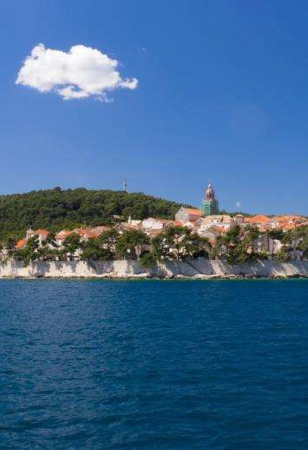
WEDNESDAY HVAR – KORČULA
During breakfast departure for Korčula, the birthplace of famous explorer MARCO POLO. Lunch on board in front of Lumbarda bay. Arrive in Korčula in the afternoon where everyone is free to do their own sightseeing. Surrounded by ancient walls and fortified bastions Korčula’s old town is very well preserved with its layout and structure dating back to 13th century. Overnight in port.

THURSDAY KORČULA – TRSTENIK
Leave Korčula and continue our cruise towards the little village and harbour Trstenik on Pelješac peninsula, where we will swim in the afternoon and spend the night. Lunch on board. Chief occupations include farming, viniculture (the famous Plavac Mali wine, the ancestor of the Californian Zinfandel), fishing and tourism. The coastline along the town and the neighbouring islets is covered by pine groves, offering fine ambience for swimming. The famous Grgić winery is situated here – have a walk and taste some of their lovely wine!

FRIDAY TRSTENIK – ŠIPAN
Early in the morning we continue our trip towards the Elafiti islands. a group of islands west of Dubrovnik. They include Šipan, Lopud and Koločep (Kalamota). They attract many tourists with their beautiful scenery and sandy beaches. Swimming and lunch is planned at one of the smaller Elafiti islands. ŠIPAN, the largest island of the Elafiti, is also the most distant from Dubrovnik. This is where we will spend the night.

SATURDAY ŠIPAN – DUBROVNIK
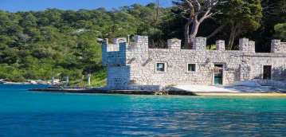
Early departure for Dubrovnik with breakfast on route. Enjoy the beautiful sights of nature along the way towards “the heaven on earth” - according to the famous writer George Bernard Shaw. Lunch on board and arrival to Dubrovnik early in the afternoon (around 14:00h) and have a whole afternoon free to explore Dubrovnik or go for a swim. You can explore Dubrovnik on your own or join our guided tour of Dubrovnik with an English speaking guide. Take a walk through STRADUN – both a street and a square, a promenade inside the city walls. For those of you with more enthusiasm we recommend a walk on top of the 1940m long city walls or take a cable car ride to top of Srđ mountain to get scenic views of the old city! Overnight in the GRUŽ port of this magical town.

SUNDAY DUBROVNIK
After an early breakfast say goodbye to the crew and all your new friends! Optional full day Montenegro coach excursion.

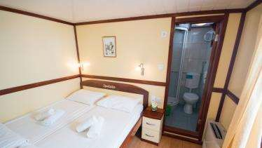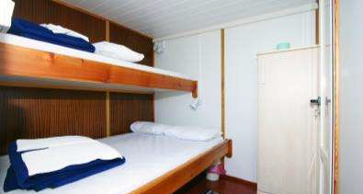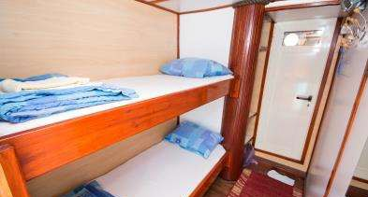 DATES & PRICES 2017:
A+ example cabin
A example cabin
B example cabin

Departures Sundays from Dubrovnik Gruž harbour: Check in Sundays from 13:00h  PRICE PER PERSON in DBL/TWN CABINS IN EUR  7 nights/ 8 days with half board (breakfast & 3 course lunch)  + 1L of water daily |  | A  April 30;  Oct 01, 08, 15; | B  May 07, 14,  21, 28; | C  Jun 04;  Sep 17, 24; | D  Jun 11, 18;  Sep 03, 10; | E  Jun 25;  Aug 20, 27; | F  Jul 02, 09, 16,  23, 30;  Aug 06, 13;
KL5 | A+ CATEGORY UPPER/MAIN DECK 765 842 912 1018 |  |  |  |  | 1089 10890891089 | 1130
 | A+ CATEGORY LOWER DECK 730 795 836 948 |  |  |  |  | 1018 | 1048
 | A CATEGORY UPPER/MAIN DECK 536 600 683 789 |  |  |  |  | 848 | 883
 | A CATEGORY LOWER DECK 500 565 600 724 |  |  |  |  | 7890 | 824
 | B CATEGORY UPPER/MAIN DECK 465 512 589 624 |  |  |  |  | 671 | 718610
 | B CATEGORY LOWER DECK 436 489 536 565 |  |  |  |  | 612 | 653
OBLIGATORY SUPPLEMENT
VISITOR’S TAX & PORT  FEES | NOT INCLUDED IN THE PRICE - To be paid on the spot: EUR 25. - per person per
SHIP CABIN TYPE DESCRIPTIONS
UPPER/MAIN DECK CABINS ARE ALLOCATED ACCORDING TO AVAILABILTIY! Lower deck cabins are in the hull of the ship below the main deck.
A+ CATEGORY  A CATEGORY B CATEGORY | One week cruise based on half board and desired route. Price also includes Captain’s dinner and sightseeing of Dubrovnik, daily cabin service, mid- week fresh set of towels and bed linen. Newly built steel hull ships with air-conditioned, spacious en-suite cabins (with double or twin beds, hair dryer, safety deposit box).  Traditional wooden ships, cabins with private shower/toilet (3rd bed possible on request), mostly bunk beds, air-conditioned salon. Traditional wooden ships, cabins with washbasin and bunk beds. Shared showers/toilettes, air-conditioned salon.
REDUCTIONS & SUPPLEMENTS
Triple Share Cabin Child Discount  Single Use Cabin | Adults on 3rd bed in a triple cabin – 30%  Children under 10 years – 50% 50% surcharge on twin share price. Excludes low season departures Apr 30; Oct 01, 08, 15;  In other seasons avoid by sharing. (limited number of single cabins without supplement available)
OPTIONAL SUPPLEMENTS (nett)
Entrance to | NP MLJET: prices vary from EUR 10. - 15.- per person depending on season (to be paid on the spot)
National Parks
Full Board | EUR 136.- per person/week , min. 10 pax required.  EUR 30.- per week – incl. choice of 1 drink - glass of wine, 1 beer or 1 soft drink with lunch  EUR 48.- per week - incl. 2 eggs, bacon, tomato and mushrooms, or fruit & yoghurt, or similar (regular continental breakfast included in price of the cruise includes: coffee, tea, milk, glass of juice, cereal, bread, a variety of spreads - butter, honey, jam, soft cheese; daily additions such as ham and cheese or boiled eggs, frankfurters, salami etc.). Hot & cold buffet breakfast included on A+ category ships.  EUR 30.- - choice of fish or meat menu - ship's speciality served (included in price on A+ vessels)  On A and A+ category ships the guests will be provided with two towels for personal use per week. No towels provided on B category ships. Extra towels can be rented for EUR 3.- & beach towels EUR 5.- per week/towel. Beach towel can be purchased on arrival for EUR 10.-  EUR 50.- per week (to be paid on the spot)  EUR 15.- per person per week - included in the price for A+ vessels - daily cabin servicing, fresh bed linen and towels midweek; Not provided on A and B category ships but can be ordered in advance;
supplement
Drink supplement
English breakfast
supplement (on A &
B category)
Captain’s dinner
Extra towels
Baby chair or baby
cot rental
Daily cabin cleaning
Parking | Possible from EUR 10.- daily
Airport transfers | EUR 48.- from Dubrovnik airport to Dubrovnik port. Other transfers available on request.  EUR 118.- per couple – includes renewal ceremony performed by the captain, certificate, champagne, gift  Available on request - villas, hotels, private accommodation, hostels...  Cabins, seats or deck, available for coastal & international ferry connections
Wedding renewal or
other occasional /
special day
celebration package
Pre/post cruise
accommodation
Ferry Tickets

LAND & CRUISE PACKAGE supplement
Add 3 nights land program to your cruise for a 10 night program; possible for all departures Price per person: EUR 618.-; Single supplement: EUR 160.-; Reduction on third bed: 10%
Includes: Combined with KL5 includes 3 nights after the cruise - accommodation in a 4* hotel in Dubrovnik with bed and breakfast service; visitor’s taxes during land part; return airport transfer, local transfers (port-hotel), guided coach excursion to Montenegro, guided coach excursion to Mostar, guided walking tour of Dubrovnik.
OPTIONAL EXCURSIONS
WINE TASTING IN HVAR EUR 18.- Try some of the quality Croatian island wines with a story about their producing and a light snack. Minimum 10 pax.
WINE TASTING IN KORČULA EUR 18.- Join our optional wine tasting in Korčula to try some of the famous Dalmatian and Croatian wines. Listen to the
story behind their flawless taste while enjoying a light snack.
SEA KAYAKING IN HVAR EUR 33.- Join our sea kayaking tour from Hvar town to Pakleni islands or sea kayaking along the beautiful coast of Hvar. Visit numerous secluded bays and beaches, natural jewels, enjoy the unspoiled scenery and crystal blue waters. Minimum 10 pax.
VILLAGE DINNER EXPERIENCE FROM KORČULA EUR 36.- Try typical Dalmatian dinner in small village near Korčula and find out more about the history
and traditional way of living.
RENT-A-BIKE ON MLJET EUR 13.- Most of the island Mljet is a National Park so enjoy the beautiful nature and rent a bike for 2 hours!
MONTENEGRO FROM DUBROVNIK EUR 57.- Visit Montenegro for a day, a small country attracting with its magnificent mountains rising above the Adriatic Sea, filled with natural beauty and historic towns like Budva and Kotor – bus excursion/passport required.
CABLE CAR IN DUBROVNIK EUR 17.- Take the cable car in Dubrovnik to Srđ mountain and enjoy the scenic views of the old city. Excellent dining possibilities.
OFF-ROAD BUGGY SAFARI IN DUBROVNIK EUR 46.- Get out of the city and get off the beaten track in 2-seater buggies! Even though the starting point is within easy reach og the old town, this expedition will take you to locations rarely seen by visitors to Dubrovnik, including hilltop fortresses and Croatian ranch. Duration aprrox. 1 hour (excluding transfers). Price includes return transfer from Gruž port to starting point on Srđ mountain. Minimum 2 persons.
SEA KAYAKING AROUND DUBROVNIK CITY WALLS IN DUBROVNIK EUR 36.- Join the adventure and admire the views on Dubrovnik walls from the sea in a one or two-seater kayak with all your belongings tucked safely inside a waterproof barrel. Departures from the entrance to the old town.
GAME OF THRONES TOUR OF DUBROVNIK FROM DUBROVNIK EUR 66.- Get to know fictional city of King's Landing from the popular Game of Thrones series with this unique tour! We will take you to discover the location sites in the Old City of Dubrovnik and its surroundings that were used for the scenes in this hit TV -series. Explore the historical gardens in Trsteno where you will get the chance to see King's Landing palace gardens and incredible exotic plants. Tour includes lunch.

Optional sightseeing in following towns (min 10 pax required):
Hvar, Korčula, Dubrovnik - EUR 12.- per person per tour; 10% discount available for 3 or more tours booked in advance; A+ ships have Dubrovnik tour included in the price.
Payment:
✗ Reservation fee of EUR 200 per person
✗ Remainder latest 45 days prior to arrival
Conditions & Cancellation policy:
✗ The Captain reserves the right in changing the route in case of bad weather conditions
✗ All cruise departures are guaranteed, however if less than 10 participants are booked, we reserve the right in cancelling the departure and changing the ship name if the need arises.
✗ Guests are obliged to follow the ship rules and regulations found in written form onboard especially in regards to bringing drinks on board.
✗ In case of inappropriate behavior captain reserve the right in asking clients to disembark
Cancellation conditions:
✗ From the day of confirmation up till 45 days prior to arrival – advance payment (EUR 200 per person) -
non-refundable
✗ 44-40 days – 25% of the remaining balance
✗ 39-32 days – 50% of the remaining balance
✗ 31- days – 100% fee
✗ Name change / date change fee – EUR 25 per person (valid only if the change is done up till 30 days prior booked departure, otherwise regular cancellation clause will be applied)

We highly recommend clients to take insurance against cancellation of reserved services!

Due specific mooring conditions and requirements in some Croatian ports, ships are moored side by side, making it necessary for the clients to cross from one ship to another with gaps in between ships in order to get to the shore. In such cases clients need to take special care when crossing and do this at their own risk. Crew assistance will be given to those needing and requesting it. Cruise not recommended for clients in wheelchairs or with limited mobility.

