THE BEST OF SOUTH AFRICA with Bonnie Braga

Safari, Garden Route & Cape Town
14 Days / 13 Nights
October 12-25, 2018

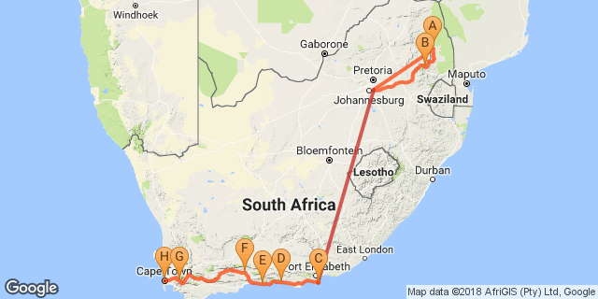

Click here to view your Digital Itinerary
Accommodation | Destination | Nights | Basis
Kapama River Lodge | Kapama Private Game Reserve | 2 | FB+
Misty Mountain Country Lodge | Mpumalanga Highlands | 1 | D, B&B
The Beach Hotel | Port Elizabeth | 1 | D, B&B
Tsitsikamma Village Inn | Tsitsikamma National Park | 1 | D, B&B
Knysna Log Inn | Knysna | 2 | B&B
Turnberry Boutique Hotel | Oudtshoorn | 1 | D, B&B
Protea Hotel by Marriott Franschhoek | Franschhoek | 2 | B&B
Radisson Blu Hotel Waterfront | Cape Town | 3 | B&B

Key
B&B: Bed and breakfast
D, B&B: Dinner, bed and breakfast
FB+: Dinner, bed, breakfast, lunch and activities daily

COSTING BASED ON BELOW ITINERARY
10 – 14 pax / 16-seater vehicle,with English/ Spanish-speaking guide
Per person sharing | ZAR | ** 60,290.00’= USD5149.00
Per single | ZAR | **80,590.00 = USD6882.00
** Exchange rate on Feb 8. 2018

October 12-13, 2018 - Day 1-2: Kapama River Lodge, Kapama Private Game Reserve

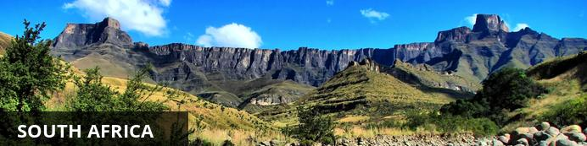
Every country in the world displays some diversity, but South Africa, stretching from the lions in the Kruger National Park to the iconic Table Mountain in the Cape, takes some beating. Enjoy the Country’s sweeping valleys of the Winelands, Cape Town’s jumping nightlife, Namakwa’s springtime symphony of wildflowers or KwaZulu-Natal’s iSimangaliso Wetland Park which alone has five distinct ecosystems, attracting both zebras and dolphins - there is something here for any person with any interest of any age. Although the country has its fair share of problems, South Africans are some of the most upbeat, welcoming and humorous folk you’ll encounter anywhere, from farmers in the rural north who tell you to drive safely on those dirt roads, to Khayelitsha kids who wish you molo (‘good morning’ in Xhosa).

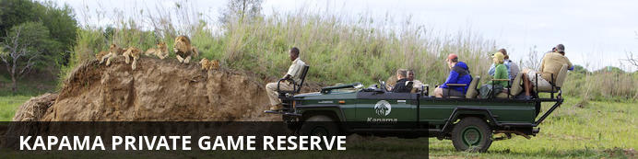
Stretching across 13 000 hectares, towards the Kruger area in South Africa, Kapama Private Game Reserve provides an authentic African safari experience. The reserve provides a range of stylish accommodation across four refined lodges and bush camps. Offering a wide range of options, from a traditional African safari camp to top-notch luxury suites. Kapama is home to the Big Five and is known for its diverse wildlife experiences which can be enjoyed on one of many game drives offering fascinating encounters with plentiful wildlife. Visitors can look forward to a variety of wonderful activities including: excellent game viewing, enjoying a relaxing spa experience and stargazing after a lamp-lit dinner under the African night sky.

Day Itinerary
On arrival at Johannesburg International Airport, you are met by a representative of All About Africa Tours & Travels and assisted to the coach. Transfer to Kapama Game Reserve.

2 Overnight: Kapama River Lodge View iBrochure
Kapama Game Reserve is located in close proximity to Eastgate Airport with the lodge providing open vehicle transfers. Kapama's location in the central Lowveld region creates the perfect base from which to explore the numerous nearby attractions. The northern Drakensberg mountain range provides a majestic backdrop to this contemporary private game lodge in the Greater Kruger National Park region. River lodge is situated within Kapama Game Reserve, and presents the perfect blend between luxurious accommodation and with 64 bedrooms, generous bed capacity. Each of the spacious rooms features a full en-suite bathroom and enjoy uninterrupted views of this game rich, big 5, reserve. The central guest entertainment areas include a swimming pool, lounge, bar, library, curio shop, multifunctional function venue and boma. Meals are of a buffet style and offer a variety of freshly prepared pan African dishes. Rates are based on a fully inclusive experience including dawn and evening safaris in open landrovers conducted by qualified rangers and trackers.
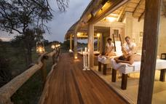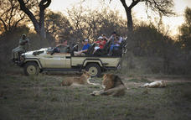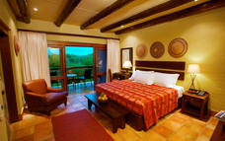

Activities: Game Drive, Bush Walks

Optional - River Lodge Spa

Game Drive
Across all of Kapama’s lodges, two daily game drives are offered and are included in the tariff. Accompanied by a skilled ranger and tracker, guests can expect to encounter a diverse range of animal and bird species on game drives. Since this is a Big Five reserve, seeing lion, leopard, elephant, rhino and buffalo is possible over a two-day safari in Kapama Private Game Reserve.
The day starts with an early wake-up call between 5am and 5:30am. Tea, coffee and rusks are enjoyed together before heading out at first light. While seeing big game is always exhilarating, there are many other smaller species that are also captivating, and birding enthusiasts will be delighted at the approximately 350 species of birds recorded on the reserve. Halfway through the game drive, there’s a stop for hot drinks and snacks, before returning to the lodge at around 9am for a full breakfast. Throughout the day, it’s likely you will see wildlife around the lodge - nyala antelope and vervet monkeys are frequent visitors, though seeing some of the Big Five is also not uncommon.
At around 3:30pm, everyone gathers for a decadent high tea, before heading out with your ranger and tracker for the afternoon game drive through the reserve. En route, you’ll stop for a sundowner drink and will have a chance to stretch your legs as you watch the sun set over the distant peaks of the Drakensberg mountains.
As darkness falls, the nocturnal animals of the bush come out. The skilled tracker will scan the landscape using a spotlight, which illuminates animals’ eyes. A variety of completely different species can be seen on the night drive back to the lodge. Arrival is at the lodge is usually around 7pm, allowing time to freshen up before enjoying a sumptuous dinner.

Bush Walks
Feel Africa underfoot on a guided bush walk with a highly trained game ranger. The experience offers an intimate encounter with nature and wildlife, and medicinal and other plants are identified en route.
Rangers also teach walkers to track wildlife in the traditional way, using animal footprints and scat. Expert trackers are able to tell the gender of many animals just from their footprints. Large and dangerous animals are avoided on walks, but many other species can be viewed from a safe distance at ground level. A bush walk through Kapama Private Game Reserve is a truly memorable and authentic encounter.

River Lodge Spa
Surrounded by stillness and sweeping bushveld, the Kapama Wellness Centre takes safari spa treatments to new heights. Considered one of the finest safari spas in Africa, the six sumptuous treatment rooms are arranged around a generous central lap pool that evokes a sense of calm.
While Dermalogica and Matisse products are used in the spa, five uniquely created African-inspired treatments are also on the menu to provide rejuvenation and complete relaxation. Soak up the signature four-hour Marula Miracle Moments - which includes a body wrap, facial, massage and more - or opt for other enticingly named treatments such as the Kapama Pinotage Bliss, which uses vine-infused products, or the Marula Sensual Steam Treatment. Various treatments are also available to couples. The luxury safari spa treatment menu includes a full range of body and beauty treatments.
Highly trained and experienced beauty therapists remain abreast of global treatment trends, while giving them a uniquely African twist for Kapama’s Wellness Centre. After your treatment, take a swim in the lap pool or relax under bushveld skies before heading back to your luxury game lodge accommodation.
Alternatively, if you’d like to work up a sweat, the state-of-the-art mini gym is fully equipped. There is both cardio and weight-lifting equipment, depending on if you want to tone or build muscle. What is guaranteed is that a visit to the Wellness Centre will energise and uplift you for the day.

Included- Full Board and Activities

Day 3 – OCT 14-: Misty Mountain Country Lodge, Mpumalanga Highlands

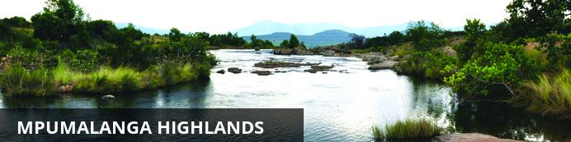
The Highlands of Mpulmalanga are a playground for nature and adventure lovers. A number of charming, high-altitude, grassland villages are scattered on a sea of cattle ranches which are interspersed with numerous trout fishing locations and mountain hideaways. Aside from the trout and quaint towns the highland scenery and flora and fauna are also major attractions.

Day Itinerary
After the morning's game activities and breakfast, transfer via the Panorama Route to the overnight hotel in the Long Tom Pass. Dinner at the hotel.

Overnight: Misty Mountain Country Lodge
Misty Mountain is a relaxed, informal, family friendly, owner managed establishment. Owned and operated as a lodge by the Sheard family since 1974, Misty Mountain is a place of tranquillity and natural beauty – an ideal place to relax, catch up and get away from it all. Friendly and helpful staff will ensure that you have a memorable stay.
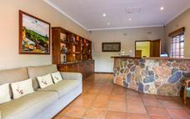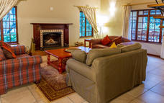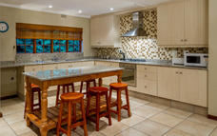

Activities: Panorama Route

Panorama Route
Visit majestic natural sights including God’s Window, Bourke’s Luck Potholes, the Three Rondavels and Blyde River Canyon – the third largest canyon of its kind in the world. This is one of the most scenic routes in the region offering magnificent views, dramatic landscapes and exquisite waterfalls.

Included - Entrance fees

Excluded - Lunch

Day 4 – OCT 15 The Beach Hotel, Port Elizabeth (Wed, 10 October)

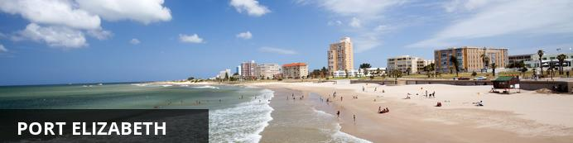
Port Elizabeth or PE is known as the Friendly City and the Windy City and hopefully if you stay here you will get a chance to experience the former and not the latter. Port Elizabeth was established to accommodate British settlers who were bought out on a government sponsored programme to provide a buffer between the warring Cape Dutch and the Xhosa. The little port grew from there and today it is the gateway to the Garden Route, as well as the Eastern Cape’s game reserves and beaches.

Day Itinerary
Transfer to Johannesburg and flight to Port Elizabeth. Here you are met by an english-speaking guide and assisted to your coach and driver.
Overnight in Port Elizabeth at The Beach Hotel. Dinner at the hotel.

Overnight: The Beach Hotel View iBrochure
Situated a stone's throw from the world renowned Hobie Beach, and adjacent to the Boardwalk Casino and Entertainment World, The Beach Hotel is probably the most attractive landmark along the Friendly City's magnificent beachfront. The safe, gently sloping stretch of golden sand on Hobie Beach is the ideal watersport playground with bathers, windsurfers, yachts and surfers enjoying this stretch of ocean. The Beach Hotel also offers a choice of 3 unique dining venues, a beautiful pool and deck for those lazy summer days.
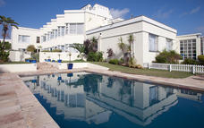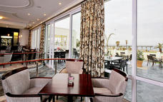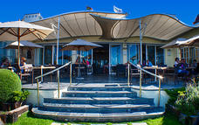

Activities - Ginger Restaurant

Ginger Restaurant
The atmosphere is friendly, airy and chic and the food a combination of the finest, fresh ingredients that in turn create subtle dishes with distinctive flavours and East Cape influence. Enjoy spectacular views of the ocean, top rate service and a taste bud experience.
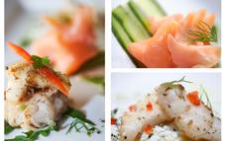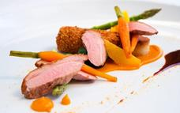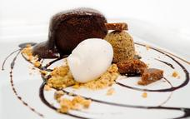

Included - Dinner

Excluded -Domestic flight JNB - PLZ

Day 5 – OCT 16: Tsitsikamma Village Inn, Tsitsikamma National Park

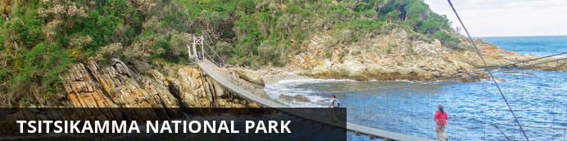
Much of the indigenous forest in this eastern part of the Garden Route falls within the Tsitsikamma National Park. The park is not only a breathtaking haven for indigenous flora and fauna but also for marine life. A marine conservation belt forms part of the park, stretching five and a half kilometres out into the ocean.

Day Itinerary
Depart Port Elizabeth and drive to your next destination on the Garden Route. Check into your hotel. Afternoon at leisure to explore the Tsitsikamma National Park.

Overnight: Tsitsikamma Village Inn View iBrochure
Tsitsikamma Village Inn, located in the village of Storms River on the beautiful Garden Route, offers a unique form of accommodation. Most of our rooms are situated around a typical Village green. These buildings represent many of the different building styles that were to be found in the Cape Colony during the 1800s. The Oude Martha Restaurant serves hearty and delicious breakfasts, lunches and dinners. Other popular on-site restaurants include the characterful Hunter’s Pub and the informal Cafe Bacchus. Next door to the hotel, is the Marilyn’s 60s Diner, where one can enjoy a trip down memory lane with the vintage motorcycles, cars, memorabilia and a typical diner menu. Enjoy an Ale or Lager in Tsitsikamma Micro Brewery which also offers a number of other South African craft beers. The hotel is a great base from which to explore the natural attractions and adventure options of the region and there are many ways to do this from hiking trails, mountain biking and horse rides to tree-top canopy tours and bungee jumping. Between excursions, guests are welcome to relax around the sparkling swimming pool, visit the hair salon or entertain themselves in the games room. There is complimentary wi-fi access available throughout the hotel. In-room facilities include air-conditioning/heating, electrical blankets, television and a tea/coffee station. The Hotel is renowned for its good food, old world charm and has been a favourite for many a year!
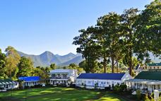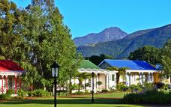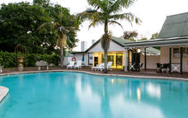

Activities - Tsitsikamma National Park

Included - Entrance fees to Tsitsikamma National Park
Dinner

Day 6 – OCT 17: Knysna Log Inn, Knysna

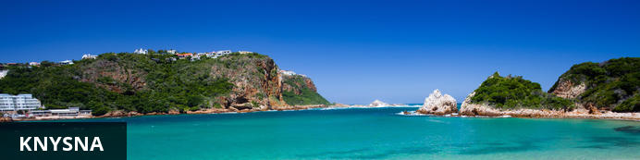
Nestled between the imposing Outeniqua Mountains and the Indian Ocean and surrounded by world-renowned forests, Knysna offers a wealth of activities for visitors. The beautiful lagoon and more than eight beaches provide opportunities to swim, surf, canoe, yacht, jet-ski, boat, fish, walk on soft sand and take ferry rides. Various markets offer organic goods, delicious food, indigenous plants and a social atmosphere. Mountains, valleys, lakes, forests and streams are ready to be explored. The region isn’t known as the “Garden of Eden” for nothing! A birding route is available for avid bird watchers. World class golf courses are at your doorstep. And of course the area is famous for the Knysna Heads and delicious oysters.

Day Itinerary
Depart early for Knysna and transfer onto the ferry for Featherbed Nature Reserve (subject to it having re-opened after the fires). Enjoy a hike around the reserve, followed by lunch. After checking into the hotel, the afternoon is at leisure to explore Knysna on foot.
Dinner to own arrangements.

2 Overnight: Knysna Log Inn
Built in 1998, the Knysna Log-Inn Hotel embodies an "indigenous" concept that combines the character and the spirit of the surrounding indigenous forests with Knysna's romantic history. Harking back to the logging history of Knysna exquisitely solid Yellowwood trunks tower upwards to the magnificent Scandinavian hammer trusses and rays of sunshine flooding through the stained glass windows, illuminating the solid Yellowwood staircase. 57 en-suite luxury bedrooms invite you to unwind in comfort and style. Each room is equipped with air-conditioning, ceiling fans, electronic safes, remote control TV's (M-Net, Sport and local channels), direct dial telephones, hairdryers and tea/coffee making facilities. The lush tropical pool area is home to an all season’s swimming pool, wooden sun deck, Jacuzzi and sauna.
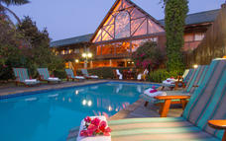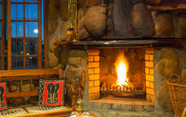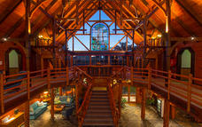

Activities
Featherbed Nature Reserve

Featherbed Nature Reserve
Featherbed is a privately-owned, registered Nature Reserve and a South African Heritage Site, No.59. It is a pristine piece of paradise situated on the Western Head of Knysna and is accessible by ferry only. In order to protect the splendour of the natural beauty, access to the Reserve is controlled. Numbers are limited and visits are only permitted in the company of the Reserve's specialist guides. This 4-hour excursion departs daily and reservations are essential. It is a wonderful outing for all ages and fitness levels. Good walking shoes are recommended and remember to bring your camera, hats, and sunblock in summer and a warm jacket for the ferry trip in winter. The nature reserve offers Knysna adventure activities not to be missed. A perfect outdoor family holiday activity to be enjoyed by both young and old.
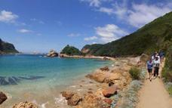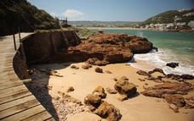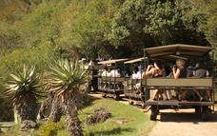

Included - Featherbed ferry, hike & lunch.

Day 7 – OCT 18: Knysna Log Inn, Knysna (Sat, 13 October)

Day Itinerary
Breakfast at leisure. Join your guide on a tour of the Knysna Lagoon and Oyster Company, followed by lunch. In the afternoon you will be taken to Mitchell's Brewery, pretty much an icon in Knysna, for some insight into the brewing industry and to enjoy some beer tasting. Dinner at leisure and to your own account.

Activities
Lunch Knysna Lagoon Oyster Tour
Mitchells Brewing

Knysna Lagoon Oyster Tour
The coastal town of Knysna and Oysters go together like champagne and caviar, sea and sky, summer breezes and cold beers . If you're more than a little intrigued by oysters, then join the Knysna Lagoon Tour for the ultimate oyster experience on the spectacular Knysna Lagoon. Learn all there is to know about one of the world's most loved delicacy, taste the difference between wild and cultivated oysters, all whilst cruising the lagoon to the Heads and surrounds.
Ask questions, take photo's, excite your taste buds - all on board our "Oyster Boat" with a small group of guests. The cruise includes complimentary local white wine and oysters for tasting. Extra oysters are available on pre-order to enjoy on the boat.
Cruise includes an oyster educational experience, complimentary white wine, and half a dozen fresh oysters per person.
Cruises depart daily from Whet Restaurant (previously Quay Four Restaurant), on Thesen Island. Please remember your camera, sunblock, sunhat and wind breaker (just in case!) And remember, the boat is perfect for families and children of all ages are welcome.
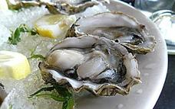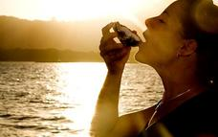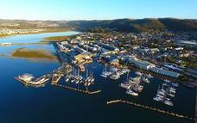

Mitchells Brewing
Mitchell’s Brewery was started in 1983 in Knysna by Lex Mitchell. He started off brewing only Forester’s Lager and Bosun’s Bitter to be distributed in Knysna. Our current brewmaster, Dave McRae, started brewing for Mitchell’s in 1984. Since then five beers have been added to our repertoire and are distributed nationally. This year a pure apple cider joins the Mitchell’s Brewery stable.
Our beers are completely natural, made with 100% barley, water, hops and yeast and contain no artificial preservatives or chemicals.

Included - Knysna Oyster Tour, lunch and Brewery.

Day 8 – OCT 19: Turnberry Boutique Hotel, Oudtshoorn

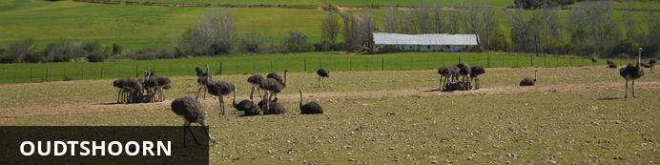
Oudtshoorn is famous for its ostriches and the magnificent Cango Caves. Located along the renowned Route 62, which takes motorists past one awe-inspiring sight after another, Oudtshoorn is known as the Ostrich Capital of the World: these huge birds are almost as common as people in this charming town. Other than ostriches and the wonderful feathers and meat they provide, the Oudtshoorn area also boasts the spectacular Cango Caves; the largest show cave system in Africa, permeated with sparkling stalactites and stalagmites and captivating rock formations.

Day Itinerary
Depart Knysna via the Outeniqua Pass and travel to Oudtshoorn. Stop and visit an Ostrich farm. Continue to hotel for overnight and dinner.

Overnight: Turnberry Boutique Hotel View iBrochure
The luxury four star Turnberry Boutique Hotel is situated in the centre of the picturesque Klein Karoo town of Oudtshoorn, South Africa. A warm welcome awaits visitors to the heart of the Klein Karoo. Relax in the comfort of one of the 22 luxury air-conditioned bedrooms (each with DSTV, a coffee station, electronic safe and a mini bar), all with en-suite bathrooms, and cozy double beds fitted with crisp white linen. Each room also has free wifi. Relax on leather couches in our cool classy tavern at the very heart of the hotel, and enjoy a spectacular South African Braai experience. Spend the afternoon cooling off in the sparkling swimming pool, and take cocktails on the patio overlooking the stark beauty of the Klein Karoo at sundown.
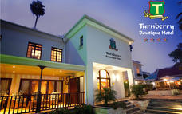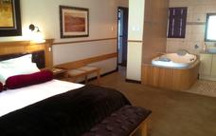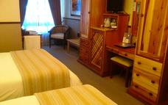

Activities
Safari Ostrich Showfarm

Safari Ostrich Showfarm
Safari Ostrich Show Farm is an operating farm where visitors will see large flocks of ostriches at different stages of development in the surrounding fields. Visitors are assured of personal attention and upon their arrival are greeted by one of our multi-lingual guides who will, during the course of the tour explain every aspect of ostrich farming, from breeding to rearing. The tour starts in the breeding camp, with a nest of ostrich eggs, where the first stage of the ostrich life cycle is explained. Visitors will get the opportunity to test the strength of the eggs by standing on them - a great photo opportunity. During the breeding season visitors get to see ostrich eggs hatching in the incubator rooms. Visitors get to sit on an ostrich and those who are brave enough can even try their hand at riding one. Every tour ends with an "Ostrich Derby" where local jockeys display their riding skills. A highly entertaining and educational tour is guaranteed.
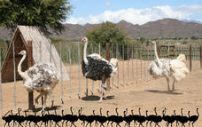

Included- Entrance fee to Ostrich farm / BBQ Dinner at hotel

Day 9 – OCT 20: Protea Hotel by Marriott Franschhoek, Franschhoek

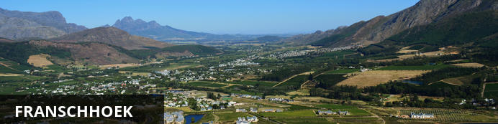
A quaint wine farming town with a quiet but buzzing main road which is, in most years, home to 2 or 3 of the country's top 10 restaurants.

Day Itinerary
After an early breakfast and check-out we drive to the Cango Caves for a 1 hour standard tour of the Caves. Continue on Route 62 to Franschhoek. Lunch stop en route and to your own account.

2 Overnight: Protea Hotel by Marriott Franschhoek
Charming 4-star hotel overlooks the mountains and vineyards of the historic village of Franschhoek, near art galleries and wine estates about 80 km east of Cape Town. Enjoy comfortable rooms, a renowned restaurant and a sparkling swimming pool. Discover a location overlooking the majestic mountains and famous vineyards of the historical village of Franschhoek, about 80 km east of Cape Town. The hotel prides itself on its charming ambience, gracious style and attentive service. This 4-star property has a rich history, with one section dating back to the 1880s. The town itself takes its name from the French Huguenots who settled in the area in the early 1680s after fleeing from their home country. Our convenient location is a superb base from which to explore Franschhoek's culinary establishments, art galleries, cheese factories and some 25 world-famous wine estates. Protea Hotel by Marriott Franschhoek boasts a renowned restaurant, conference facilities, luxury accommodations and a sparkling swimming pool. Outdoor activities such as horse-riding, golf, backpacking and trout-fishing can also be arranged.
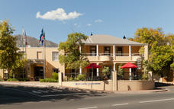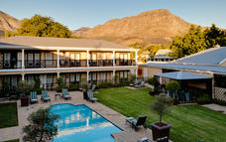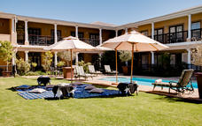

Activities- Cango Caves

Cango Caves
The spectacular Cango Caves are a subterranean wonderland of magnificent stalactite and stalagmite rock formations that attracts thousands of visitors annually. They extend more than two kilometres into the Swartberg Mountains and visitors can take guided tours that wind through narrow passageways and steep stairways linking the massive caverns.
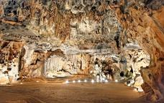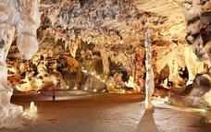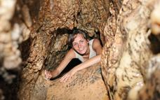

Included - Cango Caves

Excluded - Lunch

Day 10- OCT 21: Protea Hotel by Marriott Franschhoek, Franschhoek

Day Itinerary
Your day is spent in Franschhoek, visiting a number of wine-estates. You are free to choose your own routes and stops and to explore Franschhoek as much as you like. Dinner at leisure and to your own account.

Activities
10:00 Franschhoek Wine-Tram Hop-on Hop-off Tour

Franschhoek Wine-Tram Hop-on Hop-off Tour
The Franschhoek Wine Tram hop-on hop-off tour is one of the best ways to discover the true essence of the Franschhoek Valley – picturesque vineyards, breath-taking scenery, warm hospitality, world-class cuisine, fine wines and a 300 year history.
Passengers aboard the hop-on hop-off tour will experience a unique and leisurely way to see the Franschhoek Valley as they journey through rolling vineyards in an open-side tram and open-air tram-bus stopping in at some of South Africa’s oldest and most distinguished wine estates.
A combination of tram and tram-bus transports passengers around a loop of stops allowing them to hop-off at each stop and experience the activities on offer, be it wine tasting, a cellar tour, lunch or simply a stroll through the vineyards and when they are ready, hop-on to continue the tour.
The tour takes passengers right into the heart of the Franschhoek Valley, with a narration focusing on the history of Franschhoek and wine cultivation in the valley and unparalleled views of the valley and vineyards.
Franschhoek Wine Tram currently offers five hop-on hop-off lines to choose from: Blue Line, Red Line, Yellow Line, Green Line and Purple Line. Each visiting eight wine estates and showcasing a separate part of the Franschhoek Valley
These take place every day from 10 o'clock. Tickets available at the ticket office in the Main Road.
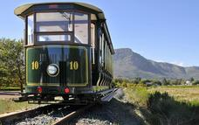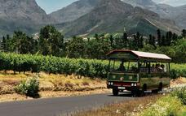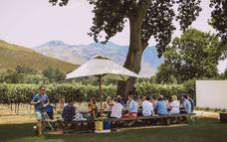

Included - Wine-tram Hop on/Hop off ticket

Excluded - Lunch, Dinner

Day 11 – OCT 22: Radisson Blu Hotel Waterfront, Cape Town

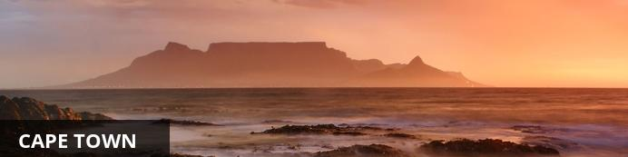
Cape Town is one of the world's most beautiful cities and a top international destination. Large numbers of tourists flock to Cape Town to enjoy this unique city with its fascinating history, interesting culture, natural beauty, award winning wines and laidback lifestyle. Whether you are a serious tourist or just want to lie on the beach and enjoy life, Cape Town will satisfy your needs.

Day Itinerary
Depart Franschhoek after breakfast. Travel along the beautiful Helshoogte Pass to Stellenbosch, stopping at a few wine farms en route. Visit to Spier wine estate, cellar tour and lunch. Continue to Cape Town. You will receive a city orientation tour before checking in to the hotel. Dinner at the hotel.

3 Overnight: Radisson Blu Hotel Waterfront View iBrochure
This international five star hotel is spectacularly situated on the edge of the Atlantic Ocean, overlooking a private marina and adjacent to the world famous V&A Waterfront with its dazzling selection of over 69 restaurants, coffee shops and bars, 400 shops and 11 cinemas. It’s as close to the water as you can be and in addition to the magnificent views, guests enjoy superb service, free broadband, the award winning Quantum spa and fitness centre, the choice of 177 luxurious rooms and the benefit of having Tobago’s Restaurant, Bar and Terrace right downstairs. Whether you enjoy an icy cocktail on the terrace, relax at the rim flow pool or indulge in a spa treatment you are guaranteed a memorable experience. If you are considering a function, the hotel offers three banqueting and meeting rooms: Two modular air-conditioned conference rooms equipped with the latest audio visual and technical equipment, catering for up to 140 delegates. The Harbour View room, overlooking a private marina is a function room ideally suited to hosting events ranging from wedding receptions to cocktail parties and banquets. This is one of the few event rooms in Cape Town to boast an exclusive seaside boardwalk. The Harbour View room can accommodate 100 guests for banquets and up to 300 guests for cocktails. The Captain's View Boardroom can seat up to 16 guests, equipped with latest audio visual equipment. If you can tear yourself away from the hotel however, the close proximity to the CBD, the Cape Town International Conference Centre, The V&A Waterfront and Cape Town’s beautiful beaches and many tourist attractions make the Radisson Blu Hotel Waterfront the perfect location for either business or pleasure.
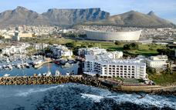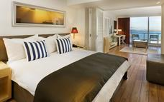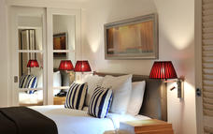

Activities - Spier Wine Farm

Spier Wine Farm
Spier is one of the oldest wine farms in South Africa with a recorded history dating back to 1692. While rooted in this heritage, Spier has a vibrant and conscious energy. Award-winning wine can be paired with fabulous food, grown either on the farm or by nearby farmers. The winery is one of the most awarded in the country and the Spier Hotel and meeting facilities offer inspiring winelands getaways in the tranquility of nature.
Spier is committed to doing the right thing for the environment and communities, and is renowned for its responsible tourism approach. The farm has been recognised by various external organisations including Fair Trade in Tourism (FTTSA) and the Wine Industry Ethical Trade Association (WIETA).
In 2011, Condé Nast Traveler World Saver Award recognised the estate as the top international destination ‘Doing it All’. Spier is a Champion member of the Biodiversity & Wine Initiative (BWI), and the cellar has ISO 22000 certification, is Fair Trade accredited, organically certified and follows the Integrated Production of Wine (IPW) criteria.
Spier’s environmental and social initiatives are many and varied, and include ways to reduce water usage. 100% of its wastewater, and over 80% of its solid waste, is recycled. Spier supports local communities through the treepreneur project, which encourages people in impoverished communities to grow trees in exchange for essential goods. The estate also supports entrepreneurs by helping them create micro-enterprises linked to Spier.
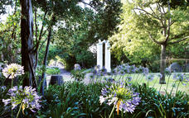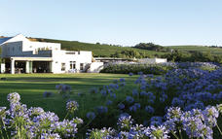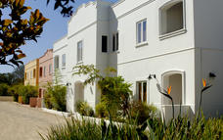

Included
Spier wine estate, wine-tasting and lunch

Day 12 – OCT 23: Radisson Blu Hotel Waterfront, Cape Town

Day Itinerary
After breakfast you meet your guide and driver for a full day tour around Cape Town's beautiful peninsula. This evening you are able to spend at leisure and make your own dinner arrangements.

Activities - Full day Cape Peninsula tour

Full day Cape Peninsula tour
Cape Point and Cape of Good Hope
Visit the Cape of Good Hope National Park, part of the Table Mountain National Park that extends from Signal Hill in the north all the way to Cape Point in the south The Cape of Good Hope is not the southern tip of Africa, despite lying at the south-west corner of the Cape Peninsula, just a little south of Cape Point on the south-east corner. Explore Cape Point with its light house which is a short but steep walk up or hop aboard the funicular and you’ll be whisked away on a scenic trip to the view site near the old Cape Point lighthouse. Over time, the means of transport to the view site changed from a diesel bus, named after the “Flying Dutchman” ghost ship, to an environmentally friendly funicular - the only one of its kind in the world.
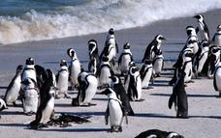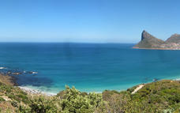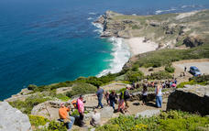

Included - Entrance fees to Cape Point and Boulders.

Excluded - Furnicular train to lighthouse, Lunch & Dinner to own account

Day 13 OCT 24: Radisson Blu Hotel Waterfront, Cape Town

Day Itinerary
If the weather permits, you will be collected after breakfast and transferred to the Table Mountain Cable Way Station. Spend the morning on Table Mountain. The afternoon is at leisure at the V&A Waterfront for some last-minute souvenir shopping. In the late afternoon you gather at the reception and transfer to the Gold Restaurant for your farewell dinner.

Activities - Table Mountain
Dinner Gold Restaurant

Recommended - V&A Waterfront

Table Mountain
Without a doubt it is Table Mountain that makes Cape Town the unique city it is. Rising up over 1000m above sea level, it is the icon that makes Cape Town instantly recognizable. It is a symbol, a playground, a spiritual retreat and a big draw card for tourists. So intertwined with the identity of Cape Town is Table Mountain that a visit to the city isn’t complete without having walked or taken the cable car to the top.
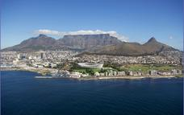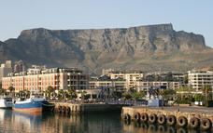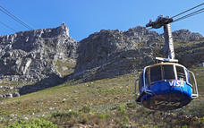

Gold Restaurant
GOLD Restaurant is a vibrant, eclectic Pan-African experience in the heart of Cape Town. It offers a night of opulent feasting with a unique bouquet of live entertainment in a mystical African setting of trees and tents in an inner city courtyard steeped in ancient history and GOLD.
A typical evening at GOLD Restaurant starts off with the drumbeat of the djembe drum. An interactive drum circle offers you the opportunity to join in and learn how to play the djembe. Soon you will be pounding your drum to the rhythms and sounds of Africa. After pounding the skins of the drums, you canl soothe your hands in a traditional hand washing ceremony as you are led into the ancient courtyards.
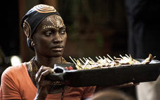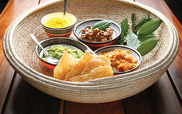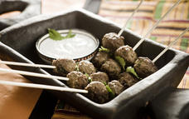

V&A Waterfront
Situated between Robben Island and Table Mountain in the heart of Cape Town's working harbour, the V&A Waterfront has become South Africa's most visited destination. Set against a backdrop of magnificent sea and mountain views, exciting shopping and entertainment venues are intermingled with imaginative office locations, world-class hotels and luxury apartments. The Waterfront is the heart of the tourist industry in Cape Town.
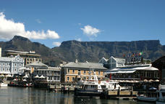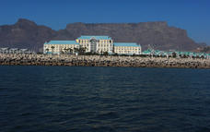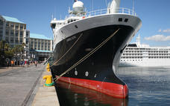

Included - Bed & Breakfast

Day 14 – OCT 25, 2018: Departure

Day Itinerary
Last morning in Cape Town. Check out of the hotel, transfer to the airport and return flight home.
Excluded:
- All personal expenses such as telephone calls, gratuities, curio and laundry
- Travel insurance
- All meals not stipulated above
- Porterage (will be charged at hotel)
- All optional items / additional entrance fees not mentioned above
- Visa fees (where applicable)
- All international and domestic flights – ARRIVE JOHANESBURG OCT 12, 2018
- THEN OCTOBER 15 – JOHANESBURG TO PORT ELIZABETH AND OCT 25 – CAPETOWN / RETURN.

Please note:
- Should any of the accommodation mentioned not be available, we reserve the right to substitute it with an alternative suitable venue. Only then will the price be finalized.
- Price is subject to currency fluctuations.
- Should the number of passengers change, the price will differ.
- Please request our Terms & Conditions of business

