CHINA TIBET BUS TOUR BTCPTB2

10-day Lhasa , Everest Base Camp & Namtso Lake Tour

Trip Overview
This is the Classic tour itinerary to visit Lhasa and Everest Base camp. If you are not used to the high altitude, then this is one of the best itineraries that cover the all the Lhasa main tourist sites like Potala Palace, Jokhang Temple, Barkhor street, Drepung and sera monastery with Gyantse Kumbum and Shigatse Tashi Lhunpho monastery.
Tourists can see much natural scenery like beautiful sacred Lake Yamdrok tso and karo glacier with beautiful views of Mt. Everest, the highest mountain in the world from Everest Base Camp. Namtso Lake is the second largest alpine saline lake in Tibet with an altitude of 4,718 meters above sea level. Its surrealistic beauty will take your breath away in no time.

Highlights:
- Potala Palace: Winter palace of the Dalai Lama
- Jokhang Temple : Spiritual Center for Buddhists in Tibet
- Sera Monastery: One of the “great three” Gelug monasteries of Tibet, the hot attraction is monks debate.
- Drepung Monstery: Drepung used to be a seat of central government until the 5th Dalai Lama built Potala Palace.
- Namtso Lake: It is the "Heavenly Lake" which is one of the four holy lakes of Tibet and also the highest salt-lake.
- Mt. Everest: The highest mountain in the world.

Outline Itinerary
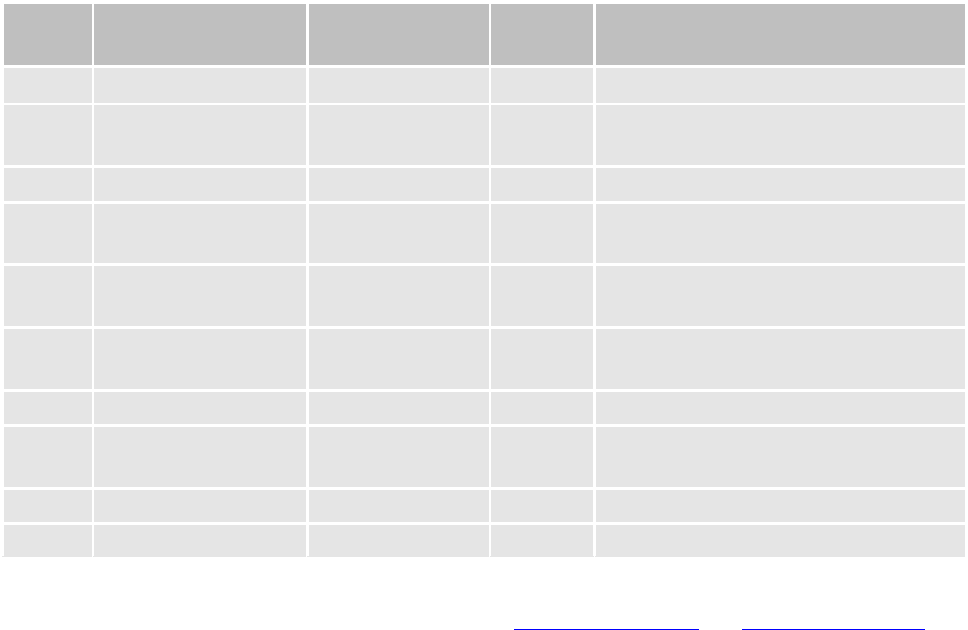
B=Breakfast D=Dinner
Day Place & Transport Accommodation Meals Today’s Activities or Sightseeing
Day 1 Arrive in Lhasa Economy Hotel - Airport/train station to Hotel transfer Day 2 Lhasa Economy Hotel B, D Potala Palace, Jokhang Monastery,
Barkhor Street
Day 3 Lhasa Economy Hotel B Drepung Monastery, Sera Monastery

Day 4 Lhasa to Gyantse to
Shigatse (330 km)
Economy Hotel B Yamdrok Lake, Kumbum Monastery

Day 5 Shigatse to Rongpuk (350 km)
Tent or Guest House
B Rongpuk Monastery, far view Peaks of Himalayas

Day 6 Rongpuk to EBC to Shigatse
Economy Hotel - Everest Base Camp

Day 7 Shigatse to Lhasa Economy Hotel B Tashi Lhunpo Monastery

Day 8 Lhasa-Namtso Lake Tents or
Guest house
B Sunset by Namtso Lake

Day 9 Namtso-Lhasa Economy Hotel - Sun rise of Namtso Lake
Day 10 Depart from Lhasa - B Hotel to airport/train station transfer
------------------------Detailed Itinerary
Day 1 Arrive in Lhasa by plane or by train
You are warmly welcome to Tibet by saying Tashi Delek at the Train station/airport by our professional employee and send you to reserved hotel in Lhasa. Then have a good rest to acclimatize the high altitude in the afternoon.
Meals included: ——
Hotel: Lhasa YAK Hotel（or other similar Hotel）

Day 2 Lhasa (B, D)
The tour will begin from UNESCO World Heritage site - Potala Palace, which is also the winter palace of Dalai Lama. It's situated at 12,139 feet above sea level. It's a 13-story high building that contains over 1,000 rooms, various statues, stupas, murals and artifacts.
Then continue to Jokhang Temple, another UNESCO World Heritage site. It’s a spiritual center for Buddhists in Tibet. Next to the temple there is Bakhor Street, filled with pilgrims and street vendors, selling traditional Tibetan items such as prayer wheels and jewelry.
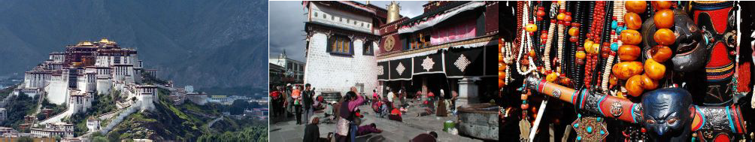
Meals included: Breakfast & Dinner
Hotel: Lhasa YAK Hotel （or other similar Hotel）

Day 3 Lhasa (B)
In the morning, you are going to visit Drepung monastery which was one of the “three greet” Gelug monasteries of Tibet and was founded in 1416. Ganden palace is used as Dalai Lama’s palace in the Drepung before moving to the Potala palace.
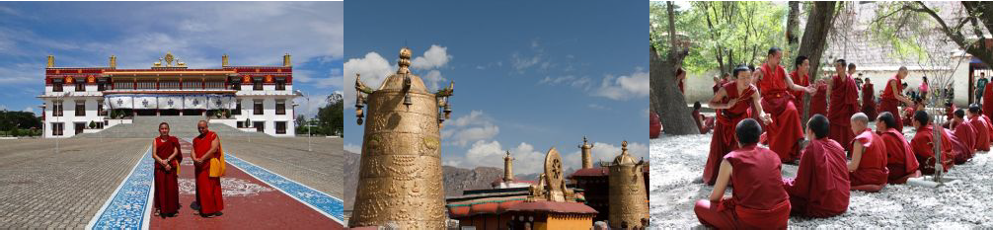
Afternoon, Sera Monastery---It was one of the “three great” Gelug monasteries of Tibet and was founded in 1419. The highlight is the Monks debate at around 3 - 5 in the afternoon.
Meals included: Breakfast
Hotel: Lhasa YAK Hotel （or other similar Hotel）

Day 4 Lhasa – Yamdrok Lake – Gyangtse – Shigatse (B)
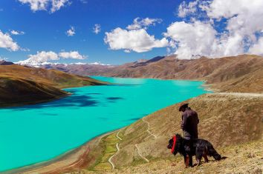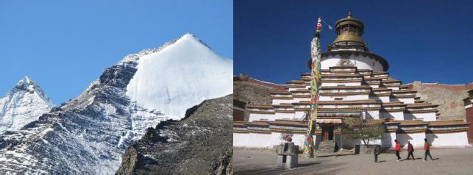Drive from Lhasa to Gyantse. Admire the Gampala pass (4790 m) on the way, and get a glimpse of Yamdrok-tso (4400m), which is surrounded by many snow-capped mountains. Then continue to drive west towards Gyantse. In Gyantse, tourists will visit the famous Pelkor Monastery and Gyantse Kumbum. After one and a half hour's drive, clients will arrive in Shigatse, which is the second largest city in Tibet.
Meals included: Breakfast Hotel: Shigatse Tsangba Hotel
（or other similar Hotel）

Day5 Everest Base Camp (B)
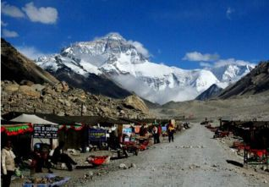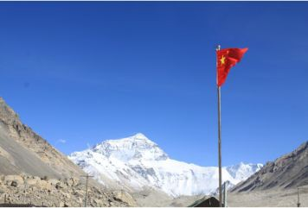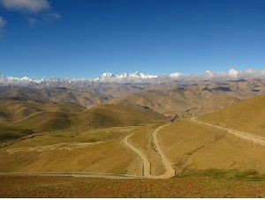Drive to Lhatse where tourists can take lunch. Then drive to Shegar and if the weather is clear enough, tourists can view the Mt. Everest in the distance on the way back down. After 4 to 6 hours, arrive at Rongbuk monastery, but on the way there, clients will pass Pang la Pass, one of the highest passes in Tibet at 5050m. From that pass, enjoy view all of the five highest peaks in the world.
Overnight at Rongphu Monastery (Tent or Guest House) Meals included: Breakfast

Day 6 Everest Base Camp Return to Shigatse
In the morning, tourists can see the sunrise appear on the top of Mt Everest, and have a full view of the magnificent Mount . Tourists may trek from tent to the base camp 4km one way, or go to EBC by local bus. Then drive back to Shigatse.
Meals included: Breakfast
Hotel: Shigatze Tsangba Hotel （or other similar Hotel）

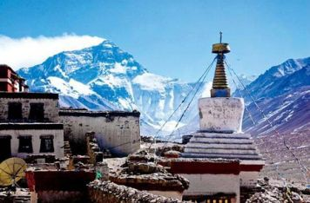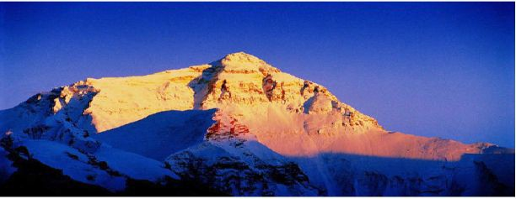

Day 7 Shigatse – Lhasa (B)
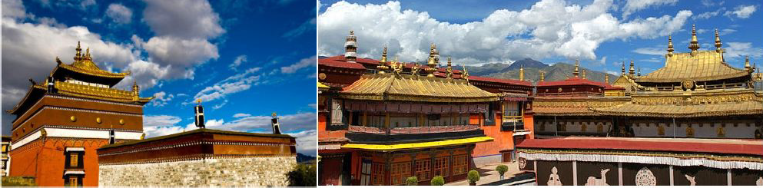
Today, explore Tashilunpo monastery of Gelug Sect, the seat of the Panchen Lama, built in 1447. The monastery houses a giant statue of the Maitreya Buddha - the biggest gilded statue of Maitreya (Buddha of the future) in the world and a tomb of all the Panchen Lama, containing jewels and gold. In the afternoon, you will drive back to Lhasa, which will take around 6 hours.
Meals included: Breakfast
Hotel: Lhasa YAK Hotel （or other similar Hotel）

Day 8: Lhasa to Namtso Lake (240km, 5 hours )
In the morning, drive from Lhasa to Lake Namtso. On the way, clients can see Nyenchen Thanglha( snow mountain ranges )and lots of nomads tent with grazing yak and sheep
densely-populated around the mountain side. Namtso Lake is the Heavenly Lake which is one of the four holy lakes of Tibet and also the highest salt lake. You can do a very relaxing trekking around the lake side and Tashi Island.

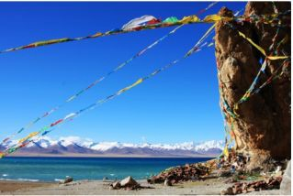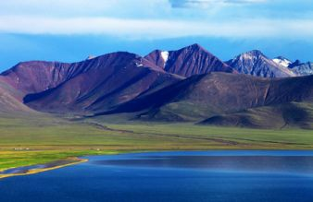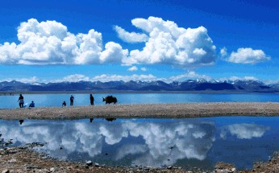To spend a night at lake shore is fantastic to see the stars.
Overnight by the lake (Tent or Guest House) Meals included: Breakfast

Day 9: Namtso Lake to Lhasa (240km, 5 hours)
Enjoy the clear morning at the lake shore; you can trek along the lake shore to Tashi Dor Island to explore the meditation caves. Drive to Dumxung to have lunch.
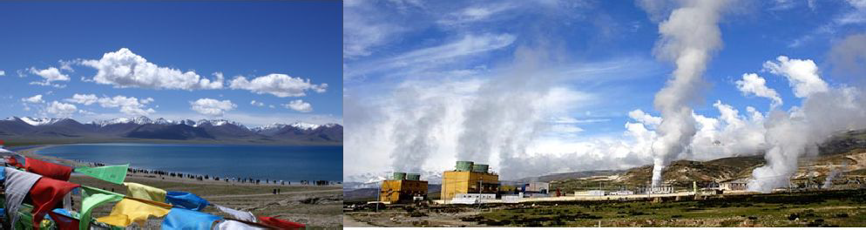
In the afternoon, tourists may enjoy Yangpachen hot spring (Optional) and have both indoor and outdoor swimming pool filled with hot springs water. Finally, head back to Lhasa.

Day 10 Depart from Lhasa (B) Transfer to Lhasa airport or train station. Service ends.
Meals included: Breakfast

Services Included
- All necessary travel permits for Tibet (excluding Chinese visa);
- Professional Tibetan English speaking tour guide;
- Admission fee of all tourist sites listed in above itinerary;
- Tourist bus/minibus with local driver for transportation between airport/train station and Hotel at designated period of time, and transfers for above tours;
- Accommodation of 7 nights (3 star hotel) with daily breakfast, 2 night Dorm or Big Tent with humble accommodation at Rongpuk Everest area and the shore of Namtso Lake;
- Welcome Tibetan dinner;
- Oxygen bottles/Oxygen tank cylinder provided during the tour days in Tibet.

Services Excluded
- China Visa;
- Lunches and Dinners;
- Breakfast at Rongpuk Monastery and Namtso Lake;
- Tips to guide and driver;
- Insurance;
- Other personal expense;
- Any air tickets/ train tickets.

Important Notes:
- Our free airport--Hotel transfer are based on bus transfers on below timings: Lhasa airport--hotel: 12:20 noon, 4:00 pm
Hotel--Lhasa airport: 07:30 am; 11:00 am
If you miss the above timing, or if your flight cannot match the above time, or if your flight delay, or if you dont want to wait for other people, or if you prefer your own private transfer, we can arrange the following for you at extra cost:
500 Yuan/per taxi with guide for airport--hotel or vise verse (all year);
650 Yuan/per 5 seats Chinese business van with guide for airport--hotel or vise verse(all year except July--Oct)
750 Yuan/per 5 seats Chinese business van with guide for airport--hotel or vise verse (July--Oct)
--please note transfers include tour guide is per government requirement.

- Lhasa train station--hotel in Lhasa transfer is free on tour date
If you miss the above timing, or if your train cannot match the above time, or if your train delay, or if you dont want to wait for other people, or if you prefer your own private transfer, we can arrange the following for you at extra cost:
350 Yuan/per taxi with guide for train station--hotel or vise verse (all year);
480 Yuan/per 5 seats Chinese business van with guide for train station --hotel or vise verse(all year except July--Oct)
580 Yuan/per 5 seats Chinese business van with guide for train station --hotel or vise verse (July--Oct)
--please note transfers include tour guide is per government requirement.

- We can upgrade your hotel with extra cost.
- Tashi Delek & Enjoy Tibet and Tibetan culture!

