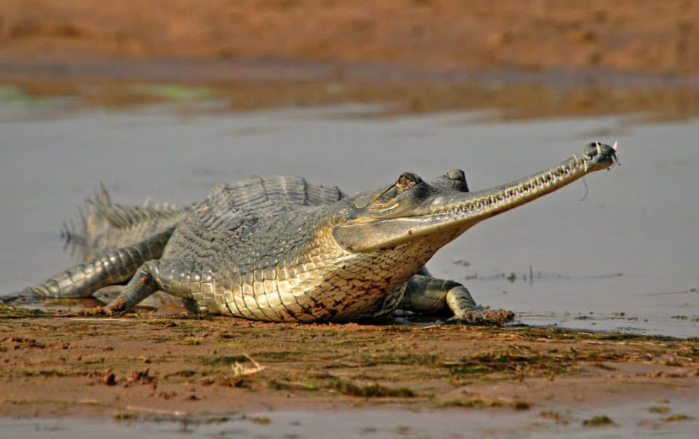
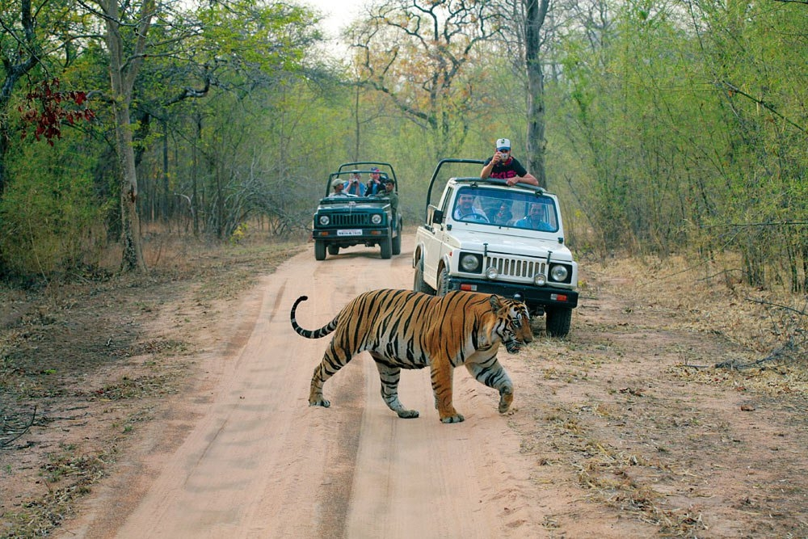
Indian Wildlife

Delhi ~ Agra ~ Chambal ~ Ranthambore ~ Bandhavgarh ~ Kanha ~ Pench ~ Tadoba ~ Nagpur ~ Mumbai

Day 01: Arrive at Delhi
Arrive at New Delhi’s International Airport. Following customs, immigration formalities and baggage collection, our representative will meet you as you exit the arrival terminal building after which you would be transferred to your hotel.
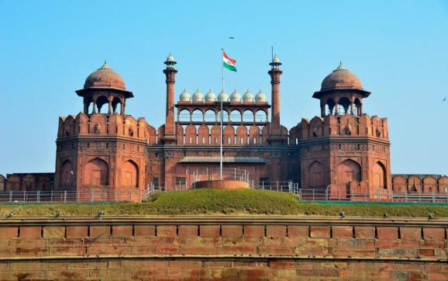
India’s capital and a major gateway to the country, contemporary Delhi is a bustling metropolis, which successfully combines in its folds - the ancient with the modern. Amidst the fast spiraling skyscrapers the remnants of a bygone time in the form of its many monuments stand as silent reminders to the region’s ancient legacy. The first impressions for any visitor traveling in from the airport are of a specious, garden city, tree-lined with a number of beautiful parks.

Upon arrival at the hotel, proceed for check-in at the hotel.

Stay overnight at hotel.

Day 02: Delhi
Morning proceed for fuIl day sightseeing of Old & New Delhi. Introduction to Delhi starts with a heritage walk to Old Delhi (Shahjahanabad) visiting Red Fort, Jama Mosque, Chandni Chowk and Raj Ghat.
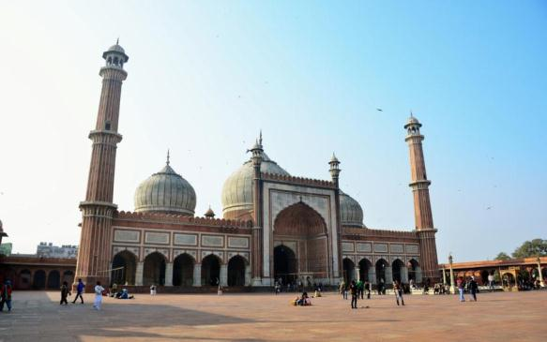
In the 17th century, the Mughal emperor, Shah Jahan, made his capital in Shahjahanabad, the area that broadly covers present-day Old Delhi, also called the walled city.
The Red Fort was built by the Mughal Emperor Shah Jahan in the 17th century that took around 9 years to complete this magnificent structure and around 10 million rupees to build the fort. The Red Fort is a masterpiece of architecture and is one of the most visited spot in old Delhi. The Red Fort, the last fort built in Delhi, has witnessed the vicissitudes of fate, the Mughals, the British, and finally the first light of Indian Independence.
Jama Masjid is the largest and most well-known mosque in India. It is flanked by Red fort on one side and old city Chandni Chowk on another side. Built by Shah Jahan in 17th century, Jama Masjid is one of the most crowded destinations in Delhi for pilgrims and tourists.
The romance of the bazaars of Delhi can be experienced at its best in and around Chandni Chowk and it’s by lanes. Today, the walled city is one of the metropolis’ most crowded, chaotic and captivating areas, with a bamboozling orchestra of sights, and sounds. According to legend, Chandni Chowk market was established during the reign of the Mughal Emperor Shah Jahan. The legend also says that Chandni Chowk market was designed by Jahanara-Emperor Shah Jahan's favorite daughter.
Following walk enjoy Rickshaw ride in the by lanes of Chandni Chowk.
Later visit Raj Ghat, resting place of Mahatma Gandhi's. Raj Ghat remembers the man who is known as the Father of the Nation for his tireless and pacifist work to reclaim India's independence.
Following visit of Raj Ghat, proceed for Lutyen’s Delhi covering a photo stop at India Gate followed by orientation tour of Raj path, Parliament House and President House.
Late afternoon visit to Humayun’s Tomb.
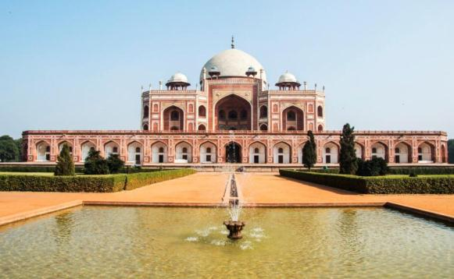
Humayun’s the second Mughal Emperor of India died in 1556, and his widow Hamida Banu Begam, also known as Haji Begam, commenced the construction of his tomb in 1569, fourteen years after his death. Humayun’s Tomb is the first distinct example of proper Mughal style, which was inspired by Persian architecture.

Later you will visit to Qutab Minar.
Qutab Minar is amongst the tallest and the most famous monuments in the world. This beautiful minaret is 234 feet high and is regarded as the tallest individual tower in the world. The Qutab Minar is one of the many masterpieces that depicted the sheer brilliance of the Mughal architects.
Qutbu'd-Din Aibak laid the foundation of Minar in AD 1199 for the use of the mu'azzin (crier) to give calls for prayer and raised the first storey, to which were added three more storeys by his successor and son-in-law, Shamsu'd-Din Iltutmish (AD 1211-36).
Stay overnight at hotel.

Day 03: Delhi to Agra to Chambal (300 Kms / 6 Hrs)
Morning by surface travel for Agra – The City of Taj Mahal.
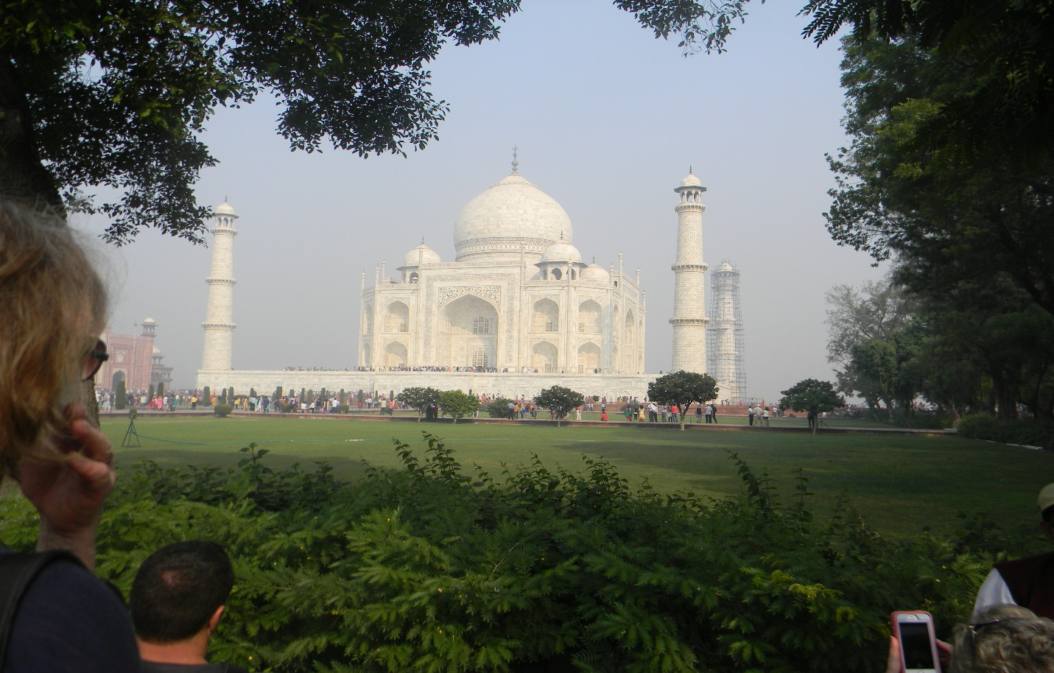
Famed with one of the Seven Wonders of the World - Taj Mahal, historical monuments, architectural grandeur ventures and the beauty of marbles, Agra thrives as one of the tourist destination in India. The city is known for its superb inlay work on marble by craftsmen supposedly with a lineage dating back to the Mughals. Agra’s handicrafts also include carpets, gold thread embroidery and leather shoes.

Upon arrival in Agra proceed for the sightseeing of Taj Mahal and Agra Fort.

Taj Mahal is one of the Seven wonders in the world and a must see place in India. It is the living specimen of romantic love life of Shah Jahan and his favorite beautiful wife Mumtaz Mahal. The construction of this beautiful monument was completed in 1653 AD. The Mughal King Sha Jahan built this as the final resting place for the queen Mumtaz.

It is believed that it took nearly 22 years to complete the grandeur palace. There are 22 small domes over the Taj Mahal, denoting the 22 years and the verses of holy Koran are inscribed on the domes. The white marble building changes its hue with the variations in the daylight.

Following visit of Taj Mahal, proceed for Agra Fort.
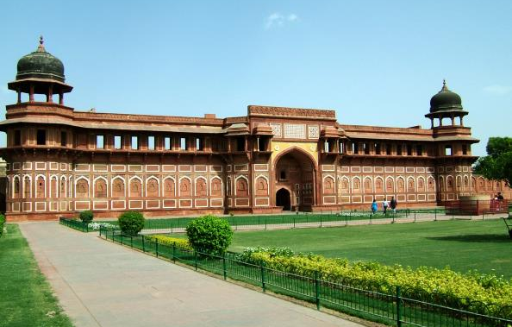
Nestled on the west banks of River Yamuna, this crescent shaped fort was commissioned by Akbar, one of the greatest Mughal Emperors, in 1565. Since then, his descendants Jehangir, Shah Jahan and even Aurangzeb have added extensions to the fort. Surrounded by mighty ramparts, the complex has within the fort has several palaces, gardens, halls, and other historical structures.

A visit to the Agra Fort complements visits to the Taj Mahal, as the fort itself offers great views of the Taj Mahal from across the Yamuna.

Later drive to Chambal.

With a rich heritage stretching back many millennia the Chambal Valley has much to offer from its stunning landscapes & magnificent wildlife, formidable fortresses & crumbling ruins, tranquil temples & flamboyant fairs, colourful history & compelling mythology, a proud resilient people & their legendary exploits.
Stay overnight at Chambal Safari Lodge.

Day 04: Chambal
Morning enjoy boat ride on river Chambal and later visit the National Chambal Sanctuary.
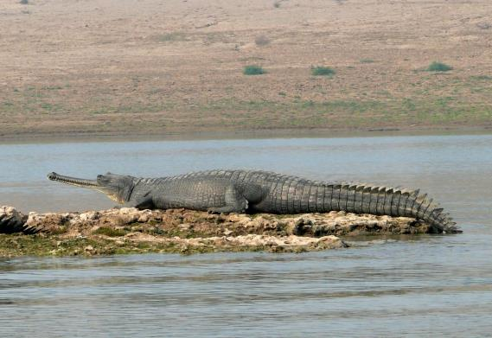
The calm and gentle waters of the Chambal River are best explored on boats and the River Safari provides spectacular opportunities to view the wildlife. You will get an experience to get close to the birds and animals as possible without disturbing them. The River Safari is a most relaxing, enjoyable and special experience.

The National Chambal Sanctuary (NCS) is a 400 km stretch of the river Chambal and a 1 to 6 km wide swathe of the ravines on both sides of the river, covering an area of 1235 sq. km. It provides protection for 1200 Gharials & 300 Marsh Crocodiles.

Later in the afternoon visit Bateshwar Temples.

The ancient temple complex at Bateshwar on the river Yamuna, consists of more than a hundred temples dedicated to the Hindu God Shiva. Referred to as Surajpur in ancient texts, Bateshwar derives its current name from its reigning deity Lord Bateshwar Mahadev (another name for Shiva). The ravines surrounding the temples and river are home to a number of Naga sadhus (snake worshiping ascetics) who have carved out little caves and temples within the mud walls.

Stay overnight at Chambal Safari Lodge.

Day 05: Chambal to Bharatpur via Fatehpur Sikri (150 Kms / 4 Hrs)
Morning enjoy Village Walk near Chambal Safari Lodge.

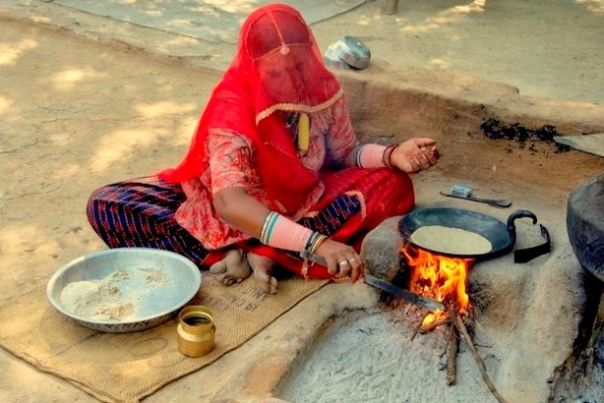
The Villages around the Chambal Safari Lodge provide an interesting insight into rural India. One can still find a potter at his wheel making earthen ware kullars (cups), a cobbler using the simplest implements to fashion and repair a most interesting variety of leather items, and shops selling all manner of goods from jaggery blocks to hand-woven quilts.

Later by surface travel to Bharatpur. En-route visit Fatehpur Sikri.

Built by the Mughal Emperor Akbar in the mid 16th century, Fatehpur Sikri was meant to be a new capital for his empire. It was also the emperor’s homage to Saint Sheikh Salim Chishti, who predicted the birth of the emperor’s much-desired son and heir. Built in almost uniform style, Sikri is a sprawling complex of palaces, mosques, temples, and other structures. It is a stunning amalgamation of the Persian and Indian styles of building. Planned under Akbar’s closer supervision, the new city was initially called Fatehabad - the City of Victory.

Evening is at leisure. Stay overnight at hotel.

Day 6: Bharatpur to Ranthambore (195 Kms / 3.5 hrs)
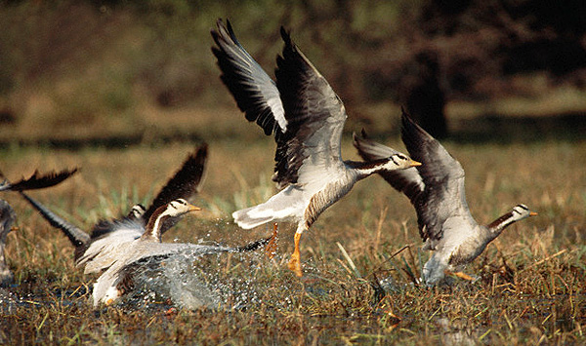
Early morning visit to Keoladeo National Park.

The Keoladeo National Park or Keoladeo Ghana National Park was formerly known as the Bharatpur Bird Sanctuary. A former duck-hunting reserve of the Maharajas and being one of the major wintering areas for large numbers of aquatic birds from Afghanistan, Turkmenistan, China and Siberia; this sanctuary has recorded close to 364 species of birds, including the rare Siberian crane during seasons. Close to 115 variable species of birds breed in this park, including 15 aquatic varieties thus forming one of the most fabulous heronries in this region. Keoladeo was declared a protected sanctuary in 1971, before being pronounced a World heritage Site by UNESCO in 1985.
Later by surface travel to Ranthambore.

Evening visit to the Dastkar women’s cooperative society.

A society for crafts and craftspeople Dastkar-Ranthambore is a registered society that aims at improving the economic status of craftspeople in the village and near by villages of Ranthambore, thereby promoting the survival of traditional crafts.

The crux of its programme is to help craftspeople of Ranthambore, especially women, to use their own traditional craft skills as a means of employment, income generation and economic self-sufficiency.
Stay overnight at hotel.

Day 07: Ranthambore
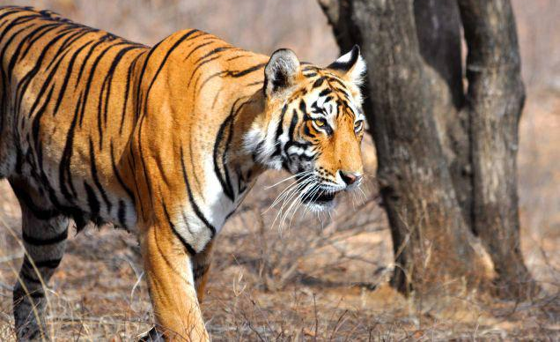
Early morning and afternoon enjoy Jeep Safari in Ranthambore National Park.

The Ranthambore National Park was once the private hunting ground of the Maharaja of Jaipur. The park is located in the Sawai Madhopur district of south-eastern Rajasthan, which is about 130 km from Jaipur. At present, the national park is a part of Project Tiger and is one of the few places in the world, where over 300 species of birds and wildlife such as tigers, leopards, nilgai, black buck and Indian black boar graze with gay abandon. Visiting Ranthambore is a dream of every wildlife enthusiast; the park is renowned for tigers and is one of the best places in India to sight the majestic species.

Evening is at leisure.
Stay overnight at hotel.
Day 08: Ranthambore to Katni
Early morning enjoy Jeep Safari in Ranthambore National Park.

Evening transfer to Sawai Madhopur Railway Station to board train for Katni.

Train Name/ Number 12182, Dayodaya Express
Departure Time, Sawai Madhopur 19:55
Arrival Time, Katni 07:05
Stay overnight on board.

Day 09: Katni to Bandhavgarh (140 Kms/ 3.5 Hrs)
Early morning arrive at Katni Railway Station.

Later by surface travel to Bandhavgarh.

Bandhavgarh National Park is spread at vindhya hills in Madhya Pradesh. Bandhavgarh National Park consists of a core area of 105 sq km and a buffer area of approximately 400 sq km of topography varies between steep ridges, undulating, forest and open meadows. Bandhavgarh National Park is known for the Royal Bengal Tigers. The density of the Tiger population at Bandhavgarh is the highest known in India.

Afternoon enjoy Jeep Safari in Bandhavgarh National Park.
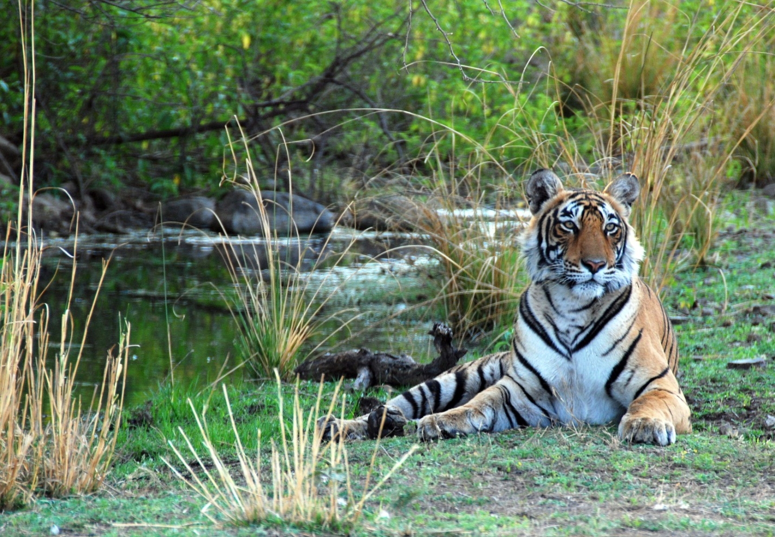

Evening is at leisure.
Stay overnight at hotel.

Day 10: Bandhavgarh
Early morning and afternoon enjoy Jeep Safari in Ranthambore National Park.

Evening is at leisure.

Stay overnight at hotel.

Day 11: Bandhavgarh to Kanha (260 Kms/ 5 Hrs)
Morning by surface travel to Kanha.

Kanha is a tiger land - home for more than 100 tigers. Wild, yet serene. Beautiful, yet deadly. Mysterious, yet revealing. Such is the experience as you wonder through these alluring majestic Sal Forests Herds of the Kanha miscellany, the axis deer (Chital), the Swamp deer (Barasingha), the Blackbuck (Hiran), the wild pig and occasionally the Gaur, throng the central park land of the valley. The lush forests and grassy meadows of Kanha provided inspiration to Rudyard Kipling for his “Jungle Book”. Successful conservation programs, make Kanha one of the best maintained National Parks in India.

Evening is at leisure. Stay overnight at hotel.

Day 12: Kanha
Early morning and afternoon enjoy Jeep Safari in Kanha National Park.
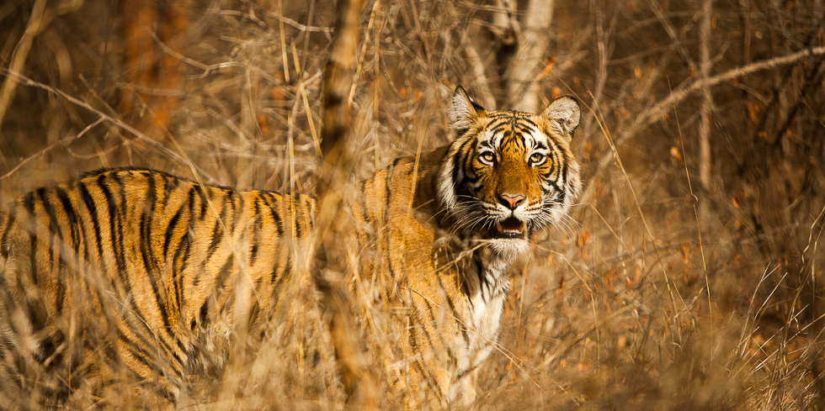
Evening is at leisure.

Stay overnight at hotel.

Day 13: Kanha to Pench (130 Kms/ 3 Hrs)
Morning by surface travel to Pench.

The Pench National Park and Tiger Reserve extends over an area of 257 sq. km. in the lower southern reaches of the Satpura hill ranges, along the northern boundary of Nagpur District. It was declared a National Park by the Government of Maharashtra in 1975 and received the official status of "Tiger Reserve of India" in February 1999. The park gets its name from the Pench River, which meanders through it like a mammoth python, dividing it down the center.
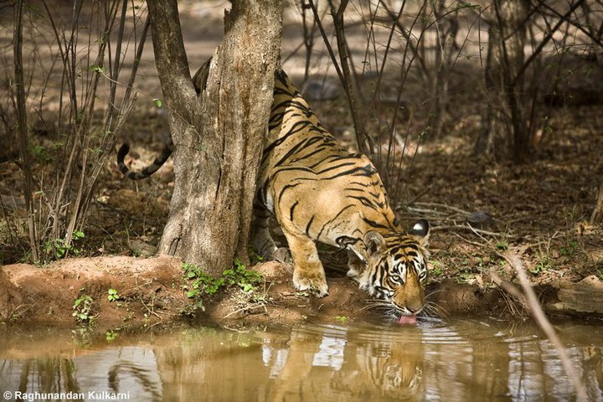
Afternoon enjoy Jeep Safari in Kanha National Park.

Evening is at leisure.

Stay overnight at hotel.

Day 14: Pench
Early morning and afternoon enjoy Jeep Safari in Kanha National Park.

Evening is at leisure. Stay overnight at hotel.

Day 15: Pench to Tadoba (260 Kms/ 5 Hrs)
Morning by surface travel to Tadoba.

In the heart of Central India lies the Tadoba Andhari Tiger Reserve, one of India’s most exciting and best protected Tiger Reserve, undiscovered, and with most visible tiger sightings. Dominated by teak forest and bamboo, it’s a rugged landscape comprising cliffs, caves, marshes, perennial lakes and boulder strewn streambeds that cater to a host of biodiversity, not least the Tiger, who are between 75 to 100 by last count including 24 cubs born in last 2 years. Other prominently spotted wildlife are the Indian Leopard, Indian Wild Dog, Sloth bear, Gaur, Ratel and a variety of mammals and over 280 species of birds including raptors like, Crested Serpent Eagle and Grey Headed Fishing Eagle. Tadoba is special also for rare Indian Owls, like Jungle Owlet, Spotted Owlet, Indian Scops Owl, Brown Fish Owl, Mottled Wood Owl and the Great Indian Horned Owl.

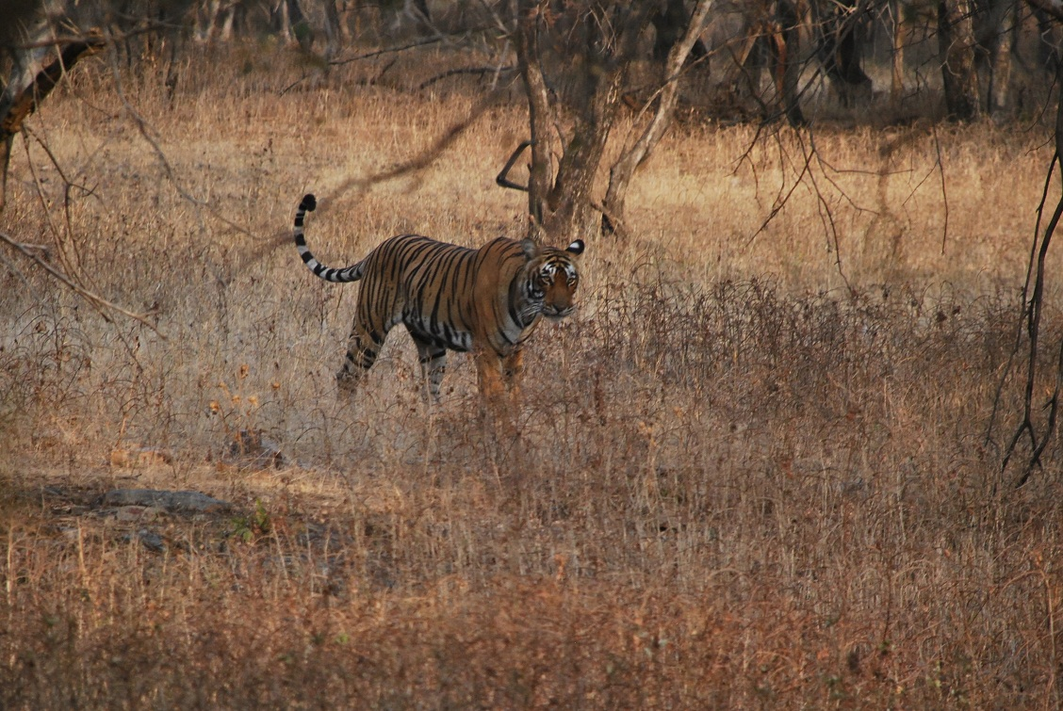

Tadoba, offers some wonderful wildlife experiences. It is also one of the few parks that are open all year round, offering visitors an opportunity to visit in the monsoon season – this extraordinary active time for all manner of plants and animals, yet otherwise closed to keen nature lovers in most other parks of India.

Afternoon enjoy Jeep Safari in Kanha National Park.

Evening is at leisure. Stay overnight at hotel.

Day 16: Tadoba to Nagpur (145 Kms/ 3 Hrs) to Mumbai (By Air)
Morning by surface travel to Nagpur.

Upon arrival in Nagpur, transfer to Nagpur Airport to board flight for Mumbai.

Flight Name/ Number Jet Airways, 9W-7005
Departure Time, Nagpur 1100 Hrs
Arrival Time, Mumbai 1230 Hrs

Arrive at Mumbai Airport. Our representative will meet you as you exit the arrival terminal building after which you would be transferred to your hotel.

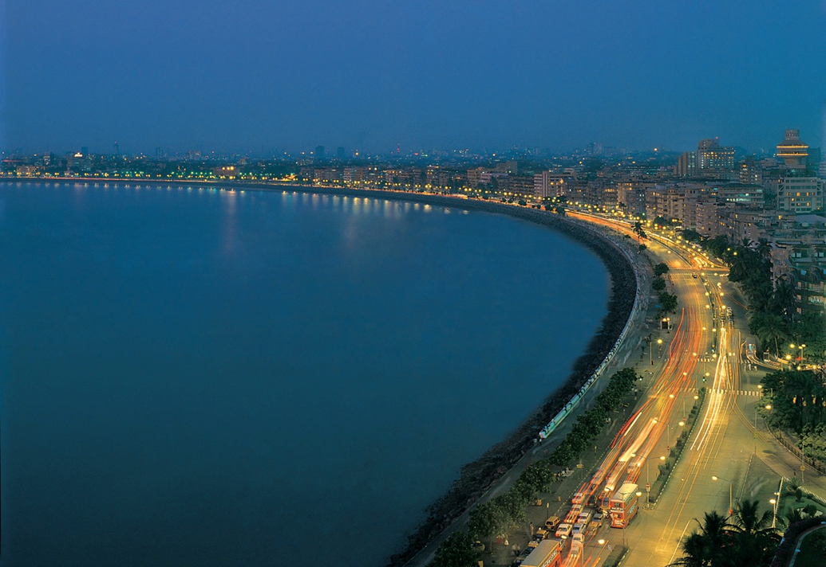
Mumbai, the city that never sleeps, is the country’s financial powerhouse and its vogue centre of fashion, film and night life. With a little over 400 years of history behind it, this bustling metropolis, home to India’s thriving movie industry and the birthplace of Indian cricket, has many colours and faces. Rags to riches stories predominate in India’s most populous city, home to almost 17 million people, as Mumbai offers umpteen opportunities to those willing to run the extra mile to realize their dreams and make their fortune. Along with a strong local flavour and traditional bazaars, visitors will get to see a bit of Los Angles’ Hollywood, New York’s traffic jams, London’s Victorian Gothic architectural masterpieces and Paris’ swish bars and restaurants in this global city which is ever-evolving and welcoming.

Evening is at leisure. Stay overnight at hotel.

Day 17: Mumbai
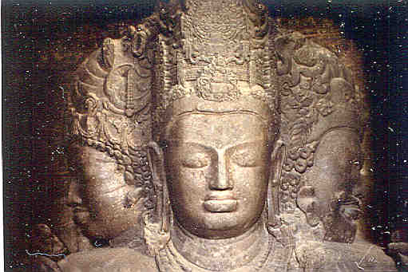
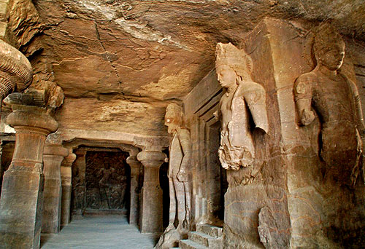
Morning enjoy a boat ride to Elephanta Island, where the 8th-century shrine was cut from the hillside and houses the "Maheshmurti," or Hindu Trinity, representing the three aspects of Shiva the Creator, the Preserver and the Destroyer. These caves provide an exciting glimpse of Indian sculpture dating from about 600 A.D. After the visit of Elephanta island transfer by boat to Mumbai.

Later proceed for sightseeing tour of Mumbai covering Gateway of India, Hanging Gardens, Prince of Whales Museum, and Mani Bhawan.
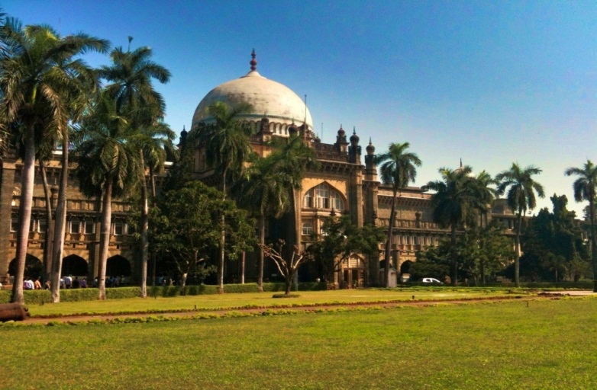
The Gateway to India is an elegant 26 mtrs stone archway, hastily erected as a symbol of welcome to Queen Mary and King George V of England on their visit to India in 1911. In the years following, artisans added decorative carvings and lovely Jharokha work (window carvings), and completed it in 1923.
Later continue to the hanging gardens perched above Malabar Hill. These terraced gardens provide a beautiful panoramic view of the Arabian Sea were laid out in the early 1880s covering Bombay’s main reservoir.
Visit to the Prince of Whales Museum and Mani Bhawan.
Mumbai’s biggest and best museum – The Prince of Whales Museum displays a mix of exhibits from all over India. Designed especially as a museum, construction commenced in 1905 with the laying of the first stone by the then Prince of Wales. The architectural style is known as Indo-Saracenic -- a mishmash of Moorish Spain, Islamic domes, and Victorian towers. The Museum was opened to the public in 1922. Its collection has grown to include ancient items excavated from the Indus valley, Hindu and Buddhist sculpture, miniature paintings, weaponry, and natural history (including a variety of stuffed animals).
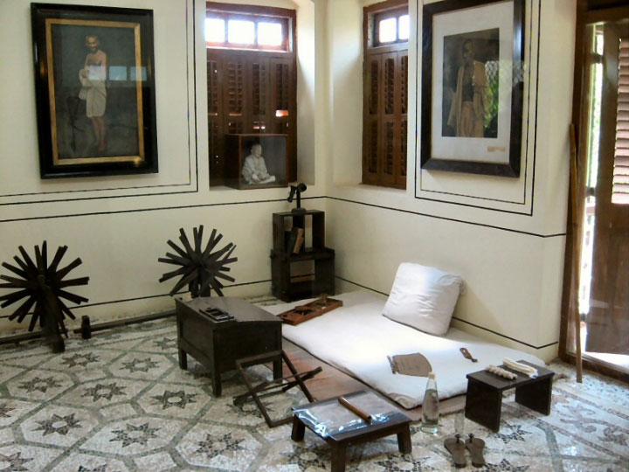
Mani Bhavan is Mahatma Gandhi’s home and Museum. This charming, 3 storied Gujarati house, painted brown and yellow, in a lovely Parsi neighborhood on Malabar Hill, was the home of Mahatma Gandhi from 1917-1934. Now overseen and maintained by the Gandhi Institute, it houses a library and a small museum about Gandhi’s life and birth.
In evening drive past through the famous Marine Drive.
Later transfer to Mumbai Airport to board flight for onward journey.

