

# 10 Days / 9 Nights - Garden Route & Safari Trip

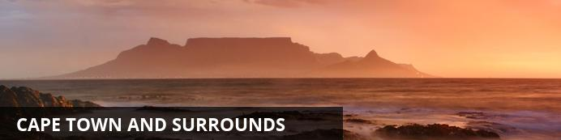

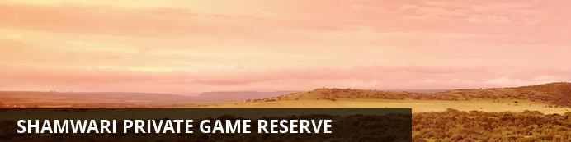

# 10 Days / 9 Nights - Garden Route & Safari Trip

*Cape Town and Surrounds - Shamwari Private Game Reserve*  
*10 Days / 9 Nights*  
*2 Persons*  
*Date of Issue: 09 June 2014*  
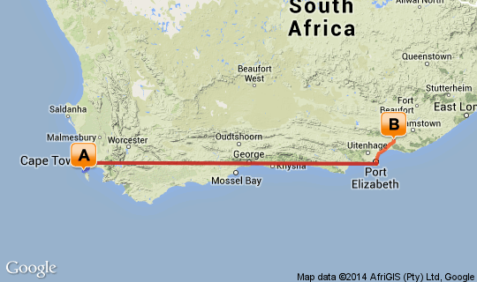

# [Click here to view your Digital Itinerary](http://wetu.com/Itinerary/VI/6972EB5A-AE30-E7ED-9C81-8003C35DC268)

## Overview

|  |  |  |  |  |
| --- | --- | --- | --- | --- |
| **Destination** | **Accommodation** | **Nights** | **Basis** | **Room Type** |
| Cape Town and Surrounds | The Last Word Long Beach | 5 | B&B | 1x Double Room |
| Shamwari Private Game Reserve | [Sarili Lodge - Shamwari Game Reserve](http://wetu.com/iBrochure/3688_10212) | 4 | B&B | 1x Double Room |

## Day 1: The Last Word Long Beach, Cape Town and Surrounds

### Cape Town and Surrounds

Cape Town is one of the world's most beautiful cities and a top international destination. Large numbers of tourists flock to Cape Town to enjoy this unique city with its fascinating history, interesting culture, natural beauty, award winning wines and laidback lifestyle. Whether you are a serious tourist or just want to lie on the beach and enjoy life, Cape Town will satisfy your needs.

### Day Notes

You collect your hired car and check into your Hotel.

### Overnight: The Last Word Long Beach

The five star The Last Word Long Beach is right on the beach in the picturesque lobster-fishing village of Kommetjie, a short 30 minute drive from Cape Town. The eight kilometres of fine white powdered sand set against a backdrop of the most stunning sea views offers Cape Town’s most romantic hideaway, one of just a handful of places where the sea is on your doorstep.  
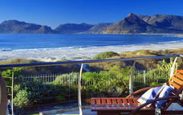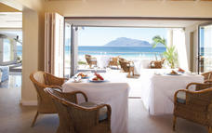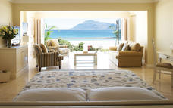

### Alternate: Adderley Hotel

The Adderley Hotel is a mix of 27 modern, self- catering apartments and luxury guest rooms, situated in the heart of Cape Town’s city centre. A blend of gracious urban historic facades, with interiors boasting 21st century luxury and design. With an excellent location in the historical part of Cape Town’s main thoroughfare, Adderley Street, this hotel is the perfect destination for corporate travellers with business interests in the city as well as for tourists who wish to explore Cape Town’s finest leisure attractions.

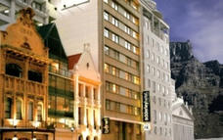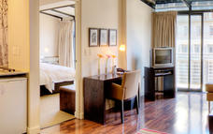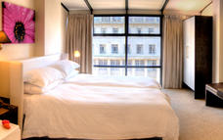

### Alternate: Cape Town Hollow Boutique Hotel

Cape Town Hollow Boutique Hotel is a four star hotel set right in the heart of Cape Town’s historical city centre, nestling in the shadow of Table Mountain. It is the ideal base from which to explore Cape Town with its gracious 18th century buildings, art galleries and museums which rub shoulders with bohemian open-air markets and musicians in quaint city squares.

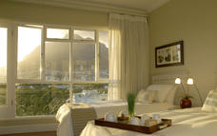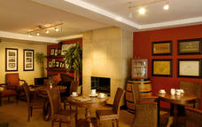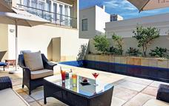

### Alternate: Queen Victoria Hotel [View iBrochure](http://wetu.com/iBrochure/3688_23723)

Queen Victoria Hotel is a luxuriously appointed, deluxe boutique hotel in the Victoria & Alfred Waterfront. The overall look does not only reflect the hotel’s unique location but also encapsulates the luxurious style and attention to detail that defines small, luxury retreats around the world.

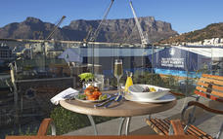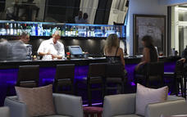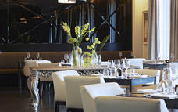

### Alternate: The Bay Hotel

The Bay Hotel is superbly designed with only 78 rooms and suites offering 5-star luxury in an unsurpassed setting. No less than four hotel pools with expansive sun decks offer superlative views of the Atlantic Ocean and majestic Lion’s head.   
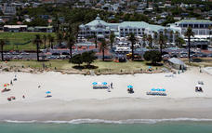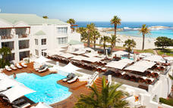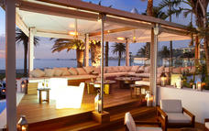

### Included

Bed & Breakfast

## Day 2: The Last Word Long Beach, Cape Town and Surrounds

### Day Notes

There are a myriad of fun things to do in Cape Town

### Optional

Table Mountain  
Cape Point & Cape of Good Hope  
Seal Island Hout Bay

#### Table Mountain

Without a doubt it is Table Mountain that makes Cape Town the unique city it is. Rising up over 1000m above sea level, it is the icon that makes Cape Town instantly recognizable. It is a symbol, a playground, a spiritual retreat and a big draw card for tourists. So intertwined with the identity of Cape Town is Table Mountain that a visit to the city isn’t complete without having walked or taken the cable car to the top.

#### Cape Point

This is the real Cape Point, not the one with the lighthouse on it.

#### Seal Island Hout Bay

Trips departing from Hout Bay Harbour ferry passengers across to nearby Duiker Island – also known as Seal Island – where thousands of Cape Fur Seals can be seen in their natural habitat. The boat trip provides beautiful views of the bay, the harbour, The Sentinel and Chapman’s Peak.

### Included

Bed & Breakfast

## Day 3: The Last Word Long Beach, Cape Town and Surrounds

### Optional

Kirstenbosch Botanical Gardens  
Planetarium  
Sea Kayak with Penguins

#### Kirstenbosch Botanical Gardens

On the lower slopes of Table Mountain, the beautiful Kirstenbosch Botanical Gardens showcases some of the Cape’s rich flora. Taking centre stage here is the unique ‘fynbos’ vegetation. Those who work up an appetite while exploring this garden paradise can visit the restaurant or tea room, which are fully stocked with delicious meals, yummy treats and refreshing beverages. In summer, Sunday music concerts provide sunset entertainment. Kirstenbosch is rated as the seventh best of its kind in the world.

#### Planetarium

The Planetarium is a celestial theatre, transporting its audience through the wonders of the universe. The ultimate in armchair travel. Inside the domed auditorium light and sound combine to reproduce the night sky an extraordinary audio-visual experience for old and young.

#### Sea Kayak with Penguins

A number of adventure sport companies operate kayaking trips along the False Bay coast, incorporating a visit to the penguin colony at Boulders Beach. In the winter and spring months, there is also a good possibility of seeing whales as you kayak.

### Included

Bed & Breakfast

## Day 4: The Last Word Long Beach, Cape Town and Surrounds

### Optional

Two Oceans Aquarium  
Waterfront Boat Trips  
Cape Town Helicopters

#### Two Oceans Aquarium

The Two Oceans Aquarium is home to more than 3000 marine animals including sharks, fishes, turtles, and penguins.

#### Waterfront Boat Trips

The Waterfront offers a number of different boat trips for harbour tours to champagne cruises out into Table Bay.

#### Cape Town Helicopters

Cape Town Helicopters is a young and vibrant company that has been exploring the African skies since 2011, giving foreigners and locals a chance to experience the most breath-taking views of the South African coastline along with the rush and exhilaration of flying. We have a small team consisting of 15 people, most of which has come straight out of University because we believe in empowering people and growing their skills to better our country.

### Included

Bed & Breakfast

## Day 5: The Last Word Long Beach, Cape Town and Surrounds

### Optional

Spier Wine Farm  
World of Birds

Gold of Africa Museum

#### Gold of Africa Museum

The Gold of Africa Museum is a treasure trove housing a collection of 350 West African gold artefacts as well as objects from the gold civilisations of southern Africa. The museum combines the ancient art of African goldsmithing with contemporary design. State-of-the-art visuals and artistic displays take you through the mythical relationship between gold and the African continent.

#### Spier Wine Farm

Everything you thought you would find in a wine estate and so much more.  
We are one of the oldest wine farms in South Africa, with a recorded history dating back to 1692. While rooted in this heritage, we offer a contemporary experience and have a vibrant and conscious culture.   
Lounge on the lawns on the banks of the Eerste River with a picnic, or visit our innovative farm-to-table restaurant Eight.

#### World of Birds

The magical World of Birds is over 30 years old. Today, this unique sanctuary hosts more than 3500 birds of 450 different species, not to mention the squirrel monkeys, meerkats and other small mammals that live here. The aviaries are so large so that you can walk freely around in them. This is a great experience for the whole family.

### Included

Bed & Breakfast

## Day 6: Sarili Lodge - Shamwari Game Reserve, Shamwari Private Game Reserve

### Shamwari Private Game Reserve

Shamwari Game Reserve is the ultimate Luxury Big Five African Safari Adventure & Conservation effort coupled with responsible Tourism. Shamwari Game Reserve is home to Africa’s Big 5 (Elephant, Rhino, Buffalo, Lion & Leopard), is Malaria Free & is situated in the Eastern Cape of South Africa.

### Day Notes

Return your hired vehicle to Cape Town International airport and check-in for your flight to Port Elizabeth. Here you will be met and transferred by road to Shamwari Private Game Reserve, where you will be spoilt for the next 4 days.   
Your programme includes 2 game drives per day, 3 meals per day and a visit to the Born Free Foundation Centre.

### Overnight: Sarili Lodge - Shamwari Game Reserve [View iBrochure](http://wetu.com/iBrochure/3688_10212)

Sarili Lodge at Shamwari Game Reserve is the perfect combination between a colonial and bush experience. Perfect for families or small parties. An environmentally Friendly private African thatch designed Villa with a spacious deck overlooking the Bushman’s River with expansive views of the plains; the Lodge is positioned in the Southern Region of the Reserve. The décor emulates an old traditional Farmhouse with interiors that reflect an easy living home lifestyle in a natural environment.

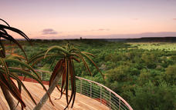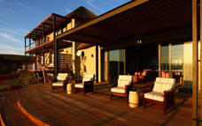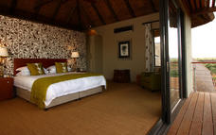

### Alternate: Riverdene Lodge - Shamwari Game Reserve [View iBrochure](http://wetu.com/iBrochure/3688_10214)

The colonial-style, Riverdene Lodge at Shamwari Game Reserve offers nine Inter-Leading Luxury Rooms, Rim Flow Pool, supervised Playroom, spacious green lawns & Jungle Gym facility ensures entertainment for the whole family. Shamwari, meaning “my friend” in Shona, is the pinnacle of private game reserves and home to the coveted Big 5. Stretching 25,000 hectares over a malaria free landscape, it offers an award-winning nature experience and is one of the largest private conservation initiatives in Southern Africa.

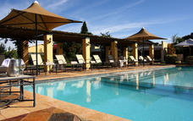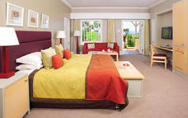

### Alternate: Long Lee Manor - Shamwari Game Reserve [View iBrochure](http://wetu.com/iBrochure/3688_8699)

Long Lee Manor at Shamwari Game Reserve, originally built in 1910, offers a distinctive Colonial Experience. This splendidly restored Edwardian Manor House offers Guests refined comfort, congenial service & enticing cuisine in the African Bush. Long Lee Manor accommodates 38 Guests in 15 elegant En-Suite Rooms & 3 Luxury Suites.

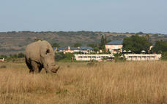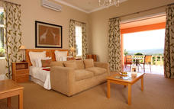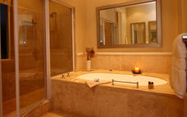

### Alternate: Eagles Crag Lodge - Shamwari Game Reserve [View iBrochure](http://wetu.com/iBrochure/3688_8700)

Eagles Crag is nestled in a Valley & provides the ultimate Luxury for the most discerning of Travellers. Each of the nine Superior Rooms has been built to maximize the privacy of the Guest in the most tranquil of settings. The En-Suite Suites boast a Private Deck with Pool, as well as, Indoor & Outdoor Showers. Decorated in light & contemporary colours, with wall-to-wall Glass Doors on two sides, these Suites provide stunning views of the surrounding cliffs.

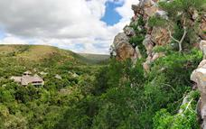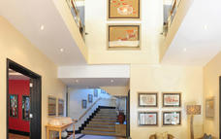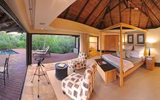

### Alternate: Bayethe Tented Lodge - Shamwari Game Reserve [View iBrochure](http://wetu.com/iBrochure/3688_10216)

Bayethe Lodge offers the ultimate in Luxury Tented Accommodation. Bayethe is a splendid stone walled & thatch roofed Lodge with a large Deck Area overlooking a Waterhole. There is a double volume Lounge & Dining Area which spills out onto the Deck which is adjacent to the outside Boma for traditional fireside dining under the stars.   
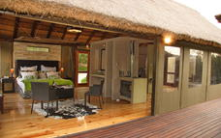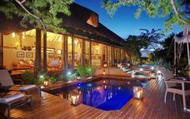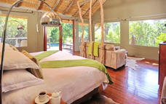

### Included

Full Board + Activities

## Day 7: Sarili Lodge - Shamwari Game Reserve, Shamwari Private Game Reserve

### Day Notes

Shamwari, a malaria free private game reserve at the end of the Garden Route and only 40 minutes from Port Elizabeth, is 20 000 hectares, boasting five eco-systems and seven separate luxury lodges. Here you can experience close up encounters with elephants, lions and other wild game.  
Enjoy and relax by the pool of your spacious and elegant lodge after an exciting game drive.

### Included

Full Board + Activities

## Day 8: Sarili Lodge - Shamwari Game Reserve, Shamwari Private Game Reserve

### Included

Full Board + Activities

## Day 9: Sarili Lodge - Shamwari Game Reserve, Shamwari Private Game Reserve

### Included

Full Board + Activities

## Day 10: Departure

### Day Notes

Transfer from Shamwari to Port Elizabeth airport for your flight back to Cape Town or via Johannesburg back home.

End of Services.