**14 Days/13 Nights - Cape Town & Safari & Mozambique Tou**r

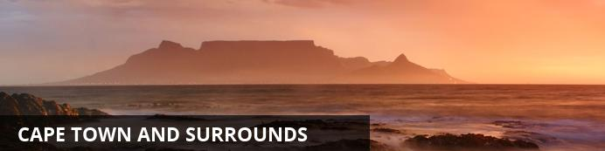

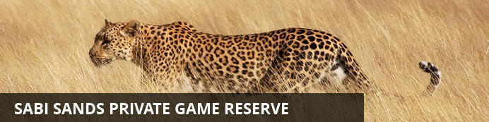

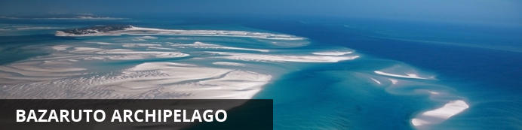

# 14 Days/13 Nights - Cape Town & Safari & Mozambique Tour

*Cape Town and Surrounds - Sabi Sand Private Game Reserve - Bazaruto Archipelago*  
*14 Days / 13 Nights - 2 Persons*  
*Date of Issue: 10 June 2014*

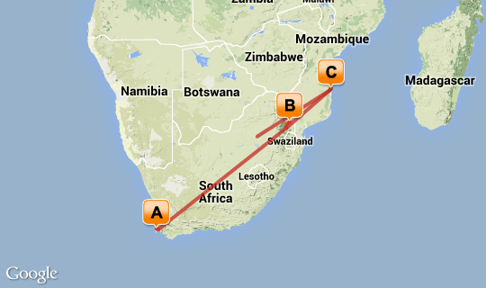

# [Click here to view your Digital Itinerary](http://wetu.com/Itinerary/VI/E797D2AA-B909-441E-D7A2-84F23B81E8BD)

## Overview

|  |  |  |  |  |
| --- | --- | --- | --- | --- |
| **Destination** | **Accommodation** | **Nights** | **Basis** | **Room Type** |
| Cape Town and Surrounds | [Belmond Mount Nelson Hotel](http://wetu.com/iBrochure/3688_1205) | 6 | B&B | 1x Double Room |
| Sabi Sand Private Game Reserve | [Savanna Private Game Reserve](http://wetu.com/iBrochure/3688_14840) | 3 | FI | 1x Double Room |
| Bazaruto Archipelago | Azura Benguerra Island | 4 | FB | 1x Double Room |

## Day 1: Belmond Mount Nelson Hotel, Cape Town and Surrounds

### Cape Town and Surrounds

Cape Town is one of the world's most beautiful cities and a top international destination. Large numbers of tourists flock to Cape Town to enjoy this unique city with its fascinating history, interesting culture, natural beauty, award winning wines and laidback lifestyle. Whether you are a serious tourist or just want to lie on the beach and enjoy life, Cape Town will satisfy your needs.

### Day Notes

On arrival at Cape Town International airport, you will be met by a representative of All About Africa Tours & Travels and transferred to your hotel.

Located at the foot of Table Mountain, in the picturesque suburb of Gardens, the Mount Nelson Hotel is the epitome of Edwardian elegance. The hotel boasts six individual wings, separated from the main hotel, each with its own unique character, private gardens and luxury facilities. All rooms are lavishly appointed and have an en-suite bathroom equipped with shower, bath, basin and lavatory. The rooms have a choice of twin or king sized beds and most have a mini-lounge where you can entertain friends in private, and a writing desk with stationery where you can catch up on correspondence.

### Overnight: Belmond Mount Nelson Hotel [View iBrochure](http://wetu.com/iBrochure/3688_1205)

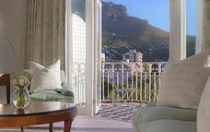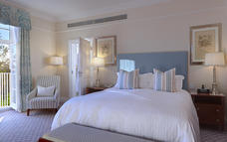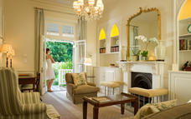

### Included - Bed & Breakfast

## Day 2: Belmond Mount Nelson Hotel, Cape Town and Surrounds

### Day Notes

Your private tour guide meets you at your accommodation and introduce the most interesting sights of this metropolis to you: Bo Kaap Quarter the Castle, visit to the Gold Museum and "The Diamond Works", where you can learn about the fabrication from the pure stone into a piece of jewellery.   
Then take the rotating cable car onto Table Mountain to enjoy the spectacular views over the city, Robben Island, Blouberg Strand and the Cape Peninsula. On a clear day you can see the Winelands from here. Take a short walk around the beautifully landscaped garden on the mountain's plateau. Descend by cable car and drive back either to your accommodation or if you want to your guide can take you to the famous V&A Waterfront where he says good bye to you and you can enjoy the rest of the afternoon at leisure. Visit the Shopping Mall and unwind in one of the many restaurants.

### Included - Bed & Breakfast

## Day 3: Belmond Mount Nelson Hotel, Cape Town and Surrounds

### Day Notes

We depart Cape Town via Sea Point, past Clifton, Camps Bay overlooked by the Twelve Apostles and past Llandudno into Hout Bay. Here we board a boat for a cruise to Seal Island. Often dolphins and whales can be seen.  
We then continue over the Constantia Nek to Noordhoek, Kommetjie and Scarborough to the Cape Of Good Hope Nature Reserve.   
Here we visit Cape Point and the Cape of Good Hope. Continue to the light house which is a short but steep walk up or hop aboard the funicular and you’ll be whisked away on a scenic trip to the view site near the old Cape Point lighthouse. Over time, the means of transport to the view site changed from a diesel bus, named after the “Flying Dutchman” ghost ship, to an environmentally friendly funicular - the only one of its kind in the world.   
We enjoy a fish platter lunch at Seaforth restaurant. After lunch we visit the Penguin Colony at Boulders and continue through Simon’s Town, Fish Hoek and Muizenberg where after the tour ends on arrival back at your hotel.

### Included- Bed & Breakfast

## Day 4: Belmond Mount Nelson Hotel, Cape Town and Surrounds

### Day Notes

Join us on a day in the winelands, steeped in history and wines, where gracious Cape Dutch homesteads are surrounded by vineyards and majestic mountains.   
Your private guide for the day will meet you at your accommodation. You depart Cape Town and commence with a historical tour of Stellenbosch and continue to Franschhoek. En route you will visit 2 wine estates and will be given the opportunity to do a tour of a wine cellar to view the winemaking process. Today's lunch stop will be in Franschhoek. Continue to the Huguenot Memorial, where after we depart Franschhoek and drive to Paarl. Visit the Afrikaans Taal (Language) Monument and KWV Cellars (largest maturation cellar in the world).  
Return to Cape Town past Table Bay where the tour ends on arrival at your place of accommodation or you may select to be dropped off at the V & A Waterfront.

### Included - Bed & Breakfast

## Day 5: Belmond Mount Nelson Hotel, Cape Town and Surrounds

### Day Notes

Day at leisure to enjoy a day of spa treatments and relaxation by the pool. Please note that tonight’s dinner needs to be booked in advance. Programme will be provided.

### Included- Bed & Breakfast

## Day 6: Belmond Mount Nelson Hotel, Cape Town and Surrounds

### Day Notes

Spend the day relaxing.

### Included- Bed & Breakfast

## Day 7: Savanna Private Game Reserve, Sabi Sand Private Game Reserve

### Sabi Sand Private Game Reserve

The Sabi Sands is South Africa's premier private game viewing destination. It was here that the southern African safari began and today this famous reserve offers exceptional game viewing and equally exceptional accommodations. Two perennial rivers, the Sabi and the Sand flow through this Game Park, sustaining the diverse fauna and flora of the area.

### Day Notes

This morning you will be transferred to Cape Town International Airport for your flight to Nelspruit, KMIA. Here you are met and transferred to a private game lodge.

### Overnight: Savanna Private Game Reserve [View iBrochure](http://wetu.com/iBrochure/3688_14840)

Savanna traverses over 10 000 hectares of pristine African bushveld, accompanied by our highly experienced rangers and trackers, we pride ourselves in delivering exceptional safaris, with the emphasis on game viewing. Savanna has nine beautifully appointed suites. The thatched Savanna Suite consists of two separate en-suite bedrooms, each with their own deck and plunge pools. These rooms lead into a central elegantly furnished lounge, ideal for families or a small group wanting privacy and exclusivity.  
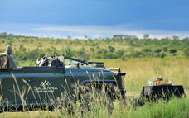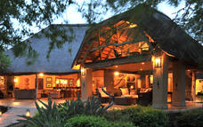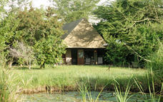

### Included- Fully Inclusive

## Day 8: Savanna Private Game Reserve, Sabi Sand Private Game Reserve

### Day Notes

Follow the programme set out by the lodge which includes 2 x daily game drives in open safari vehicles, accompanied by a professional ranger and tracker. You may also choose to go on a bush walk after breakfast to learn about the flora and smaller flora and how to identify the animal tracks.

### Included- Fully Inclusive

## Day 9: Savanna Private Game Reserve, Sabi Sand Private Game Reserve

### Included- Fully Inclusive

## Day 10: Azura Benguerra Island, Bazaruto Archipelago

### Bazaruto Archipelago

Tha Bazaruto Archipelago is a wonderful tropical island get away with numerous accomodation options and plenty of activities on offer.

### Day Notes

You are transferred to KMIA airport and check in with Pelican Air for your flight to Vilanculos, Mozambique. Here you clear customs and are transferred by helicopter to Azura Benguerra Island.

### Overnight: Azura Benguerra Island

Imagine an unspoilt island within a Marine National Park. Miles of deserted beaches with soft white sand. Sparkling turquoise seas, crisscrossed by local dhows plying their trade. Swaying palms, gentle breezes. Sunny days and star studded nights. This is Azura Mozambique.

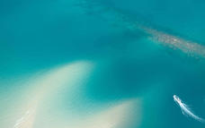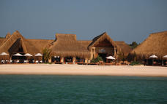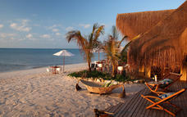

### Included- Full Board

## Day 11: Azura Benguerra Island, Bazaruto Archipelago

### Included- Full Board

## Day 12: Azura Benguerra Island, Bazaruto Archipelago

### Included- Full Board

## Day 13: Azura Benguerra Island, Bazaruto Archipelago

### Included- Full Board

## Day 14: Departure

### Day Notes

You will be transferred back to catch your flight from Vilanculos, Mozambique to OR Tambo International Airport.

End of Services.