EGYPT TREASURES OF THE NILE 9D

Friday - Arrive Cairo
Upon arrival Cairo International airport on @ and before immigration Egypt and Beyond travel representative will meet you and assist you through immigration “Look for your name on a sign”., Once you have collected your bags, then pass through customs to transfer you to your hotel.
OVERNIGHT: CAIRO

Saturday Cairo
Today after breakfast you will be collected from the hotel lobby and taken on a private guided tour to visit Sakkara, Giza Pyramids and Sphinx. A day of inspiration and enlightenment will be yours today. First will visit the Step Pyramid of Djoser in Sakkara, the oldest stone structure known to man, dating back to 2600 BC under the 3rd Dynasty. Afterword Lunch will be served at a local restaurant nearby the Pyramids. Then will proceed to the Giza Plateau, where the only remaining Wonder of the Ancient World is found, the imposing Pyramids of Giza. During your visit to the Pyramids you will have time for unique photo opportunities of the three Pyramids Cheops, Chephren & Mycerinus from the Western Plateau. Continue down the valley where the guardian of this mortuary complex, the Mighty Sphinx, bears witness to the passage of time and man in eons of silence.
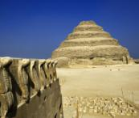
OVERNIGHT: CAIRO (B,L)

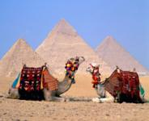
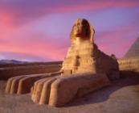

Sunday Cairo
After breakfast will proceed today’s sightseeing begins with the Egyptian Museum. The Egyptian Museum in Cairo contains the world's most extensive collection of pharaonic antiquities; no visit to Egypt is complete without a trip through its galleries. The Museum of Antiquities where over 120,000 objects in its 107 halls - including the treasures of Tutankhamun (King Tut) - are exhibited home to a fabulous collection of world-renowned antiquities, including those from the tomb of Tutankhamun whose death-mask is magnificent. Next stop will be to explore the fascinating world of Islamic Cairo, including the 19th century Mosque of Mohammed Ali and the Citadel. This great Mosque of Mohamed Ali, is one of the landmarks and tourist attractions of Cairo and is one of the first features to be seen when approaching the city from no matter which side. The Saladin Citadel is a medieval Islamic fortification in Cairo, it's located on Mokattam hill near the centre of Cairo, was once famous for its fresh breeze and grand views of the city. It is now a preserved historic site, with mosques and museums. After lunch you stop will be at the exotic and colourful Khan El Khalili Bazaar of the world’s oldest bazaars, where you will have the time to wander and explore.
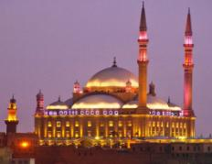
OVERNIGHT : CAIRO (B,L)

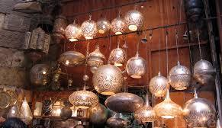
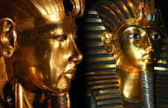

Monday Cruise
Transfer from hotel to Cairo domestic airport to fly to Luxor .Upon arrival to Luxor airport, meet & greet and transfer to your cruise, which you will board for the next 4 nights. Afternoon will visit Karnak Temple, the greatest example of worship in the history, dedicated to the God Amon, his wife Mut and their son Khonsu. Dinner and overnight on board ship .
OVERNIGHT: CRUISE (B,L,D)
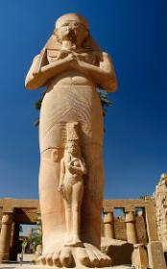
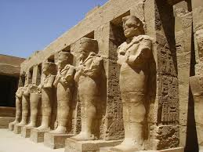

Tuesday Cruise
Optional: Ballooning ride this morning over Luxor City.
Experience the sun rise over some of Egypt’s most famous ancient monuments on this exhilarating hot air Luxor balloon ride. After early morning pickup, travel to the west bank of the Nile River, and board a shared balloon basket for a 30-45 minute flight. Then, as you ascend, behold the thrilling bird’s-eye views as the sunlight illuminates the temples and mountains below. Gaze down over Karnak, Queen Hatshepsut’s Temple and other monuments, and absorb the peaceful dawn.
Today start your visits at West Bank of the Nile for sightseeing of the Valley of the Kings. Here, hundreds of tombs, including that of Tutankhamun, were carved into the desert rock. Continue on to the Temple of Hatshepsut, The mortuary temple of Queen Hatshepsut of Dynasty XVIII was built just north of the Middle Kingdom temple of Mentuhotep Nebhepetre in the bay of cliffs known as Deir el-Bahri. In ancient times the temple was called Djeser-djeseru, meaning the ‘sacred of sacred’. It was undoubtedly influenced by the style of the earlier temple at Deir el-Bahri, but Hatshepsut’s construction surpassed anything which had been built before both in its architecture and its beautiful carved reliefs. Sail to Esna, Rest of the afternoon is free at leisure to enjoy cruising the Nile.
OVERNIGHT: CRUISE (B,L,D)
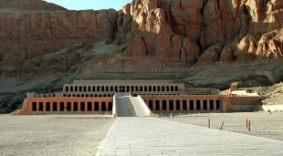
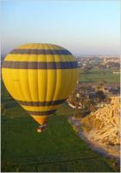

Wednesday Cruise
The morning will start with breakfast on board the Nile Cruise and a visit to Edfu to see the Ptolemaic Temple of Horus. Afterwards, you'll sail to Kom Ombo to visit the Temple of Sobek, the crocodile god and Horus, the falcon headed sky god of ancient Egypt. From there, you'll sail on to Aswan.
OVERNIGHT: CRUISE (B,L,D)

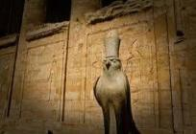

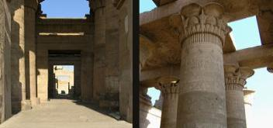

Thursday Cruise
This day your tour will begin with breakfast on board followed by a day of sightseeing in Aswan. You'll see the High Dam and from there you'll proceed to the Temple of Philae, Return to your Nile Cruise for lunch and an overnight stay.
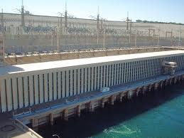
OVERNIGHT: CRUISE (B,L,D)

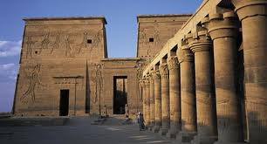

Friday Cairo
Optional: After breakfast check out from your cruise to be transferred to Aswan airport to fly to Abu Simbel, at Abu Simbel you will visit the temples of the great Ramses II and his Queen Nefertari. These temples received world-wide attention in 1968 when they were completely dismantled and relocated to avoid inundation.
After breakfast, you'll check out from cruise and transfer to Aswan airport, upon arrival to Cairo airport our representative will meet, assist and transfer to your hotel where you can spend the rest of the day relaxing or enjoying with extra night sightseeing
OVERNIGHT: CAIRO (B)
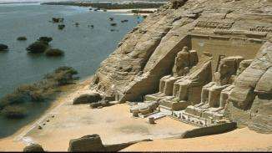
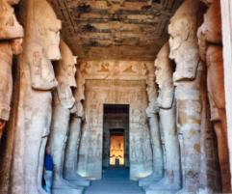

Saturday - Departure (B)
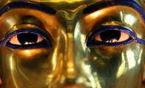
After breakfast, we will be transferred to Cairo international airport to fly back home with everlasting memories of the Land of Egypt , departure on….. @.......

(MAA EL SALAMA, GOOD BYE)

Tour Includes:
- Twin share accommodation.
- All entrance fees as per itinerary.
- All arrangements as per itinerary.
- Bottled water in vehicle during tours.
- Meet and assist upon arrival and departure.
- English speaking licensed Category A guides.
- 18 meals “8 breakfasts, 6 lunches & 4 dinners.”
- Private transfers and sightseeing in modern A/C Car.
- Domestic airfares Cairo / Luxor - Aswan / Cairo in Economy Class.

Tour Excludes:
Egypt Visa, any arrangements not specified on itinerary, travel insurance, international airline tickets, laundry and tipping ground staff, guides & drivers, any extra hotel or cruise beverages or any other items not mentioned above itinerary.

01 OCT TO 30 APRIL 2019

9 DAYS TREASURES OF THE NILE (EVERY FRIDAY), EXCEPT PEAK DATES (CHRISTMAS, NYE, EASTER)

TWIN SHARE

4* $2136 PP (MERCURE PYRAMIDS OR OASIS, PRESIDENTIAL NILE CRUISE)

5* $2707 PP (STEIGENBERGER OR CAIRO SHERATON, SONESTA NILE OR AMARCO I OR SIMILAR)

5* LUXURY $3797 PP (FOUR SEASONS CAIRO & SONESTA STAR GODDESS OR AMARCO I PRESIDENTIAL SUITE)

01 MAY TO 20 SEP 2019

9 DAYS TREASURES OF THE NILE (EVERY FRIDAY), EXCEPT PEAK DATES (CHRISTMAS, NYE, EASTER)

TWIN SHARE

4* $2136 PP (MERCURE PYRAMIDS OR OASIS, PRESIDENTIAL NILE CRUISE)

5* $2421 PP (STEIGENBERGER OR CAIRO SHERATON, SONESTA NILE OR AMARCO I OR SIMILAR)

5* LUXURY $3278 PP (FOUR SEASONS CAIRO & SONESTA STAR GODDESS OR AMARCO I PRESIDENTIAL SUITE)

OPTIONAL TOURS:

HOT AIR BALLOONING LUXOR $314 PP

ABU SIMBEL EXCURSION BY AIR WITH PRIVATE LOCAL GUIDE $643 PP

