CLASSIC TOUR OF SCOTLAND
SCOTLAND
8 Day / 7 Night Car Tour ‘Ideal for the first time visitor, this tour covers all of Scotland’s highlights’
Self-Drive/Private/Chauffeur-Drive Tours

Day 1 – Welcome to Scotland
Welcome to Scotland! After you pick up your car, drive the short distance to Stirling. Visit Stirling Castle, one of the most beautiful castles in Scotland situated upon a volcanic plug with a wonderful view over Stirlingshire, or you may choose to visit Bannockburn – a new, interactive visitor centre depicting one of the most important battles in Scottish history – or the Wallace Monument, commemorating William Wallace, famous from the Braveheart film.
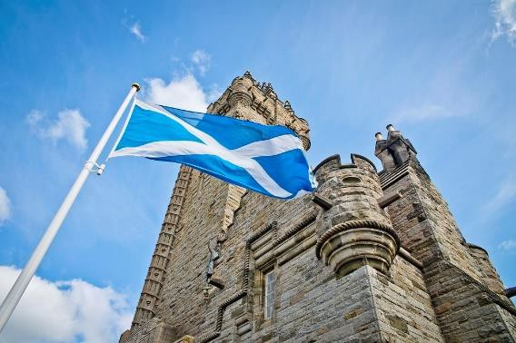

Overnight: Stirling area (Bed & Full Scottish Breakfast)

Day 2 – Stirling - Loch Lomond - Oban
This morning leave Stirling and drive towards the west coast via Loch Lomond, the largest lake in the whole of Great Britain and known for the tranquil beauty of its wooded shores and islands.
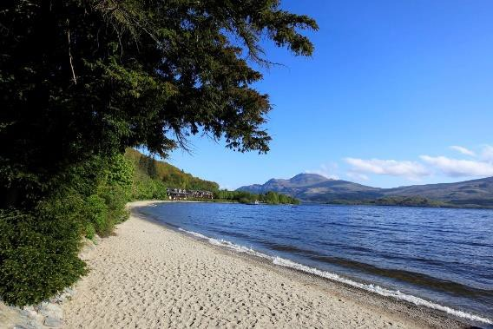

Continue North West along Loch Fyne and its beautiful landscape. Pass by Inveraray Castle and the charming homeland of the Duke of Argyll, the head of the Campbell Clan on your way to Oban.
The castle testifies to the power and wealth of the Campbells, one of the most powerful of the Highland Clans. Or you can choose to travel via the rugged landscape of Rannoch Moor and Glencoe, one of the most scenic valleys in Scotland.
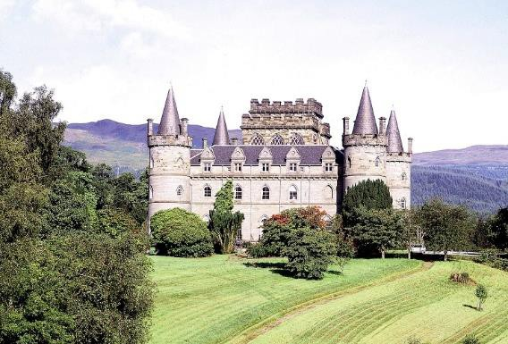

Overnight in Oban or Fort William or area (Bed & Full English Breakfast)
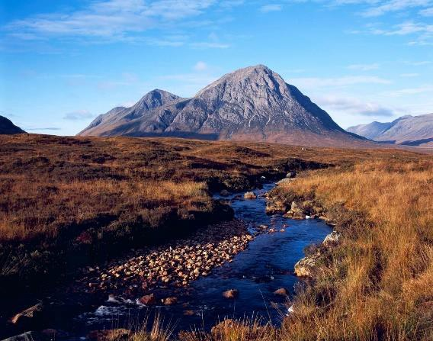

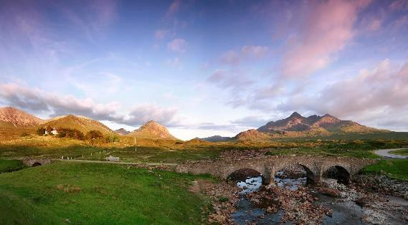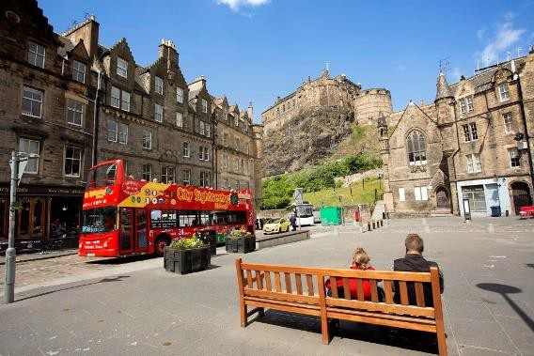This morning drive north and take a ferry from Mallaig to the Isle of Skye or continue via Loch Lochy to Kyle of Lochalsh and take the bridge to the Isle of Skye, the largest and most scenic of the Hebridean Islands.
Day 3 – Fort William - Isle of Skye

Overnight: Isle of Skye (Bed & Full Scottish Breakfast)

Day 4 – Loch Ness - Inverness
Travel east today for Eilean Donan Castle, one of the most iconic images of Scotland. Continue for the Inverness area via Loch Ness. You may choose to stop at Urquhart Castle, which is magnificently situated on the banks of Loch Ness. If you dare, take a cruise on Loch Ness, most famous for the elusive monster!

Overnight: Inverness area (Bed & Full Scottish Breakfast)
Day 5 – Inverness - Pitlochry - Perth
This morning, drive east of Inverness where you can visit Cawdor Castle and its beautiful gardens, or drive south via Aviemore where you can explore the impressive Cairngorm Mountains located in the Cairngorm National Park. Continue to Pitlochry where you may choose to visit the smallest distillery in Scotland, the Edradour Whisky Distillery. Why not stroll through the Victorian village before travelling south towards Perth.

Overnight: Perth area (Bed & Full Scottish Breakfast
Day 6 – St Andrews – Fife - Edinburgh

Today, visit St Andrews, named after Scotland's patron saint. St Andrews is the famous home of golf, played on the Old Course since the 15th century. Continue along the coast via the small fishing villages of Elie and Pittenweem. Cross the Queensferry Crossing with its spectacular views of the Firth of Forth. Return your hire car at Edinburgh Airport, and transfer to your hotel.
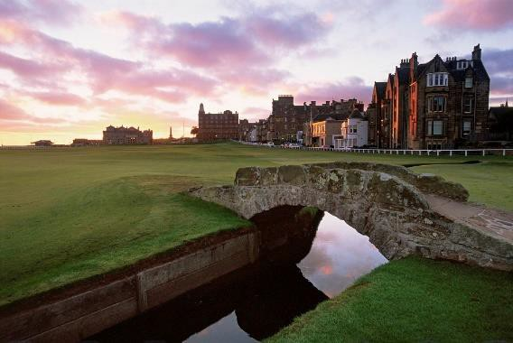

Overnight: Edinburgh area (Bed & Full Scottish Breakfast)

Welcome to Edinburgh! Spend the day soaking up the atmosphere of this exciting city. Visit some of its many attractions such as famous Edinburgh Castle, the Royal Mile and the Palace of Holyroodhouse, the Royal Family’s official residence in Scotland.
Day 7 – Edinburgh

Overnight: Edinburgh area (Bed & Full Scottish Breakfast)

Day 8 – Goodbye
Return home from Edinburgh Airport or extend your stay in Edinburgh.

Highlights:
- Stirling Castle
- Bannockburn Visitor Centre
- Wallace Monument
- Loch Lomond
- Glencoe
- Isle of Skye
- Eilean Donan Castle
- Inverness City
- Loch Ness Cruise
- Cairngorm National Park
- Edradour Whisky Distillery
- St Andrews
- Queensferry Crossing
- Edinburgh Castle
- Palace of Holyrood

Price Includes:
- 7 nights sharing a double/twin room at specified properties (Pre-booked Accommodation)
- Service Charges & taxes at exiting rates
- Entrance to Urquhart Castle (B&B Package only)

Example Accommodations
(Or Similar):
- Stirling – 3* Golden Lion Hotel or similar
- Oban/Fort William – 3* Onich Hotel or similar
- Inverness – 3* Priory Hotel or similar
- Perth – 3* Mercure Perth Hotel or similar
- Edinburgh – 3* Cairn Hotel or similar

Notes:
- Please advise all clients that they should check- in to their hotel/bed and breakfast accommodation no later than 6pm.
- Child Policy: Supplements apply when a child between 2 & 11 years incl. is sharing with 2 full paying adults to a maximum of 2 children in the room. A child sharing with a single adult is charged the normal per person rate. Children sharing 0-2 year’s incl. are free and meals paid directly to the hotel.
Email for rates

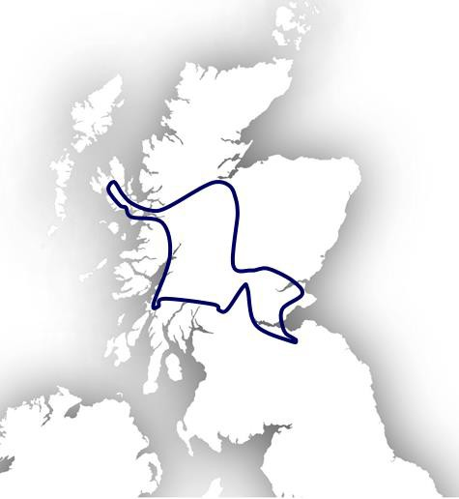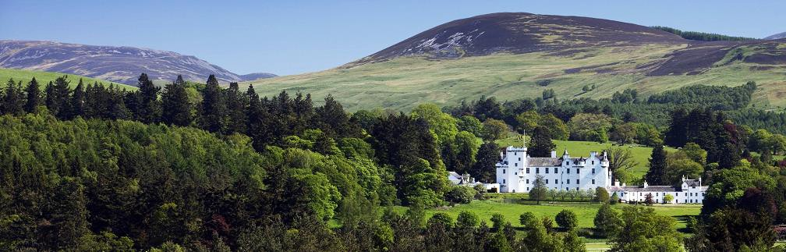

FOR FULL PRODUCT LISTING AND REDUCED PRICES VISIT HTTP://B2B.ABBEYIRELANDANDUK.COM/

