ADVENTURE IN THE FEROE ISLANDS - 6 DAYS/5 NIGHTS FLY AND DRIVE

(6 days/5 nights)

(Reykjavik-Gasadalur-Torshavn-Suduroy-Gjogv-Klaksvik-Reykjavik *****On daily basis on request*****)

Guaranteed departures GUARANTEED DEPARTURES
Take a spectacular 6-day trip to the Faroe Islands and experience these small but picturesque islands in the North Atlantic. This is the tour for those who want to explore the Faroe Islands by car. Traveling in your own car gives you the freedom to travel through small towns, see the fantastic views and investigate local events at your own pace. Flights, car rental and accommodation are all reserved and we also offer suggestions for photo stops and activities.

Day 1 Arrival in Feroe Islands
On your own, transfer to Reykjavik National Airport (taxis are plentiful). Departure from Reykjavik National Airport to Vagar. Pick up your rental car at the airport. Experience the island of Vagar on your own. We recommend a visit to the small town of Gasadalur. From here you can walk along marked nature trails and enjoy the breathtaking views of Tindholmur. Do not miss a view of the beautiful waterfall that flows into the ocean. You will spend the night in Vagar.
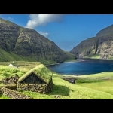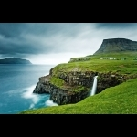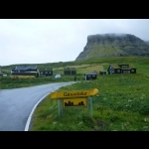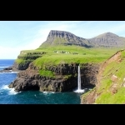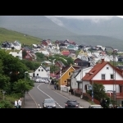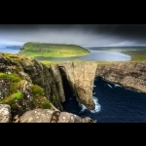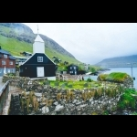

Day 2 Mykines Island - A gem of the North Atlantic
Breakfast at your hotel. We suggest booking a day trip to the bird island of Mykines (not included in the price). The tour starts from the port of Sorvagur, where you can park your car. Enjoy an impressive sailing trip along the majestic sea cliffs. On the same island you can see the lovely puffins with their colorful red beaks and the striking collectors that only reproduce on the island of Mykines. (Note: puffins usually seen in the Faroe Islands between mid-April and early September). Cross a pedestrian bridge over the Atlantic Ocean to reach the holm oak and the lighthouse. When you return to town again, a visit to the local cafeteria is always pleasant. On your return to Sorvagur, pick up your car and then head to Torshavn. You will spend the night in Torshavn.
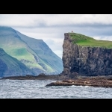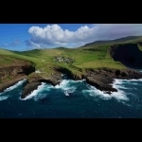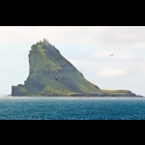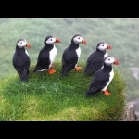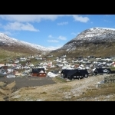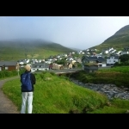

Dia 3 Suduroy Island Light house in Akraberg
Breakfast at your hotel. Take the ferry from Torshavn to the island of Suduroy (not included in the price). The nature in Suduroy varies from that of the northern islands and is particularly suitable for hiking. We recommend visiting the Akraberg lighthouse at the southern end of the island and also Beinisvord, to enjoy the magnificent panorama that unfolds when you reach the top. The town of Famjin, located in a beautiful and spectacular environment, is also worth a visit. The original flag of the Faroe Islands hangs in the village church. In Tvoroyri, visit some of the historic buildings used by the Danish royal store Monopoly Royal. You may have coffee at the cozy Pubbin café bar, located in the harbor. The night in Suduroy.
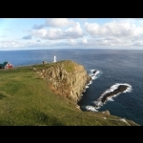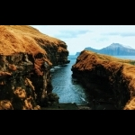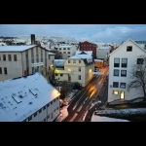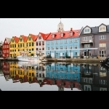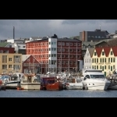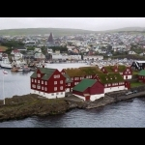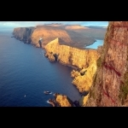

Day 4 Explore Torshavn and the historical and cultural center of Kirkjubour
Breakfast at your hotel. Return to Torshavn with the ferry (not included in the price). Stroll through the old town and soak up the atmosphere of small houses with their white window frames and grass roofs. The old town is unique, not only in the Faroe Islands but throughout the world. We recommend a visit to the village of Kirkjubour, which is the historical and cultural center of the country. Here you can see an unfinished cathedral, a small church and a family farm, dating from the Middle Ages. Back in Torshavn there are many different restaurants and cafes where you can enjoy excellent food. Spend the night in Torshavn. Return to Torshavn with the ferry. Walk through the old town to absorb the atmosphere of the small houses with their white window frames and grass roofs. The old town is unique, not only in the Faroe Islands but throughout the world. We recommend a visit to Kirkjubour, which is the historical and cultural center of the country. Back in Torshavn, you will find many different restaurants and cafes where you can enjoy excellent food. You will spend the night in Torshavn.
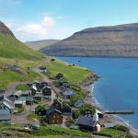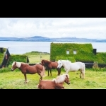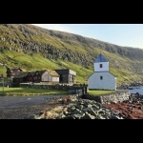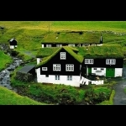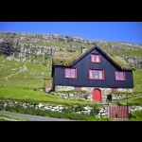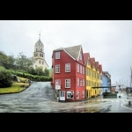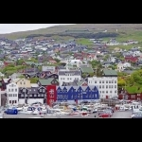

Day 5 Faroese artists, rock formations and colorful villages
Breakfast at your hotel. Today you will visit the northern islands. Drive through Streymoy Island, pass the old Vid Air whaling station and cross the bridge to Eysturoy Island. Continue to the town of Eidi, following the panoramic route to the city of Gjogv. See the impressive rock formations called Risin and Kellingin (the giant and the old witch) and the highest mountain in the country, Slaettaratindindur (882m / 2,893 feet). Explore the town of Gjogv, famous for its natural harbor. Drive from Leirvik through the underwater tunnel to Klaksvik, the second largest city in the Faroe Islands. The tunnel is decorated with "light" exhibits by the well-known Faroe Islands artist, Trondur Patursson. When you arrive in Klaksvik, we suggest a visit to the elegant Christian church and the exhibition in the church's cellar. It is easy to explore the other islands of northern Klaksvik, each with its own dramatic landscape. You will spend the night in the northern islands.
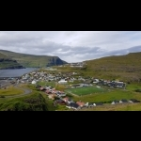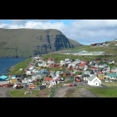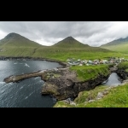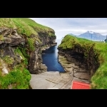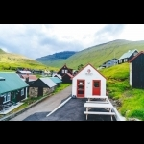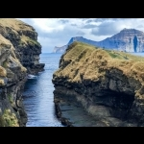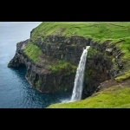

Day 6 Flight back to Reykjavik
Breakfast at your hotel. Today you return to the island of Vagar and its airport. Remember to give yourself a good time to drive to the airport. We suggest leaving the hotel early and, on the way to the airport, depending on the departing time of your flight, take the fascinating two-hour boat trip to the cliffs of Vestmanna birds, navigate between the cliffs and the caves (not included). Take the time to visit the exclusive Museum of the Saga, which describes the history of the Faroe Islands of the Viking ages through exhibits of realistic wax figures. Continue to Vagar airport and leave your rental car before your flight back to Reykjavik. Your trip ends at Reykjavik National Airport.
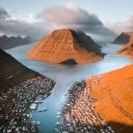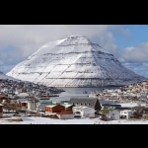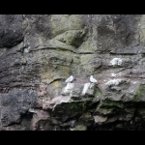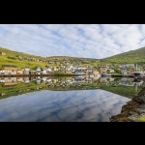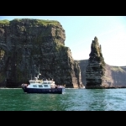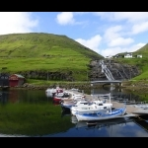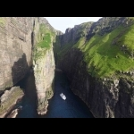
Eur 2276 Per person in double/twin
Eur 776 single supplement
The rates and availability should be reconfirmed in the moment of reservation.
The luggage service is not available in Faroese hotels. Travelers should be critical in preparing their travel luggage. A good rule of thumb is not to bring more than you can comfortably carry between your vehicle and your hotel room.
During the season 2020/2021
On a daily basis during the operational period.
Included:
- Round trip flight from Reykjavik National Airport to Vagar Airport (Faroe Islands)
- All airport taxes.
- Car rental with pick up / drop off at the airport, unlimited mileage and CDW.
- Accommodation with private bathroom and breakfast for 5 nights.
Not included:
- Breakfast the day of arrival.
- Lunches, dinners, drinks and soft drinks other than those listed on the itinerary
- Petrol
- Round trip ferry between Torshavn and Suðuroy Island (purchased in the Faroe Islands)
- Admissions and activities.
- Luggage storage at the airport and hotels
- Guaranteed early check-in or late check-out
- Accommodation in Iceland
- Airport / hotel transfers in Iceland
- Any service that is not specifically listed under "included"ortant notice
Luggage handling service is not included on this tour. Dorothy Tours is not responsible or liable for loss, damage or theft of luggage and/or personal belongings. Please be sure to have adequate travel insurance to cover medical emergencies, loss, damage or theft.
For further details and booking email: braga.bonnie@gmail.com bonniebraga@msn.com frances@bragatravelconsulting.com

