COMPLETE SCANDINAVIAN ADVENTURE 22 DAYS/21 NIGHTS

(22 days/21 nights)

(Copenhagen-Oslo-Balestrand-Bergen-Odda-Trolltunga-Longyearbyen-Bodö-Lofoten-Tromsö-Stockholm *****on daily basis on request*****)

Guaranteed departures
GUARANTEED DEPARTURES
The ultimate tour of Scandinavia with all of the most important sights of interest included. If you are an adventurous soul, this is a program tailor-made for you. Everything is organized down to the smallest detail for your comfort. All transfers are included, and the sightseeing in main cities such as Copenhagen, Oslo, Bergen and Stockholm are by private car and with local guide. We hope that you will be tempted by this challenge!
Arrival transfer from Copenhagen airport to your hotel in the city center. The rest of the day or afternoon free for your own activities. Overnight.
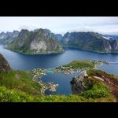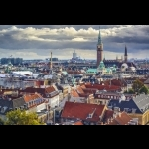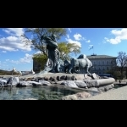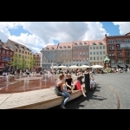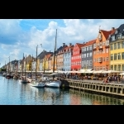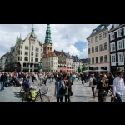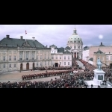

Day 2 Copenhagen
Buffet breakfast. In the morning, you will go on a panoramic sightseeing tour of Copenhagen. You will be able to see the most important and attractive parts of this beautiful city, including the Little Mermaid and the picturesque area of Nyhavn. Overnight.
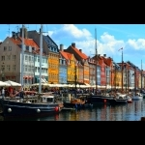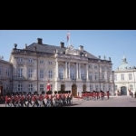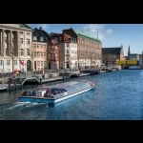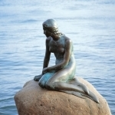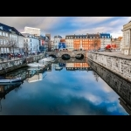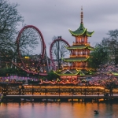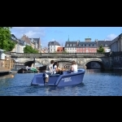

Day 3 Copenhagen-Oslo
Buffet breakfast. Almost full day at leisure - until 15.30hrs when you will be transferred to the Scandinavian Seaways pier. Board the ship for an overnight cruise to Oslo. Buffet-dinner on board. Overnight.
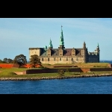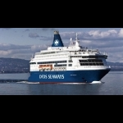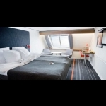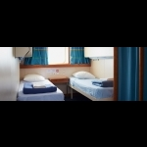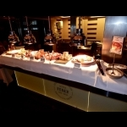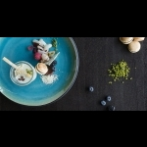

Day 4 Oslo
Buffet breakfast onboard. Upon arrival you will be transferred from the pier to the sightseeing tour of Oslo which includes the Vigeland Sculpture Park or to your hotel (depending on the starting time of the regular tour). If you are dropped for the sightseeing tour, the transfer service will drive your baggage to your hotel. After the regular sightseeing tour, you can have lunch or take a short walk back to the hotel for check in. Afternoon at leisure. Overnight.
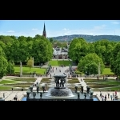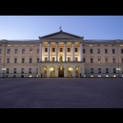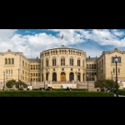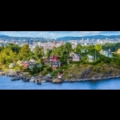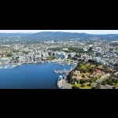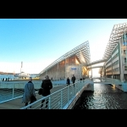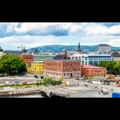

Day 5 Oslo
Buffet breakfast. All day free to explore this city on your own. We suggest several museums (including Viking Ship Museum) or others. Check with the reception of your hotel. Accommodation 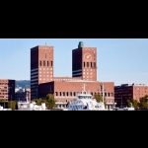 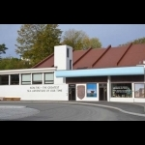 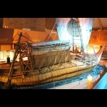 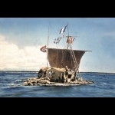 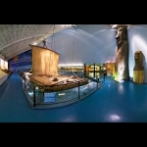 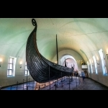 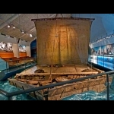

Day 6 Oslo-Balestrand or Flåm
Buffet breakfast. Today starts your individual program of “Norway in a Nutshell” between Oslo-Balestrand or Flåm -Bergen. The day starts by taking a train from Oslo to Myrdal and continuing the journey on the famous Flåm Railway until reaching the village of Flåm. The descent down the valley of Flåm offers a constantly changing panorama of sky-high snow covered mountains, waterfalls and green pastures at the bottom of the valley. Flåm is situated at the start of the Aurlandsfjord- one of the “arms” of the majestic Sognefjord - and here you join the express boat out into the Sognefjord. From Flåm the express boat takes you to Balestrand where you overnight at a local hotel, situated by the fjord. Dinner at hotel.
(*) Between 1st of October - 30th of April the Express boat will not operate from Flåm -Balestrand -Bergen. We will provide you with another itinerary. The night in Balestrand will be replaced by a night in Oslo, Voss, Flåm or Bergen according to your wishes and availability.
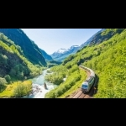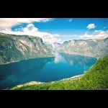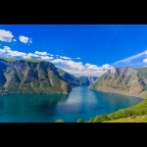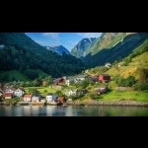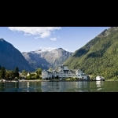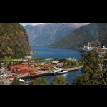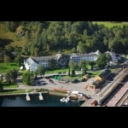

Day 7 Balestrand or Flåm - Bergen
Buffet breakfast. Morning free at the surroundings of the hotel where you have the possibility of going for a walk and visit the St Olafs Church or taking a cold swim in the deep fjord. In the afternoon you will depart for Bergen by an express boat trip which takes almost 4 hours. Transfer and overnight at hotel in Bergen city. 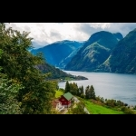 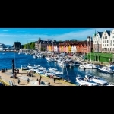 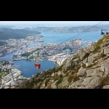 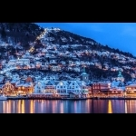 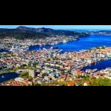

Day 8 Bergen - Trolltunga - Hardangerfjord
Buffet breakfast at the hotel. We travel to Odda / Trolltunga (approx. 3 hours). Information meeting at the hotel at 9 pm. Your guides will inform you about the trek, the necessary equipment, the weather forecast and more. Accommodation at the Trolltunga Hotel. You must Keep in mind that this getaway requires good physical conditions for each person.
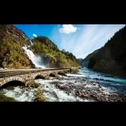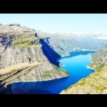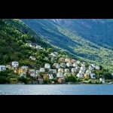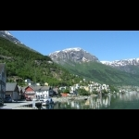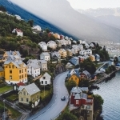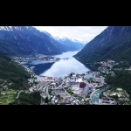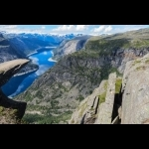

Day 9 Trolltunga
Buffet breakfast at the hotel. Remember to prepare 2 lunches at the hotel for your trip. Transportation service at the beginning of the hike point. 11.00 Start of the trek to Trolltunga - approximately 14 hours of walking ending in Troltunga Dome where you have dinner and spend the night enjoying the fantastic view. 6 people can spend the night in the small dome. IMPORTANT: Duration approx. 28 hours 2x14km, 800m of ascent. Requirements: Good physical condition. Please report medical conditions such as asthma, epilepsy, etc. Min. age is 15 years. The list of luggage and all the necessary adventure information will be provided in the confirmation of your reservation.
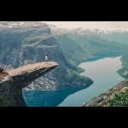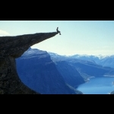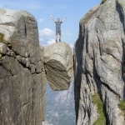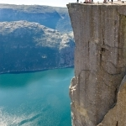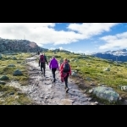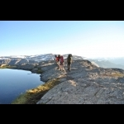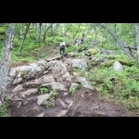

Day 10 Trolltunga - Bergen
Breakfast in the dome. Today you will walk back to the Trolltunga Hotel, where you will arrive around 2pm. Stop for lunch on the road. Traveling to Bergen (3 hours). Arrival, check in and accommodation at the hotel in Bergen.
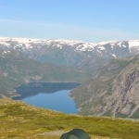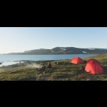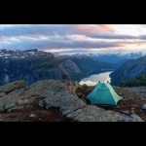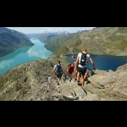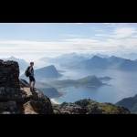

Day 11 Bergen
Buffet breakfast. In the morning you will be introduced to this remarkable City of the old Hansa. You will enjoy the view of the Bryggen area of old wooden houses that is part of the UNESCO World Heritage, as well as the traditional Fish Market. Afternoon free to explore Bergen. Overnight.
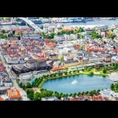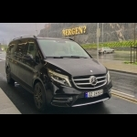

Day 12 Bergen - Longyearbyen (Spitzbergen)
Buffet breakfast at the hotel. Private car transfer with English-speaking driver to Bergen airport for your flight to Longyearbyen. The airport bus will stop outside the arrivals hall. Transfer to all hotels and guest houses in Longyearbyen when all guests have received their luggage. Accommodation at Funken Lodge that includes full buffet breakfast, Longyearbyen.
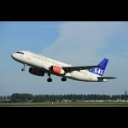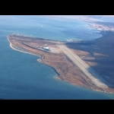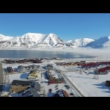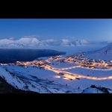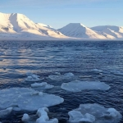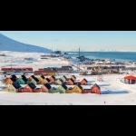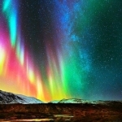

Day 13 Longyearbyen
Buffet breakfast at the hotel. Northern Lights at 19.00. The northern lights can be seen 24 hours a day during the polar night. Increase your chances being away from the city lights, and learn more about this fascinating display while enjoying a complete dinner! The Aurora Boreal is a magical light show created by the sun, and although it happens throughout the year, the Polar Night gives us the opportunity to see it at any time of the day. Our base of the northern lights is about 10 km from Longyearbyen at Camp Barentz. During this all-inclusive night, you will enjoy a fascinating presentation about these polar "fireworks", as well as a delicious dinner and drinks. Meeting point: in front of your hotel where they will pick you up. Duration: approximately 3 hours.
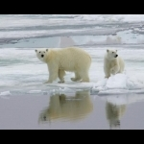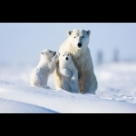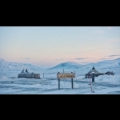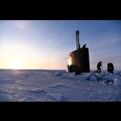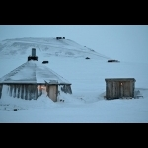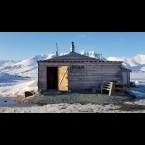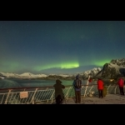

Day 14 Longyearbyen
Buffet breakfast at hotel. Northern light cruise in the polar night at 18:40. The northernmost fjord cruise in the Polar night with a chance to experience nature's own unique light show. This is a 4 hour evening trip. The Guide on board tells about the Northern Light and about how it is to live in the dark. A hot meal from the grill on deck is included in the price. Bring warm and windproof clothing, including hat and mittens. Remember your camera & souvenirs! Bar with all rights. Waffles & souvenirs can be bought on board. Both cash and card can be used (VISA, Mastercard).
The evening cruise does not operate between December and March. You will be recompensated with one of our activities: husky or snowmobile or other available activity.
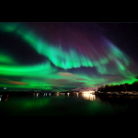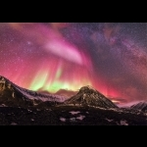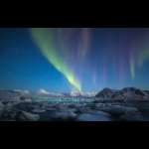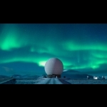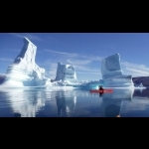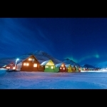

Day 15 Longyearbyen - Bodö
Buffet breakfast. At noon we will have the transfer from the hotel to the airport to travel by plane to Bodö. Arrival transfer from Bodö airport to your 4 * hotel located downtown. You will be notified of the name of the hotel at the time of confirmation of services. The rest of the day / night at leisure. Accommodation.
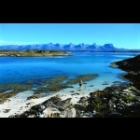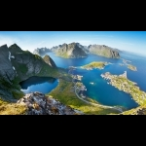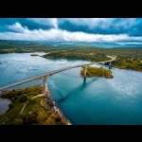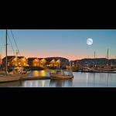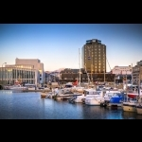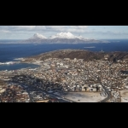

Day 16 Bodö-Moskenes-Kabelvåg-Lofoten
Breakfast buffet. Today you will travel all the way to Vesterålen Islands. You will pass amazing places with fantastic geographic sceneries and unforgettable view. Please, prepare your cameras since at all times you will have great panorama views. Stop for lunch. After lunch you continue your trip towards the magnificent areas. Arrival, dinner and overnight.
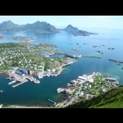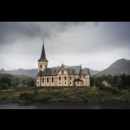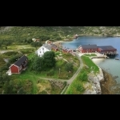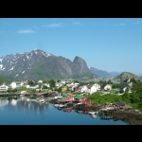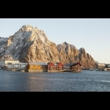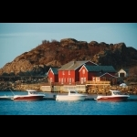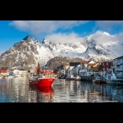

Day 17 Lofoten - Tromsö
Buffet breakfast. Today you will have full day travelling by coach to Tromsö. You will continue to admire the scenery of this incredible part of the world. Stop for lunch and after lunch continue to Tromsö where you will stay at 4* hotel. Dinner and overnight.
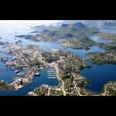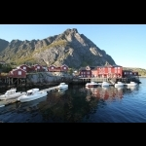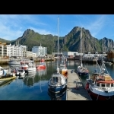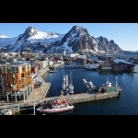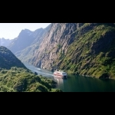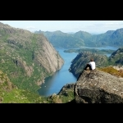

Day 18 Tromsö-Oslo-Stockholm
Breakfast buffet. Transfer from your hotel to Tromsö airport in order to board the flight to Stockholm via Oslo. Upon arrival in Stockholm, transfer to your hotel located in the center of Stockholm. Overnight.
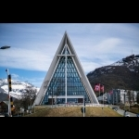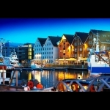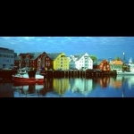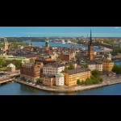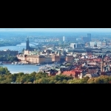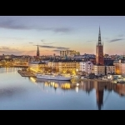

Day 19 Stockholm
Buffet breakfast at the hotel. After breakfast, you will have a panoramic tour of Stockholm, including Fjällgatan, where you can enjoy the beautiful view of the city. Afternoon free in Stockholm, with the possibility of visiting the Town Hall or the famous Wasa Museum or taking one of the popular canal tours. Accommodation.
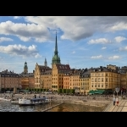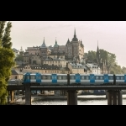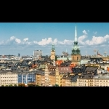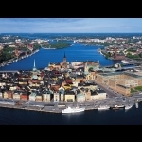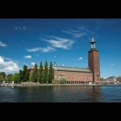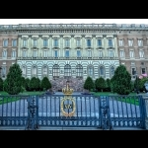

Day 20-21 Stockholm
Breakfast buffet. All day free for your independent activities. We suggest you contact the reception of your hotel to give you some suggestions on how you can make the most of this day. A good idea would be to make an excursion to Drottningholm Palace where our kings reside. The next day you can optionally visit the cities of Uppsala and Sigtuna. Cities known for its University in Uppsala with the Silver Bible and the Cathedral, and Sigtuna where the smallest Town Hall in Europe is located. Duration of this excursion is approximately 5 hours. Overnights.
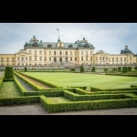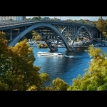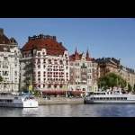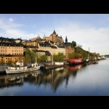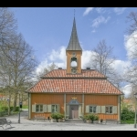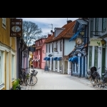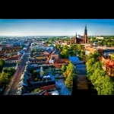

Day 22 Stockholm Departure
Buffet breakfast. The tour ends with departure transfer from your hotel to Arlanda International Airport in time for your departure back home. We thank you for using our services and hope to welcome you again in the near future.
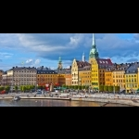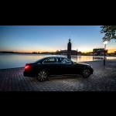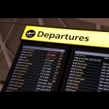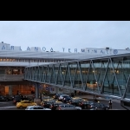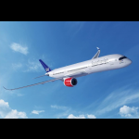
Rates in EUR
Economy class (3 *) in Euro
* 13970 per person in triple
* 14690 per person in double/twin
* 16790 per person in single
First class (4 *) in Euro
* 15490 per person in triple room
* 17590 Per person in double/twin room
* 19580 per person in single room
Superior First Class/De Luxe (4 + -5 *) in Euro
* 17390 per person in triple room
* 18560 per person in double/twin room
* 22580 per person in single room
We can not offer Superior First Class/De luxe class hotels in all the cities in our itinerary. The best hotels available will be booked.
Tour escort guaranteed when minimum 10 persons are travelling on the same departure. Otherwise the tour is with no accompanying tour escort.
Children under 12 years have a 25% discount as long as they share the room with both parents.
Minimum of 4 people traveling.
We have even group rates. Please contact our office. id
During the season 2020/2021
On a daily basis on request during the operational period.
The rates include:
- Scandinavian breakfast daily
- 1 Buffet dinners aboard Scandinavian Seaways between Copenhagen
- 1 buffet dinner at the hotel in Balestrand or Flåm or similar. (* or at the hotel available according to the date of the trip).
- Any other dinners or meals indicated in the itinerary.
- Private car transfers with English speaking driver
- Train and ferries between Oslo-Balestrand-Bergen or vice versa in 2nd class
- Air tickets between Bergen-Longyearbyen-Bodö-Tromsö-Oslo-Stockholm in economy class (max 1 suitcase of max 20 kg per person).
- 20 nights accommodation in a double room with private bathroom or shower in selected or similar hotels.
- 1 night accommodation in "cupola"
- 2 lunch packages from Trolltunga Hotel.
- “Trolltunga Dome - package according to the detail in important notice.
- Visits by private car and local guides in Copenhagen, Oslo, Bergen and Stockholm.
- Regular excursion “Sognefjord in a Nutshell” between Oslo and Bergen.
Not included:
- Any service that is not indicated in Included above or in the itinerary.
Prices are subject to change at the time of reservation.
Important notice
Trolltunga package (28hrs) includes: Professional guide with navigation equipment, safety and first aid. Dinner and breakfast and hiking sticks and small appetizer taste of Hardanger-Surprise. (The snack does not replace any food. Bring food for two lunches.) Trolltunga has only one hotel so it is for 3 categories the same hotel.
The personal belonging of the traveler are not the object of the Dorothy Tours transport contract and the passenger must be with you at all times. Dorothy Tours is not responsible for the loss, deterioration or theft of luggage or personal items, so it is extremely important that each traveler has a safe travel insurance to cover this risk. Dorothy Tours reserves the right to change some services / hotels if necessary, always keeping the same category and standard. Aurora Borealis is a natural phenomenon that nobody can guarantee to be present at the moment of your visit to this city. Dorothy Tours guarantees the services indicated above but does not guarantee natural phenomena.
For further details email: braga.bonnie@gmail.com bonniebraga@msn.com frances@bragatravelconsulting.com

