FINNISH LAPLAND WITH HELSINKI AND STOCKHOLM 11 DAYS/10 NIGHTS

(11 days/10 nights) (Rovaniemi-Helsinki-Stockholm *****Winter*****)

Guaranteed departures GUARANTEED DEPARTURES
We are happy to present the possibility of enjoying winter activities with relaxation and a life totally different from what you are used to. In northern Finland, you will find forests, huskies, reindeer, snowmobiles and igloos. After the adventure of the north, you will feel the pulses of Helsinki and later Stockholm (capital of Sweden). All this in 11 days / 10 nights at a stress-free pace and with an open soul to adventure. This tour is guaranteed with min. 2 pax travelling.

Day 1 Rovaniemi - Finland Arrival
Individual arrival at Rovaniemi airport. Already at the airport you can see the polar circle marked on the ground. You can take a picture with your foot stepping on the polar circle. Arrival at the Arctic Light hotel, check-in and accommodation. Tomorrow you will start the winter program with many interesting activities. Dinner at the hotel.
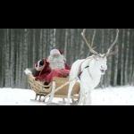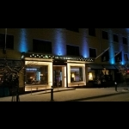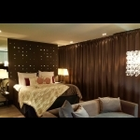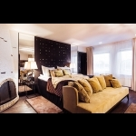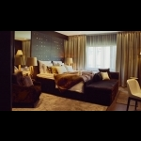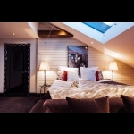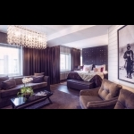

Day 2 Rovaniemi-Kemi-Rovaniemi
Breakfast buffet at the hotel. Today transfers are included. A cruise with the ice-breaker Sampo offers you the most exciting and memorable moments in the Arctic nature; While the great ship breaks the ice, you can admire the beauty of the immense ice fields open around and the ever changing sky above. The sun can be reflected from the layer of white snow, or, as the twilight sets, it can be set in rays of warm colors of yellow, orange and red, even lilac. What would be a good cruise experience without shopping? At Sampo you can buy souvenirs and gifts for friends and loved ones at home. Dinner at the hotel.
Important: Please keep in mind that the order of services may change.
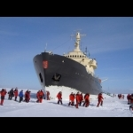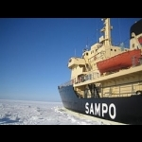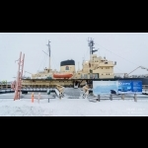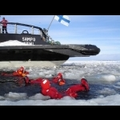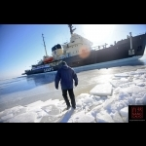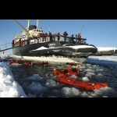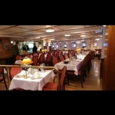

Day 3 Rovaniemi
Breakfast buffet. Our most popular safari combines the nature, culture and spirit of Christmas. The day begins with a snowmobile safari to a reindeer farm where you will hear more about reindeer breeding and Lappish culture. You can take a reindeer ride and attend a special Lapp ceremony when crossing the Arctic Circle. In the afternoon, the trip continues by car to Santa Claus Village with time to shop in Santa Claus' Village. You will also have the opportunity to send postcards from the main post office of Santa Claus. And you will get a Diploma for crossing the Arctic Circle! Due to the conditions of the track / weather in December, for safety reasons, transfers to and from the farms can be done by car. Dinner at the hotel.
Important: Please keep in mind that the order of services may change.
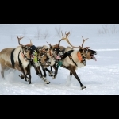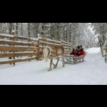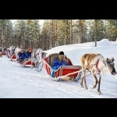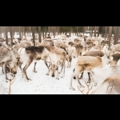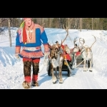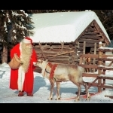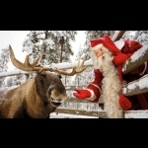

Day 4 Rovaniemi
Breakfast buffet. Did you know that there is a secret training camp for Santa Claus reindeer in Rovaniemi? This is the place where the special reindeers Santa uses to pull his sleigh are trained for the gigantic journey around the world. Santa himself is attending his important Christmas tasks, but he has given his elves and reindeer herders permission to reveal the secrets of this training camp. You can try driving the reindeer on a short practice track (on land). All this in 15 minutes by coach from the city center. Dinner at the hotel.
Important: The order of activities may change.
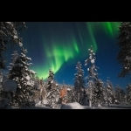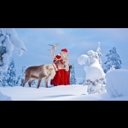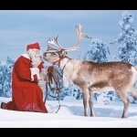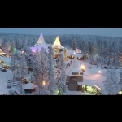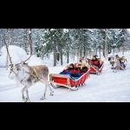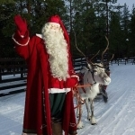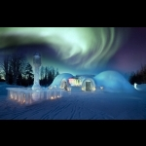

Day 5 Rovaniemi
Breakfast buffet. Winter safari with husky equipment. After a short drive from the city, you will arrive at a husky dog ​​ranch, where these friendly dogs will bark at you enthusiastically. Before leaving on the safari, you will be instructed on how to control the sleds. Enjoy a hot berry juice by a fireplace and chat with the Chief Musher about these amazing northern animals once you return to the ranch. Dinner and accommodation.
Important: The order of activities may change.

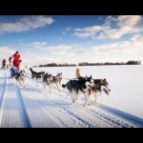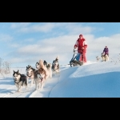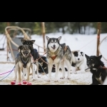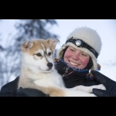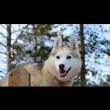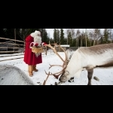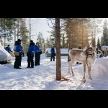

Day 6 Rovaniemi
Breakfast buffet. Today you are going to change hotels and need to be transferred to Arctic Snow hotel and an igloo with a pleasant temperature of + 21C. Transfer is not included. Perhaps the Aurora Borealis will dance over the skies tonight again – this is a fantastic memory for life! Accommodation at the Arctic Snow hotel.
Important: Tonight is on demand and cannot be guaranteed. In the event that the igloo was complete, you will continue with the previous hotel (with dinner included in this case).
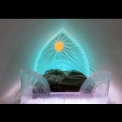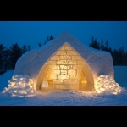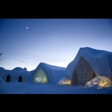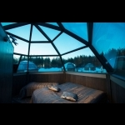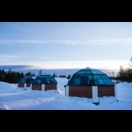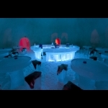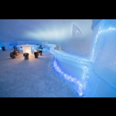

Day 7 Rovaniemi-Helsinki
Breakfast buffet. Departure from your hotel to Rovaniemi airport to continue your trip to Helsinki, the capital of Finland. Transfers are not included. Arrival in Helsinki and departure to your hotel in the city center. Check-in and accommodation. The rest of the day or afternoon free for your individual activities.
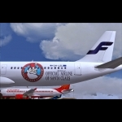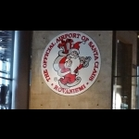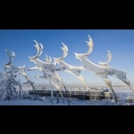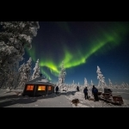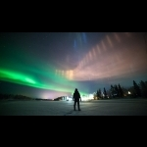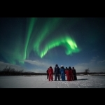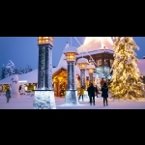

Day 8 Helsinki
Breakfast buffet. In the morning part you will have your panoramic tour of the city including visits to the most important points such as: Senate Square, Uspensky Cathedral, Parliament, Park and Sibelius Monument, Tempeliakko Church cut in rock (if open to the public) and much more. Free afternoon. Accommodation.
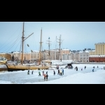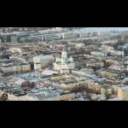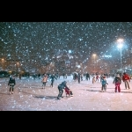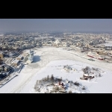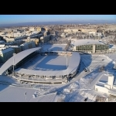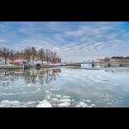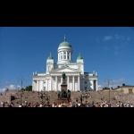

Day 9 Helsinki-Stockholm
Breakfast buffet. Departure transfer from your hotel to Helsinki International Airport. Flight to Stockholm. Arrival in Stockholm and directly from the airport, arrival transfer to your hotel. The rest of the day or afternoon free for rest or private activities. Accommodation.
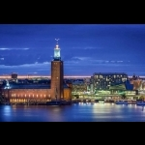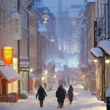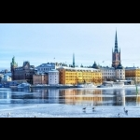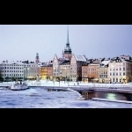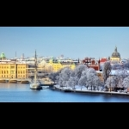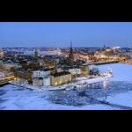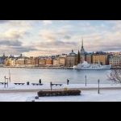

Day 10 Stockholm
Breakfast buffet. Today you will enjoy a panoramic visit to this wonderful city, located on 14 islands with 70 bridges, called the Venice of the North. You will pass through the old town (Gamla Stan) where the Royal Palace is located, through the Cathedral and the typical streets of medieval times, among other places. In the afternoon you can optionally visit the City Hall. Accommodation.
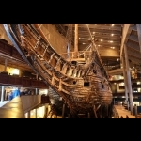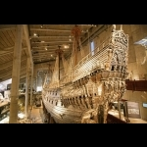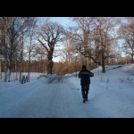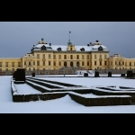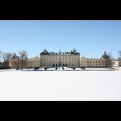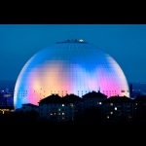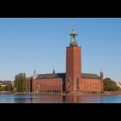

Day 11 Stockholm Departure
Buffet breakfast. Today you have the last day and it is time to say good bye to this beautiful part of the world. The departure transfer is not included. Thank you so much of joining our tour and we wish you very welcome back maybe in summer time.
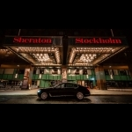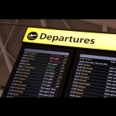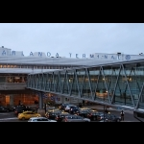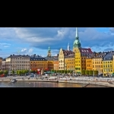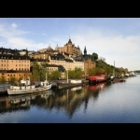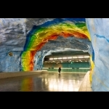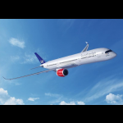
Rates in EUR
Price per person based on 3 pax (1 triple) Eur 6756.-
Price per person based on 2 pax (1 twin or double) Eur 7256.-
(Rovaniemi-Helsinki-Stockholm flights not included). The activities in Lapland are in English. Visits in Helsinki and Stockholm are with a local Spanish speaking guide. Transfers included according to the program. Between Rovaniemi and Kemi (Sampo) are by taxi.
Hotels included or similar:
Rovaniemi Arctic Light hotel 4 + *
Rovaniemi Arctic Snow hotel 4+
Helsinki - hotel Kämp 5 *
Stockholm - 5 * Sheraton hotel
The program according to the itinerary. The order of activities may change.
During the season 2020/2021
Every day between December and March during the season 2020/2021 on request.
Included in the price
- 10 nights accommodation at the indicated or similar hotels
- Daily buffet breakfast
- Sightseeings in Helsinki and Stockholm as per our program
- Activities and excursions in Rovaniemi according to the program
- In winter activities the thermal clothing included
- Meals specified in the itinerary
Not included
- Flight Rovaniemi-Helsinki-Stockholm
- No travel insurance
- Breakfast on arrival day
- Tour Escort is not included
- please check when transfers are included
- No service that is not indicated in “included”
Children under 12 years have a 25% discount as long as they share the room with both parents.
rtant notice
The personal belonging of the traveler are not the object of the Dorothy Tours transport contract and the passenger must be with you at all times. Dorothy Tours is not responsible for the loss, deterioration or theft of luggage or personal items, so it is extremely important that each traveler has a safe travel insurance to cover this risk. Dorothy Tours reserves the right to change some services / hotels if necessary, always keeping the same category and standard. Aurora Borealis is a natural phenomenon that nobody can guarantee to be present at the moment of your visit to this city. Dorothy Tours guarantees the services indicated above but does not guarantee natural phenomena.
For further details email: braga.bonnie@gmail.com bonniebraga@msn.com frances@bragatravelconsulting.com

