THE NORTHERN LIGHTS IN FINLAND - APUKKA 7 DAYS/6 NIGHTS

(7 days/6 nights)

(Rovaniemi-Apukka *****Winter*****)

Guaranteed departures GUARANTEED DEPARTURES
We are pleased to offer you a tour where you will have the possibility of experiencing the natural phenomenon occurring in winter months at latitudes north of the Arctic Circle - The Aurora Borealis (Northern Lights) in Finland.

Day 1 Rovaniemi-Apukka
Arrival transfer from the airport to Apukka Resort located outside Rovaniemi in Finland. You will have free time in order to rest after your trip and tomorrow you will start your Lapland adventure. Accommodation.
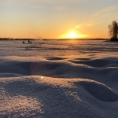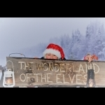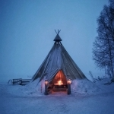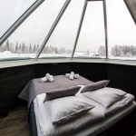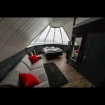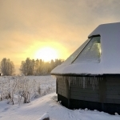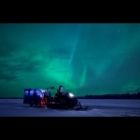

Day 2 Apukka
After breakfast you will pay a visit to a typical Sami Reindeer farm. Here you will be able to experience a memorable reindeer sleigh ride. ransportation by car to a reindeer farm to try reindeer sleighing. This traditional way of travelling through snowy forests is a unique experience – in the evening, you may even see the Northern Lights blaze up the sky. Enjoy a hot cup of coffee with a bun around a campfire and learn about the life of reindeer herders. Return to Apukka and Ice Snow hotel where you will overnight in an Ice Room (0 to -5C) or in a warm Glass Igloo. If you wish to have warm room you can continue at glass igloo. Please note that there is no toilett/bath this night available in the Cold room at Ice Snow hotel. If the hotel is fully booked this night we will try to accommodate you another night.
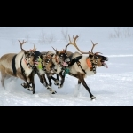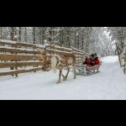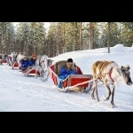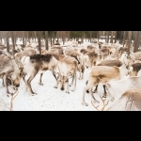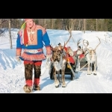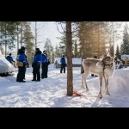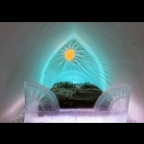

Day 3 Apukka-Kemi-Apukka
After breakfast you will start our excursion towards Kemi – located 2-3 hours drive from Apukka (180 km). You will visit the Sampo Icebreaker ship and join the ice-breaking cruise into the Baltic Sea. This tour is not operating every day, so we will have to reconfirm the day and possibility to join this cruise. Sampo has operated since 1961, first as an icebreaker for the Finnish government, and in tourism since 1988. A cruise on Sampo offers you the most exciting, memorable moments in the Arctic nature; while the huge vessel breaks ice, you may admire the beauty of vast open ice fields all around, and the ever changing sky above. Travel back to your hotel in Apukka and overnight.
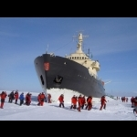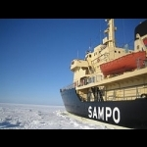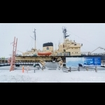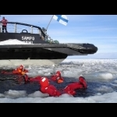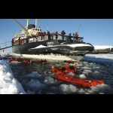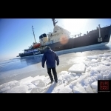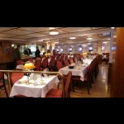

Days 4-5 Apukka
Buffet breakfast in the hotel restaurant. 10:00-13:00 or 13.00-16.00 Huskies or Snowmobiles Galore! The thrill of snowmobiling and the speed of husky sleigh ride all in one - this must be a lucky day! We drive a good distance from Apukka on snowmobiles; to a wilderness husky farm where the dogs are waiting to take you for a speedy 30 minutes ride in their sledges. The sleigh takes one passenger and one driver, or musher as we call it. There will be a chance to swap places during the outing. After the ride you have time to get familiar with the dogs and hear about their daily life. The visit is topped off with a tasty lunch and hot drinks by the fire, after which we head back to Rovaniemi. Overnight. Please note that day 4-5 look exactly the same which means that you can choose the snowmobile on day 4 and huskies on day 5 or the opposite way.
Recommendation: Arktikum is a museum and research center for Lapland and other arctic areas in the world. It is located within walking distance from the city center and open daily in the winter season. Arktikum tells the story of the people of the North as well as the fantastic nature and its phenomena like the Aurora Borealis.
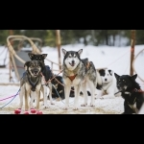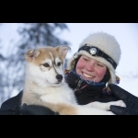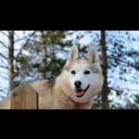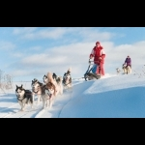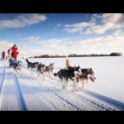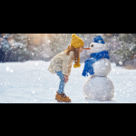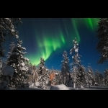

Day 6 Apukka
After breakfast we will visit Santa Claus Village and of course Santa Claus in his chamber. Visiting Santa Claus’ Main Post Office is also a must and it is located right here, in Santa Claus Village on the Arctic Circle. You will find out that an amazing number of letters are coming in daily from all over the world. Before we leave the village, you will have time for own explorations and to do some shopping in the boutiques and souvenir shops. Overnight.
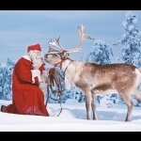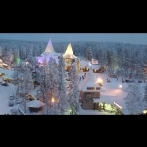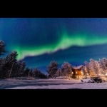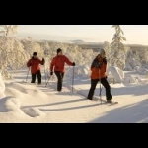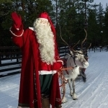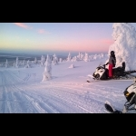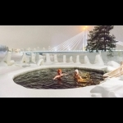

Day 7 Apukka - Departure
Buffet Breakfast. Today is a last day of your Lapland experience and you will have your departure transfer to Rovaniemi Airport which lies right on the Arctic Circle. You can see the line right on the airport floor. We thank you so much for joining our Lapland Tour and hope to see you in our part of the World soon again. Maybe in the summer time?
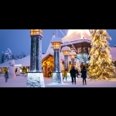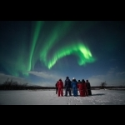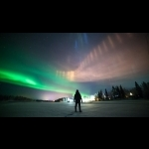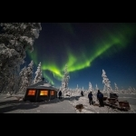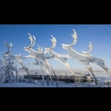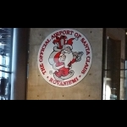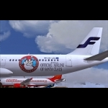
Rates in EUR
PRICES:
3576 €/person in twin room (min 2 adults / booking)
2296 €/person when sleeping in sofa bed as 3rd-4th person
5996 €/single if only 1 pax travelling.
1550 €/person in twin room supplement for Christmas and New Year period 20/12/2019-3/1/2020
1350€/ single supplement if only 1 pax travelling for Christmas and New Year period 20/12/2019-3/1/2020
IMPORTANT NOTICE:
The rates are subject to changes and reconfirmation upon the reservation.
During the winter season 2020/2021
Departures
Daily on request.
Rates include
Including:
- 6 nights in 4 star hotels
- 6 x buffet breakfast
- Other meals as specified in the program
- Visit to the Sami Reindeer farm, sleigh ride, visit to Husky farm, visit to Sampoo Icebreaker ship and be on the cruise. Snow mobile ride, Santa Claus Village
- English speaking companion guide service on all tours
- Winter clothing / outdoor safari clothing mentioned in the program
- Return transfers from Rovaniemi airport to Apukka Resort
Snow/Ice activities are subject to weather conditions.
Minimum of participants: 2 persons
*** Please note special conditions for Christmas and New years eve will apply.
Children under 12 years have a 25% discount as long as they share the room with both parents.
No one can guarantee this natural phenomenon, which can appear suddenly with low temperatures in the northern part of Scandinavia. Dorothy Tours provides services but does not guarantee the above natural phenomena.
Dorothy Tours is not responsible or liable for loss, damage or theft of luggage and/or personal belongings. It is of the utmost importance that passengers have adequate travel insurance to cover last minute cancellations, medical emergencies, loss, damage and/or theft.
Dorothy Tours reserves the right to change some services / hotels if necessary, always keeping the same category and standard. Aurora Borealis is a natural phenomenon that nobody can guarantee to be present at the moment of your visit to this city. Dorothy Tours guarantees the services indicated above but does not guarantee natural phenomena.
The order of the activities can change. All activities are operated in English.
For further details and booking email: braga.bonnie@gmail.com bonniebraga@msn.com frances@bragatravelconsulting.com

