EGYPT ITINERARY ESPECIALLY MADE FOR

Wednesday - Arrive Cairo
Upon arrival Cairo International airport on @ and before immigration Egypt and Beyond travel representative will meet you and assist you through immigration “Look for your name on a sign”., Once you have collected your bags, then pass through customs to transfer you to your hotel.
OVERNIGHT: CAIRO

Thursday Cairo
Today after breakfast you will be collected from the hotel lobby and taken on a private guided tour to visit Giza Pyramids and Sphinx. A day of inspiration and enlightenment will be yours today. First will go to the Giza Plateau, where the only remaining Wonder of the Ancient World is found, the imposing Pyramids of Giza. During your visit to the Pyramids you will have time for unique photo opportunities of the three Pyramids Cheops, Chephren & Mycerinus from the Western Plateau. Continue down the valley where the guardian of this mortuary complex, the Mighty Sphinx, bears witness to the passage of time and man in eons of silence. Afterword Lunch will be served at a local restaurant nearby the Pyramids. Next stop will be the Egyptian Museum. The Egyptian Museum in Cairo contains the world's most extensive collection of pharaonic antiquities; no visit to Egypt is complete without a trip through its galleries. The Museum of Antiquities where over 120,000 objects in its 107 halls - including the treasures of Tutankhamun (King Tut) - are exhibited home to a fabulous collection of world-renowned antiquities, including those from the tomb of Tutankhamun whose death-mask is magnificent.
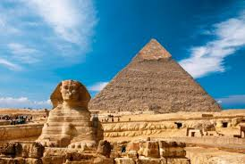
OVERNIGHT: CAIRO (B,L)

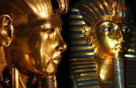

Friday Cruise
Transfer from hotel to Cairo domestic airport to fly to Aswan ( Optional Abu Simbel Excursion ) .Upon arrival to Aswan airport, meet & greet and transfer
to your cruise , which you will boar for the next 3 nights afloat. After lunch ,will visit the High Dam and from there you'll proceed to the Temple of Philae, return to your Nile Cruise for lunch and an overnight stay.
OVERNIGHT: CRUISE (B,L,D)

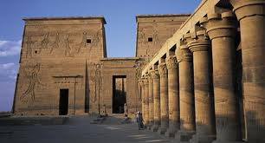
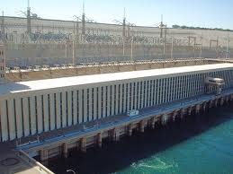

Saturday Cruise
This morning sail to Kom Ombo to view the Temple of Kom Ombo, dedicated to both Sobek, the crocodile god and Horus, the sun god. In ancient times, sacred crocodiles could be seen here basking in the sun on the banks of the Nile. Afternoon sail to Edfu to visit the Temple of Horus. Sail to Luxor. tonight experience an evening of local entertainment onboard.
OVERNIGHT: CRUISE (B,L,D)
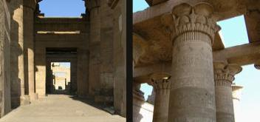
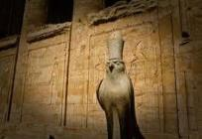

Sunday Cruise
Optional: Ballooning ride this morning over Luxor City.
Today start your visits at West Bank of the Nile for sightseeing of the Valley of the Kings. Here, hundreds of tombs, including that of Tutankhamun, were carved into the desert rock. Continue on to the Temple of Hatshepsut, The mortuary temple of Queen Hatshepsut of Dynasty XVIII was built just north of the Middle Kingdom temple of Mentuhotep Nebhepetre in the bay of cliffs known as Deir el-Bahri. In ancient times the temple was called Djeser-djeseru, meaning the ‘sacred of sacred’. It was undoubtedly influenced by the style of the earlier temple at Deir el-Bahri, but Hatshepsut’s construction surpassed anything which had been built before both in its architecture and its beautiful carved reliefs, Rest of the afternoon is free at leisure to enjoy cruising the Nile. Afternoon will visit Karnak Temple, the greatest example of worship in the history, dedicated to the God Amon, his wife Mut and their son Khonsu.
OVERNIGHT: CRUISE (B,L,D)
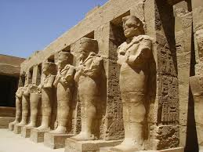
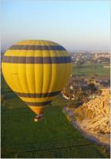
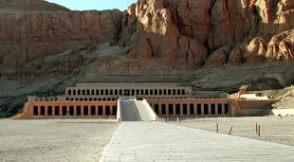

Monday Cairo
After breakfast, you'll check out from cruise and transfer to Luxor airport ,upon arrival to Cairo airport our representative will meet, assist and transfer to your hotel where you can spend the rest of the day relaxing or enjoying with extra night sightseeing
OVERNIGHT: CAIRO (B)

Tuesday - Departure (B)
After breakfast, we will be transferred to Cairo international airport to fly back home with everlasting memories of the Land of Egypt , departure on….. @.......
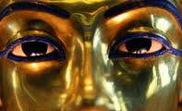

(MAA EL SALAMA, GOOD BYE)

Tour Includes:
- Twin share accommodation.
- All entrance fees as per itinerary.
- All arrangements as per itinerary.
- Meet and assist upon arrival and departure.
- English speaking licensed Category A guides.
- 13 meals “6 breakfasts, 4 lunches & 3 dinners.”
- Private transfers and sightseeing in modern A/C Car.
- Domestic airfares Cairo / Aswan - Luxor / Cairo on Economy Class.
- Bottled water in vehicle during tours.

Tour Excludes:
Any arrangements not specified on itinerary, travel insurance, international airline tickets, laundry and tipping ground staff, guides & drivers, any extra hotel or cruise beverages or any other items not mentioned above itinerary.

Opcional: ABU SIMBEL – USD600.00 por pessoa inclui voo domestic, excursao privado com guia falando ingles.
Hot Air ballooning em Luxor sobre o Vale dos Reis USD293.00

Perhaps you add another 7days program Glimpse of Egypt every Wednesday arrivals
Cost per person double / twin sharing
4* US$1670
Hotels: MERCURE PYRAMIDS OR OASIS, PRESIDENTIAL NILE CRUISE
5* US$1935
Hotels: STEIGENBERGER OR CAIRO SHERATON, SONESTA NILE OR AMARCO I OR SIMILAR
5* Luxury $3595
Hotels: FOUR SEASONS CAIRO & SONESTA STAR GODDESS OR AMARCO I PRESIDENTIAL SUITE
Optional: ABU SIMBEL – USD600.00 per person includes round trip domestic airfare, private excursion with private English speaking guide.
Hot Air ballooning in Luxor over the Valley of the Kings USD293.00 per person

For further details: braga.bonnie@gmail.com

