Braga Travel

Safari, Garden Route & Cape Town
Johannesburg - Kapama Private Game Reserve - Mpumalanga Highlands - Port Elizabeth - Garden Route - Plettenberg Bay - Oudtshoorn - Stellenbosch - Cape Town
14 Days / 13 Nights
12Persons - Reference: Q101215
30 April – 14 May 2021

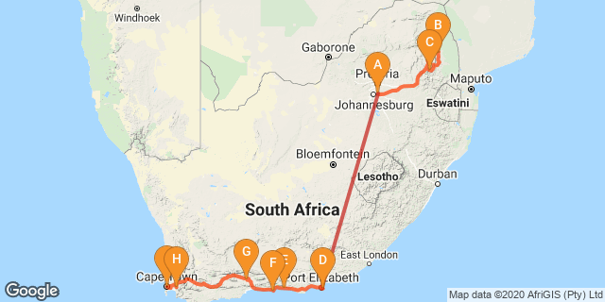

Click here to view your Digital Itinerary

Introduction
A warm welcome to your very personal tailor-made Africa trip!
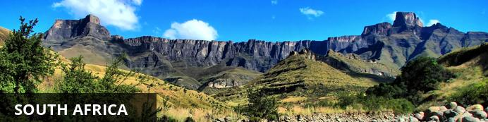
Every country in the world displays some diversity, but South Africa, stretching from the lions in the Kruger National Park to the iconic Table Mountain in the Cape, takes some beating. Enjoy the Country’s sweeping valleys of the Winelands, Cape Town’s jumping nightlife, Namakwa’s springtime symphony of wildflowers or KwaZulu-Natal’s iSimangaliso Wetland Park which alone has five distinct ecosystems, attracting both zebras and dolphins - there is something here for any person with any interest of any age. Although the country has its fair share of problems, South Africans are some of the most upbeat, welcoming and humorous folk you’ll encounter anywhere, from farmers in the rural north who tell you to drive safely on those dirt roads, to Khayelitsha kids who wish you molo (‘good morning’ in Xhosa).

Day 1: City Lodge OR Tambo Airport, Johannesburg (Fri, 30 April)
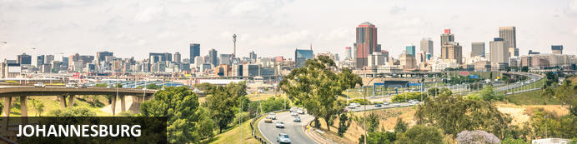
Johannesburg is one of Africa’s biggest and most vibrant cities. It is the economic capital of Africa and the gateway to Southern Africa. Although not as famous as other South African destinations, there is plenty to do in Johannesburg and nearby Pretoria. The old city is a multi-cultural mixture of traditional medicine shops, Chinese restaurants, taxi ranks and ultra modern skyscrapers. There are excellent museums, art galleries and organised tours of historical and political interest. The shopping is Southern Africa’s best and the many restaurants cater for all tastes. The nearby township of Soweto is Johannesburg’s most popular tourist attraction.

Day Itinerary
On arrival at Johannesburg International Airport, you are met by a representative of All About Africa Tours & Travels and assisted to your overnight hotel situated within walking distance of the airport.

Overnight: City Lodge OR Tambo Airport
Based at Africa’s busiest airport, City Lodge Hotel at OR Tambo Airport will provide business and leisure travellers with home away from home accommodation that is ideal for those commuting to and from Johannesburg and perfect for those who require immediate access to the airport. OR Tambo Airport offers a number of services from banking to a wide range of retailers, so whether its a good book or a scrumptious meal, the airports facilities have everything you need. The hotel boasts boardroom and conference facilities, a fitness room as well as a deck with a pool and a large commercial area with a coffee shop.
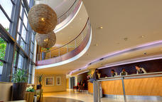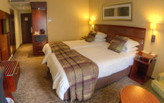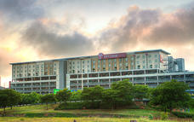

Basis - Bed and Breakfast

Day 2-4: Kapama River Lodge, Kapama Private Game Reserve (Sat, 1 May to Mon, 3 May)

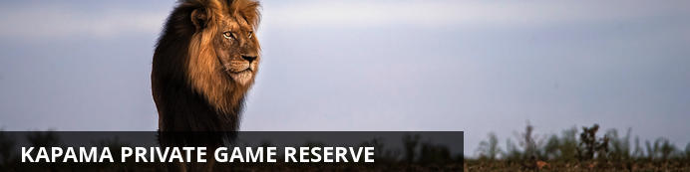
Stretching across 15 000 hectares, towards the Kruger area in South Africa, Kapama Private Game Reserve provides an authentic African safari experience. The reserve provides a range of stylish accommodation across four refined lodges and bush camps. Offering a wide range of options, from a traditional African safari camp to top-notch luxury suites. Kapama is home to the Big Five and is known for its diverse wildlife experiences which can be enjoyed on one of many game drives offering fascinating encounters with plentiful wildlife. Visitors can look forward to a variety of wonderful activities including: excellent game viewing, enjoying a relaxing spa experience and stargazing after a lamp-lit dinner under the African night sky.

Day Itinerary
On arrival at Johannesburg International Airport, you are met by a representative of All About Africa Tours & Travels and assisted to the coach. Transfer to Kapama Game Reserve.

Activities included Game Drive
Across all of Kapama’s lodges, two daily game drives are offered and are included in the tariff. Accompanied by a skilled ranger and tracker, guests can expect to encounter a diverse range of animal and bird species on game drives. Since this is a Big Five reserve, seeing lion, leopard, elephant, rhino and buffalo is possible over a two-day safari in Kapama Private Game Reserve. The day starts with an early wake-up call between 5am and 5:30am. Tea, coffee and rusks are enjoyed together before heading out at first light. While seeing big game is always exhilarating, there are many other smaller species that are also captivating, and birding enthusiasts will be delighted at the approximately 350 species of birds recorded on the reserve. Halfway through the game drive, there’s a stop for hot drinks and snacks, before returning to the lodge at around 9am for a full breakfast. Throughout the day, it’s likely you will see wildlife around the lodge - nyala antelope and vervet monkeys are frequent visitors, though seeing some of the Big Five is also not uncommon. At around 3:30pm, everyone gathers for a decadent high tea, before heading out with your ranger and tracker for the afternoon game drive through the reserve. En route, you’ll stop for a sundowner drink and will have a chance to stretch your legs as you watch the sun set over the distant peaks of the Drakensberg mountains. As darkness falls, the nocturnal animals of the bush come out. The skilled tracker will scan the landscape using a spotlight, which illuminates animals’ eyes. A variety of completely different species can be seen on the night drive back to the lodge. Arrival is at the lodge is usually around 7pm, allowing time to freshen up before enjoying a sumptuous dinner.
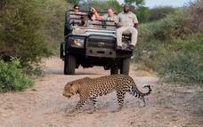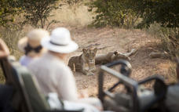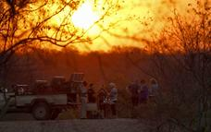

Bush Walks
Feel Africa underfoot on a guided bush walk with a highly trained game ranger. The experience offers an intimate encounter with nature and wildlife, and medicinal and other plants are identified en route. Rangers also teach walkers to track wildlife in the traditional way, using animal footprints and scat. Expert trackers are able to tell the gender of many animals just from their footprints. Large and dangerous animals are avoided on walks, but many other species can be viewed from a safe distance at ground level. A bush walk through Kapama Private Game Reserve is a truly memorable and authentic encounter.

Optional

River Lodge Spa & Wellness Centre
Surrounded by stillness and sweeping bushveld, the Kapama Wellness Centre takes safari spa treatments to new heights. Considered one of the finest safari spas in Africa, the six sumptuous treatment rooms are arranged around a generous central lap pool that evokes a sense of calm.
While Dermalogica and Matisse products are used in the spa, five uniquely created African-inspired treatments are also on the menu to provide rejuvenation and complete relaxation. Soak up the signature four-hour Marula Miracle Moments - which includes a body wrap, facial, massage and more - or opt for other enticingly named treatments such as the Kapama Pinotage Bliss, which uses vine-infused products, or the Marula Sensual Steam Treatment. Various treatments are also available to couples. The luxury safari spa treatment menu includes a full range of body and beauty treatments.
Highly trained and experienced beauty therapists remain abreast of global treatment trends, while giving them a uniquely African twist for Kapama’s Wellness Centre. After your treatment, take a swim in the lap pool or relax under bushveld skies before heading back to your luxury game lodge accommodation.
Alternatively, if you’d like to work up a sweat, the state-of-the-art mini gym is fully equipped. There is both cardio and weight-lifting equipment, depending on if you want to tone or build muscle. What is guaranteed is that a visit to the Wellness Centre will energise and uplift you for the day.

2 Overnight: Kapama River Lodge View iBrochure
Kapama Game Reserve is located in close proximity to Eastgate Airport with the lodge providing open vehicle transfers. Kapama's location in the central Lowveld region creates the perfect base from which to explore the numerous nearby attractions. The northern Drakensberg mountain range provides a majestic backdrop to this contemporary private game lodge in the Greater Kruger National Park region. River lodge is situated within Kapama Game Reserve, and presents the perfect blend between luxurious accommodation and with 64 bedrooms, generous bed capacity. Each of the spacious rooms features a full en-suite bathroom and enjoy uninterrupted views of this game rich, big 5, reserve. The central guest entertainment areas include a swimming pool, lounge, bar, library, curio shop, multifunctional function venue and boma. Meals are of a buffet style and offer a variety of freshly prepared pan African dishes. Rates are based on a fully inclusive experience including dawn and evening safaris in open landrovers conducted by qualified rangers and trackers.

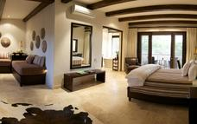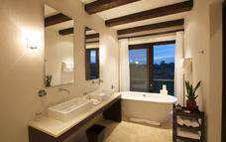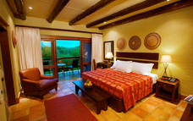

Basis - Full Board Plus - Dinner, Bed, Breakfast, Lunch and Activities

Day 4: Misty Mountain, Mpumalanga Highlands (Mon, 3 May)
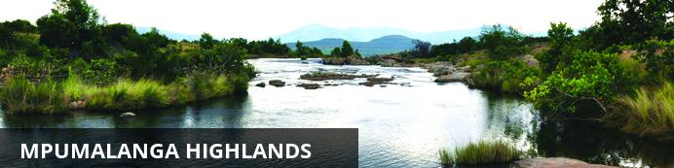
The Highlands of Mpulmalanga are a playground for nature and adventure lovers. A number of charming, high-altitude, grassland villages are scattered on a sea of cattle ranches which are interspersed with numerous trout fishing locations and mountain hideaways. Aside from the trout and quaint towns the highland scenery and flora and fauna are also major attractions.

Day Itinerary
After the morning's game activities and breakfast, transfer via the Panorama Route to the overnight hotel in the Long Tom Pass. Dinner at the hotel. Visit majestic natural sights including God’s Window, Bourke’s Luck Potholes, the Three Rondavels and Blyde River Canyon – the third largest canyon of its kind in the world. This is one of the most scenic routes in the region offering magnificent views, dramatic landscapes and exquisite waterfalls.

Overnight: Misty Mountain View iBrochure
Misty Mountain is a relaxed, informal, family friendly, owner managed establishment. Owned and operated as a lodge by the Sheard family since 1974, Misty Mountain is a place of tranquillity and natural beauty – an ideal place to relax, catch up and get away from it all. Friendly and helpful staff will ensure that you have a memorable stay.
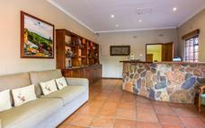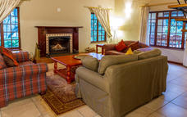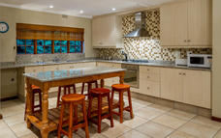

Basis Dinner, Bed and Breakfast

Included: Entrance fees; Lunch at a local restaurant – no drinks

Excluded All beverages to own account: USD 2 - 5 per person

Day 5: Singa Town Lodge, Port Elizabeth (Tue, 4 May)

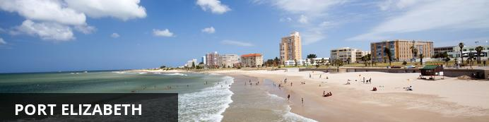
Port Elizabeth or PE is known as the Friendly City and the Windy City and hopefully if you stay here you will get a chance to experience the former and not the latter. Port Elizabeth was established to accommodate British settlers who were bought out on a government sponsored programme to provide a buffer between the warring Cape Dutch and the Xhosa. The little port grew from there and today it is the gateway to the Garden Route, as well as the Eastern Cape’s game reserves and beaches.

Day Itinerary
Transfer to Johannesburg and flight to Port Elizabeth. Here you are met by an English-speaking guide and assisted to your coach and driver. Overnight in Port Elizabeth. Dinner to your own account

Overnight: Singa Town Lodge View iBrochure
Welcome to the gentle seaside city of Port Elizabeth, gateway to both the Garden Route and the Eastern Cape Safari Belt, has always been well-known and well-loved for its relaxed-pace, rejuvenating, traffic-jam-free holiday experiences. In the last few years, return visitors have also been pleasantly surprised by a new era of stylish, luxury accommodation options in Port Elizabeth, lending a swirl of cosmopolitan energy to the friendly city. The latest and most intriguing of these is the new Port Elizabeth Boutique Hotel, Singa Lodge. Named for the mystical dragon-lion of Indonesian mythology, this luxury boutique hotel in PE is one of five select lodges brought to you by Lion Roars Safaris & Lodges, and offers distinctive 5-star accommodation in Port Elizabeth. Setting itself apart from the “every-room-looks-the-same” standardization of the major hotel chains, this luxurious modern fusion of Eastern & African architecture and décor is an artistic masterpiece. Each of the twelve suites at our 5-star boutique hotel is a unique space that not only provides deep comfort, but also inspires and enriches your journey. From the bright sea air of the Port Elizabeth seafront, you are transported into a rich world of texture, colour, vibrant mosaics, opulent fittings and luxuriously appointed rooms, infused with the scent of frangipani blossom and leaf-filtered light. Our tranquil, leafy oasis includes a private gym & holistic treatment room, where you can indulge your body as well as your senses, and rebalance mind and spirit in a truly remarkable space.
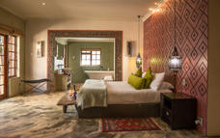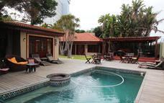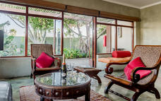

Basis Bed and Breakfast Included Lunch at a local restaurant – no drinks

Excluded Domestic flight JNB - PLZ
Dinner: approx. USD 15-20 per person. All beverages to own account: USD 2 - 5 per person

Day 6: Tsitsikamma Village Inn, Garden Route (Wed, 5 May)
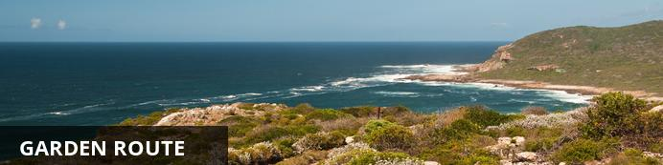
With its great beaches along a narrow strip of fertile land nestled between majestic mountains and the big blue Indian Ocean the Garden Route is one of South Africa’s premier holiday destinations.

Day Itinerary
Depart Port Elizabeth and drive to your next destination on the Garden Route. Check into your hotel. Afternoon at leisure to explore wonderful on-site venues that this little village has to offer. Not to be missed is the micro-brewery, brewing up uniquely local brews available on tap. Afternoon at leisure to explore wonderful on-site venues that this little village has to offer. Not to be missed is the micro-brewery, brewing up uniquely local brews available on tap.

Overnight: Tsitsikamma Village Inn View iBrochure
Tsitsikamma Village Inn, located in the village of Storms River on the beautiful Garden Route, offers a unique form of accommodation. Most of our rooms are situated around a typical Village green. These buildings represent many of the different building styles that were to be found in the Cape Colony during the 1800s. The Oude Martha Restaurant serves hearty and delicious breakfasts, lunches and dinners. Other popular on-site restaurants include the characterful Hunter’s Pub and the informal Cafe Bacchus. Next door to the hotel, is the Marilyn’s 60s Diner, where one can enjoy a trip down memory lane with the vintage motorcycles, cars, memorabilia and a typical diner menu. Enjoy an Ale or Lager in Tsitsikamma Micro Brewery which also offers a number of other South African craft beers. The hotel is a great base from which to explore the natural attractions and adventure options of the region and there are many ways to do this from hiking trails, mountain biking and horse rides to tree-top canopy tours and bungee jumping. Between excursions, guests are welcome to relax around the sparkling swimming pool, visit the hair salon or entertain themselves in the games room. There is complimentary wi-fi access available throughout the hotel. In-room facilities include air-conditioning/heating, electrical blankets, television and a tea/coffee station. The Hotel is renowned for its good food, old world charm and has been a favourite for many a year!
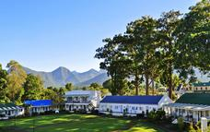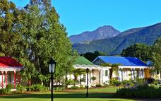

Basis Bed and Breakfast

Included Lunch at a local restaurant – no drinks

Excluded Dinner: approx. USD 10 - 15 per person
All beverages to own account: USD 2 - 5 per person

Day 7: The Robberg Beach Lodge, Plettenberg Bay (Thu, 6 May)
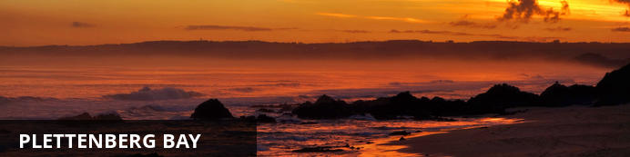
The Portuguese explorers called it the Beautiful Bay, and it’s easy to see why – Plettenberg Bay is a picturesque, charming town with miles of pristine beaches, tranquil lagoons, clean rivers, indigenous forests and a dramatic rocky peninsula. Playground to the wealthy, beach mansions overlook the Indian Ocean, often dotted with luxury yachts, while leisure time is given over to polo and golf, among other things. However, all kinds of visitors will feel at peace here as simply swimming in the warm water on a safe beach is a great way to experience the beauty of Plettenberg Bay.

Day Itinerary
After breakfast depart to the Tsitsikamma National Park. Spend the morning in the park. Lunch may be enjoyed at the restaurant situated directly on the rocks (own account). After lunch depart to Plettenberg Bay. Spend the remainder of the afternoon at leisure on the beach or in the town. Meet for sundowners and dinner to own arrangements.

Beach
Robberg Beach, only a 2- minute walk from the lodge is popular for shore-based dolphin and whale watching, striking views of Robberg Peninsula as well as lengthy strolls. This snow-white sandy beach stretches for kilometres between the Robberg Peninsula and Beacon Island. The beach has lifesavers in season, ablution facilities, a deck, boardwalks and benches as well as chair and umbrella rentals and various parking spots.

2 Overnight: The Robberg Beach Lodge View iBrochure
Robberg House offers guests all the luxuries of penthouse living, just stone's throw from the beach. Enjoy sundowners on the rooftop deck of Robberg House, with panoramic views of the ocean and Robberg Nature Reserve.
Robberg House offers a fresh modern luxury accommodation, with 5 luxury Rooms, 4 Luxury Suites and 1 Luxury View suite in Plettenberg Bay located in Garden Route of South Africa.
Guests are served a full Continental and a full English breakfast at the dining room and the veranda next to the pool of the Beachy Head Villa.
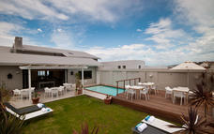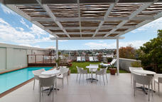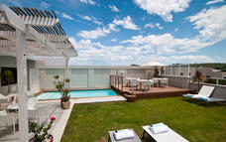

Basis Bed and Breakfast

Included Entrance fees to Tsitsikamma National Park. Lunch at a local restaurant – no drinks

Excluded Dinner: approx. USD 15-20 per person. All beverages to own account: USD 2 - 5 per person

Day 8: The Robberg Beach Lodge, Plettenberg Bay (Fri, 7 May)

Day Itinerary
After breakfast, depart to Knysna to join the ferry to Featherbed Nature Reserve. After lunch, return to Knysna. Spend the afternoon at leisure walking around this quaint village. Optional activities are to your own account and can be arranged. Return to Plettenberg Bay for dinner at leisure and to your own account. Activities – Morning – Featherbed Nature Reserve

Optional – Afternoon – Knysna Lagoon Oyster Tour or Mitchells Brewing

Featherbed Nature Reserve
Featherbed is a privately-owned, registered Nature Reserve and a South African Heritage Site, No.59. It is a pristine piece of paradise situated on the Western Head of Knysna and is accessible by ferry only. In order to protect the splendour of the natural beauty, access to the Reserve is controlled. Numbers are limited and visits are only permitted in the company of the Reserve's specialist guides. This 4-hour excursion departs daily and reservations are essential. It is a wonderful outing for all ages and fitness levels. Good walking shoes are recommended and remember to bring your camera, hats, and sunblock in summer and a warm jacket for the ferry trip in winter. The nature reserve offers Knysna adventure activities not to be missed. A perfect outdoor family holiday activity to be enjoyed by both young and old.
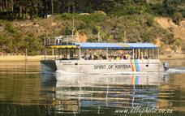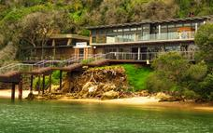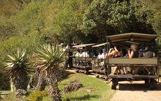

Knysna Lagoon Oyster Tour
The coastal town of Knysna and Oysters go together like champagne and caviar, sea and sky, summer breezes and cold beers. If you're more than a little intrigued by oysters, then join the Knysna Lagoon Tour for the ultimate oyster experience on the spectacular Knysna Lagoon. Learn all there is to know about one of the world's most loved delicacy, taste the difference between wild and cultivated oysters, all whilst cruising the lagoon to the Heads and surrounds.
Ask questions, take photos, excite your taste buds - all on board our "Oyster Boat" with a small group of guests. The cruise includes complimentary local white wine and oysters for tasting. Extra oysters are available on pre-order to enjoy on the boat. Cruise includes an oyster educational experience, complimentary white wine, and half a dozen fresh oysters per person. Cruises depart daily from Whet Restaurant (previously Quay Four Restaurant), on Thesen Island. Please remember your camera, sunblock, sunhat and wind breaker (just in case!) And remember, the boat is perfect for families and children of all ages are welcome.
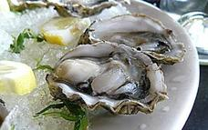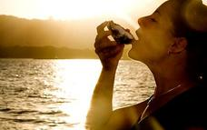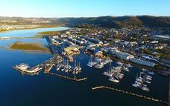

Mitchells Brewing
Mitchell’s Brewery was started in 1983 in Knysna by Lex Mitchell. He started off brewing only Forester’s Lager and Bosun’s Bitter to be distributed in Knysna. Our current brewmaster, Dave McRae, started brewing for Mitchell’s in 1984. Since then five beers have been added to our repertoire and are distributed nationally. This year a pure apple cider joins the Mitchell’s Brewery stable. Our beers are completely natural, made with 100% barley, water, hops and yeast and contain no artificial preservatives or chemicals.

Basis - Bed and Breakfast

Included Featherbed ferry, hike & lunch.

Excluded Dinner: approx. USD 15-20 per person
All beverages to own account: USD 2 - 5 per person

Day 9: Mooiplaas Guest House, Oudtshoorn (Sat, 8 May)
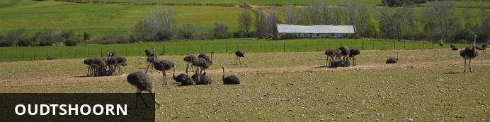
Oudtshoorn is famous for its ostriches and the magnificent Cango Caves. Located along the renowned Route 62, which takes motorists past one awe-inspiring sight after another, Oudtshoorn is known as the Ostrich Capital of the World: these huge birds are almost as common as people in this charming town. Other than ostriches and the wonderful feathers and meat they provide, the Oudtshoorn area also boasts the spectacular Cango Caves; the largest show cave system in Africa, permeated with sparkling stalactites and stalagmites and captivating rock formations.

Day Itinerary
Depart Knysna via the Outeniqua Pass and travel to Oudtshoorn. Continue to hotel for overnight and dinner.

Overnight: Mooiplaas Guest House
Excellent Accommodation with a beautiful view in the heart of the Klein Karoo.
Viljee and Hanlie Keller invite you to experience real peace and tranquillity in their Cape Dutch House. Terrific view, candlelit dinners, ostrich tours etc.
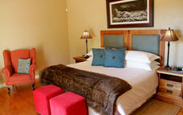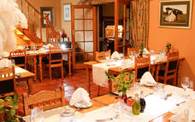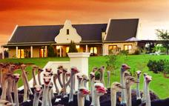

Basis Dinner, Bed and Breakfast Included Tour of the Ostrich farm.
Lunch at a local restaurant – no drinks

Excluded All beverages to own account: USD 2 - 5 per person
******************************************************************************

Day 10: Stellenbosch Hotel, Stellenbosch (Sun, 9 May)
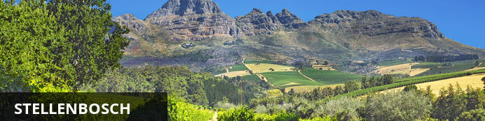
A blend of historical architecture, student life, epicurean delights and oak-lined avenues, Stellenbosch is a picturesque university town surrounded by mountains and vineyards. A walking tour of the town centre allows visitors to take in its beautifully preserved Cape Dutch and Victorian architecture, as well as the many enticing art galleries, craft shops, clothing boutiques and gift stores, while foodies may prefer indulging in mouth-watering cuisine and fine wines at one of the chic restaurants or buzzing bistros. Stellenbosch is also the ideal base from which to explore the renowned local wine route, boasting a high proportion of the country’s leading wine estates.

Day Itinerary
After an early breakfast and check out we drive to the Cango Caves for a 1-hour standard tour of the Caves. Continue on Route 62 to Stellenbosch. Lunch stop en route at a local restaurant.

Activities – Morning – Cango Caves

Cango Caves
The spectacular Cango Caves are a subterranean wonderland of magnificent stalactite and stalagmite rock formations that attracts thousands of visitors annually. They extend more than two kilometres into the Swartberg Mountains and visitors can take guided tours that wind through narrow passageways and steep stairways linking the massive caverns.
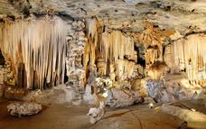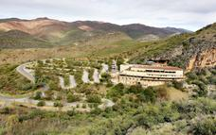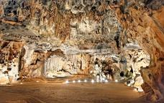

2 Overnight: Stellenbosch Hotel
The Stellenbosch Hotel is a 27 room boutique style hotel that also offers 6 self-catering studio and two-bedroom apartments. The hotel was built on land granted by Gov. Simon van der Stel between 1692 and 1701. The building was restored in 1987 and has been declared a national monument. Breakfast in the morning is served in our famous Jan Cats Restaurant where lunch and dinner can be enjoyed from a range of fine local and foreign dishes offered by our a la Carte menu. The Stellenbosch Hotel is also able to offer conference and banquet facilities for groups up to 80 persons. The TGCSA 3 star hotel is strategically located in the heart of the beautiful and historical town of Stellenbosch. Museums, art galleries and curio shops are all within safe walking distance. It is the ideal destination from which our guests could explore the heart of South Africa's Wine Country, Franschhoek, Paarl , Cape Town with Table Mountain, Cape Point, the Waterfront, the Peninsula and the many other attractions offered by the Western Cape.
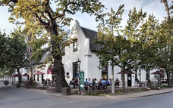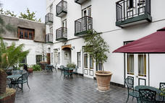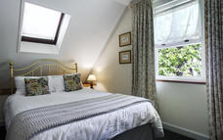

Basis Bed and Breakfast

Included Cango Caves
Lunch at a local restaurant en-route – no drinks

Excluded Dinner: approx. USD 15 - 20 per person
All beverages to own account: USD 2 - 5 per person

Day 11: Stellenbosch Hotel, Stellenbosch (Mon, 10 May)

Day Itinerary
Your day is spent in the surrounding winelands, visiting a number of wine-estates. You are free to choose your own routes and stops and to explore Stellenbosch as much as you like. Dinner at leisure and to your own account.

Activities – Spier Wine Farm Spier Wine Farm
Spier is one of the oldest wine farms in South Africa with a recorded history dating back to 1692. While rooted in this heritage, Spier has a vibrant and conscious energy. Award-winning wine can be paired with fabulous food, grown either on the farm or by nearby farmers. The winery is one of the most awarded in the country and the Spier Hotel and meeting facilities offer inspiring winelands getaways in the tranquility of nature.
Spier is committed to doing the right thing for the environment and communities, and is renowned for its responsible tourism approach. The farm has been recognised by various external organisations including Fair Trade in Tourism (FTTSA) and the Wine Industry Ethical Trade Association (WIETA).
In 2011, Condé Nast Traveler World Saver Award recognised the estate as the top international destination ‘Doing it All’. Spier is a Champion member of the Biodiversity & Wine Initiative (BWI), and the cellar has ISO 22000 certification, is Fair Trade accredited, organically certified and follows the Integrated Production of Wine (IPW) criteria.
Spier’s environmental and social initiatives are many and varied, and include ways to reduce water usage. 100% of its wastewater, and over 80% of its solid waste, is recycled. Spier supports local communities through the treepreneur project, which encourages people in impoverished communities to grow trees in exchange for essential goods. The estate also supports entrepreneurs by helping them create micro-enterprises linked to Spier.
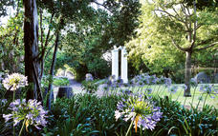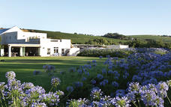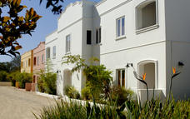

Basis Bed and Breakfast Included Visit to Spier wine-tasting
Lunch at a local restaurant – no drinks Excluded Dinner All beverages to own account: USD 2 - 5 per person
Day 12: City Lodge V&A Waterfront, Cape Town (Tue, 11 May)
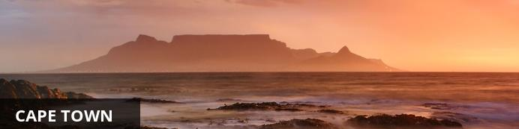
Cape Town is one of the world's most beautiful cities and a top international destination. Large numbers of tourists flock to Cape Town to enjoy this unique city with its fascinating history, interesting culture, natural beauty, award winning wines and laidback lifestyle. Whether you are a serious tourist or just want to lie on the beach and enjoy life, Cape Town will satisfy your needs.

Day Itinerary
Depart Stellenbosch. Continue to Cape Town. You will receive a city orientation tour before checking in to the hotel. Dinner on own account at a restaurant in the V&A Waterfront.

3 Overnight: City Lodge V&A Waterfront
A centrally located hotel at the gateway to the vibrant and dynamic V&A Waterfront, within walking distance of Cape Town’s CBD, close to the N2 motorway and 15 minutes from the international airport. A nautical theme runs through the hotel and a spa-pool is available for guests to relax in the warm Cape weather.
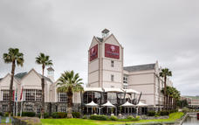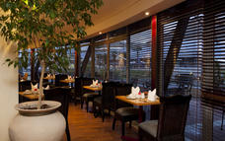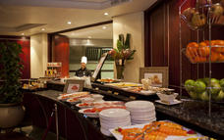

Basis Bed and Breakfast Included Lunch at a local restaurant – no drinks Excluded Dinner
All beverages to own account: USD 2 - 5 per person

Day 13: City Lodge V&A Waterfront, Cape Town (Wed, 12 May) Day Itinerary
After breakfast you meet your guide and driver for a full day tour around Cape Town's beautiful peninsula. This evening you are able to spend at leisure and make your own dinner arrangements.

Activities Cape Peninsula tour - Cape Point and Cape of Good Hope
Visit the Cape of Good Hope National Park, part of the Table Mountain National Park that extends from Signal Hill in the north all the way to Cape Point in the south The Cape of Good Hope is not the southern tip of Africa, despite lying at the south-west corner of the Cape Peninsula, just a little south of Cape Point on the south-east corner. Explore Cape Point with its light house which is a short but steep walk up or hop aboard the funicular and you’ll be whisked away on a scenic trip to the view site near the old Cape Point lighthouse. Over time, the means of transport to the view site changed from a diesel bus, named after the “Flying Dutchman” ghost ship, to an environmentally friendly funicular - the only one of its kind in the world.

Included Entrance fees to Cape Point and Boulders. Lunch at a local restaurant – no drinks. Furnicular train to lighthouse

Excluded Dinner
All beverages to own account: USD 2 - 5 per person

Day 14: City Lodge V&A Waterfront, Cape Town (Thu, 13 May) Day Itinerary
If the weather permits, you will be collected after breakfast and transferred to the Table Mountain Cable Way Station. Spend the morning on Table Mountain. The afternoon is at leisure at the V&A Waterfront for some last-minute souvenir shopping. You may wish to visit the Zeitz Museum which is within walking distance of your hotel. In the later afternoon you gather at the reception and transfer to the Gold Restaurant for your farewell dinner.

Activities – Morning – Table Mountain Dinner – Gold Restaurant Recommended - Afternoon V & A Waterfront

Zeitz Museum Of Contemporary Art Africa
Zeitz Museum of Contemporary Art Africa (Zeitz MOCAA) is a public not-for-profit cultural institution. Their mission is to collect, preserve, research, and exhibit cutting edge contemporary art from Africa and its Diaspora, to develop supporting educational and enrichment programs for all, to encourage intercultural understanding and guarantee access for all. It is the first major museum in Africa dedicated to contemporary art.
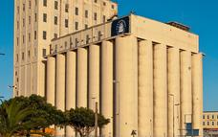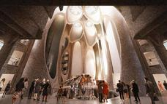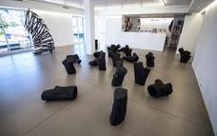

Table Mountain
Without a doubt it is Table Mountain that makes Cape Town the unique city it is. Rising up over 1000m above sea level, it is the icon that makes Cape Town instantly recognizable. It is a symbol, a playground, a spiritual retreat and a big draw card for tourists. So intertwined with the identity of Cape Town is Table Mountain that a visit to the city isn’t complete without having walked or taken the cable car to the top.
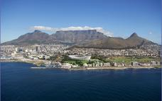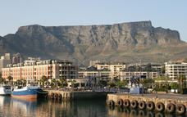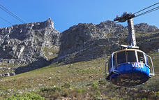

GOLD Restaurant
GOLD Restaurant is a vibrant pan-African experience offering a set Cape Malay and African menu, together with live entertainment and djembe drumming 7 nights a week. Operating from an old warehouse building and a modern function venue, GOLD offers visitors a sophisticated African experience.
Enjoy an award-winning,14-dish tasting menu inspired by ingredients and textures from all over the African continent. Be seduced by live dancing and singing to the rhythmic beating of African djembe drums. Feel part of their tribal community with some optional pre-dinner drumming under the guidance of an experienced facilitator.
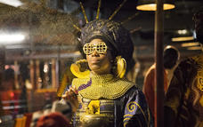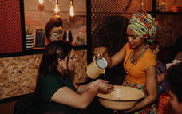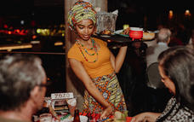

V&A Waterfront
Situated between Robben Island and Table Mountain in the heart of Cape Town's working harbour, the V&A Waterfront has become South Africa's most visited destination. Set against a backdrop of magnificent sea and mountain views, exciting shopping and entertainment venues are intermingled with imaginative office locations, world-class hotels and luxury apartments. The Waterfront is the heart of the tourist industry in Cape Town.
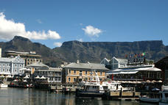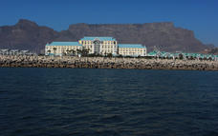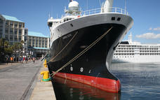

Basis Bed and Breakfast Included Zeitz Museum Entrance fees - Lunch at a local restaurant – no drinks - Dinner at Gold Restaurant Excluded - All beverages to own account: USD 2 - 5 per person

Day 15: End of Itinerary (Fri, 14 May)

Day Itinerary
Last morning in Cape Town. Check out of the hotel, transfer to the airport and return flight home.
COSTS based on 11 persons:
Sharing per person | USD 3,330.00
Single per person | USD 4,150.00
Included:
- 1 night at Johannesburg Airport Hotel on bed & breakfast basis
- 2 nights at Kapama River Lodge with full board, 2 game activities per day & conservation levy
- 2 nights’ accommodation on dinner, bed & breakfast basis
- 9 nights’ accommodation on bed & breakfast basis
- 11 lunches in local restaurants with no drinks
- Accommodation based on standard rooms as per itinerary subject to availability
- Entrance fees to activities and parks mentioned in the itinerary
- Transportation in a minivan (maximum 11 persons) with an English-speaking driver/guide
- 2 safaris per day at Kapama with an English-speaking qualified field guide
- Excursion to Featherbed Nature Reserve includes lunch
- Ostrich Farm Tour
- Cango Caves Heritage Tour
- Dinner in Cape Town at Gold Restaurant including interactive drumming experience
- Funicular to Lighthouse in Capetown
- Zeitz museum entrance fee
- Tips to local driver and guide

Excluded:
- All personal expenses such as beverages, telephone calls, gratuities, curio and laundry
- Travel insurance – highly recommended -
- All meals not stipulated above
- Porterage (will be charged at hotel directly per person as needed)
- All optional items / additional entrance fees not mentioned above
- Visa fees (where applicable)
- All international flights to JOHANNESBURG arriving Johannesburg Airport APRIL 30, 2021 departing Capetown May 14, 2021 and domestic morning flight – APRIL 30 – JOHANNESBURG TO PORT ELIZABETH.

Please note:
- All accommodation is subject to availability. Should any of the accommodation mentioned not be available, we reserve the right to substitute it with an alternative suitable venue.
- Price is subject to currency fluctuations. Should the number of passengers change, the price will differ.
- A non-refundable deposit in the amount of USD400.00 per person by October 2020, balance of payments can be made by installments until March 25, 2021 by check / wire transfer / or CC visa or mastercard.
- Cancellation fees: 10% of tour by January 1, 2021
- 25% of tour by February 1, 2021
- 50% of tour by March 1, 2021
- 100% of tour by March 25, 2021

For further details: www.chinalife.com – www.bonniebraga.com – email: braga.bonnie@gmail.com bonniebraga@msn.com frances@bragatravelconsulting.com – phone: 1305-3824294 – 1305-6069894

Enjoy South Africa.

