BUDAPEST, VIENNA, PRAGUE, OBERAMMERGAU, MUNICH for the Lusitano Club of California – June 16- 28, 2022
June 16, 2022 – Budapest – arrival (Dinner cruise)
Arrival at Budapest airport. Meet and greet by your guide. Transfer to your hotel (with panoramic city tour ). Check-in at the hotel during the afternoon. Rest of the day on your own.
Evening: Private dinner cruise on the Danube ( 2-hour dinner cruise – 3 courses plus ¼ bottle of wine and 1 mineral water)
Radisson Blu Beke (4 étoiles) https://www.danubiushotels.com/fr/hotels-budapest/radisson-blu-beke-hotel
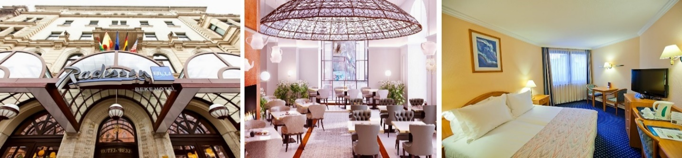
The hotel is located in the centre of the city on the Grand Boulevard, near the Nyugati Railway Station, and only a few steps from Andrássy Avenue. The historical hotel was built at the beginning of the 20th century and is famous for its stained-glass windows and frescoes created by Hungarian artist Jenő Haranghy. It offers 239 air-conditioned rooms and 8 suites, a restaurant with Hungarian- Mediterranean cuisine and a luxury café decorated with Zsolnay ceramics. The building and the equipment was refreshed in 2018.
Day 2 – June 17, 2022 – Budapest (Breakfast)
Breakfast at the hotel. Full day guided tour of Budapest with bus and English-speaking guide. Buda side with Castle District (entry to Mathias Church and Fisherman’s Bastion), Heroes Square, Andrassy Avenue, State Opera, Central Market Hall, St Stephen’s Cathedral, Great Synagogue, Parliament (interior subject to confirmation, Parliament reserves the right to cancel any confirmed visit for diplomatic reasons).
Day 3 – June 18, 2022 – Budapest (Breakfast, Lunch)
Breakfast at the hotel. Full-day excursion to Danube Bend (Visit of Esztergom with the cathedral (Cathedral of Esztergom is under renovation right now, interior visit is not possible. I have no information on the date of re-opening), Visegrád – Royal Fort and Szentendre. Possibility of returning from Szentendre to Budapest with public boat service (this trip depends on water level of the Danube).
Or
Half day excursion to Gödöllő – visit of the Grassalkovich Castle.
Day 4 – June 19, 2022 – Budapest / Vienna
Breakfast at the hotel. Check-out. Bus transfer with English-speaking assistance to Vienna (152 miles approximately 2.5 hours). Drop off at the hotel Hotel Mercure Biedermeier **** - www.mercure.com
Lunch at a nice traditional Austrian Restaurant – 3 course menu no drinks, followed by Walking tour. This walking tour starts at your Hotel. A walk through the historic part of the city with State Opera, Albertina, the newly renovated art gallery, and the famous Hotel Sacher. A short walk awaits you through the small lanes of the historic centre the landmark of Vienna, the St. Stephen’s Cathedral. On the way to Hofburg Palace, the former winter residence of the Habsburg family, we will pass by the monument of the “Plague” and the “House of Loos”. After that you will make a short roundtrip inside the Hofburg area to have a glance at the Royal Treasury, the Spanish Riding School, the Royal Chapel and the National Library. Inside Visit of St. Stephens Cathedral.

Day 5 – June 20, 2022 – Vienna
Breakfast at hotel. 9:30 a.m. Vienna City tour by coach and visit of Schonbrunn Castle (3-4 hours). Free afternoon for shopping and additional sightseeing, opera, concert on your own.

Day 6 – June 21, 2022 – Vienna
Breakfast at hotel. Day trip to Wachau Valley with visit of Melk Abbey and boat ride (7-8 hours)
Departure from your hotel. One of the highlights of your excursion is the visit of the Abbey of Melk, where a guide shows you the interior and the garden of this exciting baroque monument which has always been the spiritual and cultural center of Austria.
Lunch will be served in a cozy restaurant at the River Danube (3 course menu no drinks). There you will enjoy a wonderful view over the River Danube and the vineyards.
Afterwards boat ride to Dürnstein, one of the most historically impressing villages of this valley. Walking tour with your guide through the small lanes. King Richard Lion heart was once imprisoned while waiting for his ransom to arrive from England. Transfer back to Vienna.

Day 7 – June 22, 2022 – Vienna / Prague Breakfast at hotel. 10:00 a.m. depart for Prague. Arrive Prague, drop off luggage at hotel Leonardo 4* - Karoliny Svetle, Prague 1 – Top location, walking distance from Charles Bridge. Lunch on your own. Around 2:30 p.m. half day Prague city tour with English speaking guide including entry to Prague Castle.
Day 8 – June 23, 2022 – Prague
Breakfast at hotel. Full day tour of Cesky Krumlov by private bus with English speaking guide including entry to Krumlov Castle, and lunch at a local restaurant – no drinks.
Day 9 – June 24, 2022 – Prague
Breakfast at hotel. Full day tour to Karlovy Vary by private bus with English speaking guide including entry to Jan Moser Museum, and lunch at a local restaurant – no drinks.
Day 10 – June 25, 2022 – Prague / Munich / Oberammergau
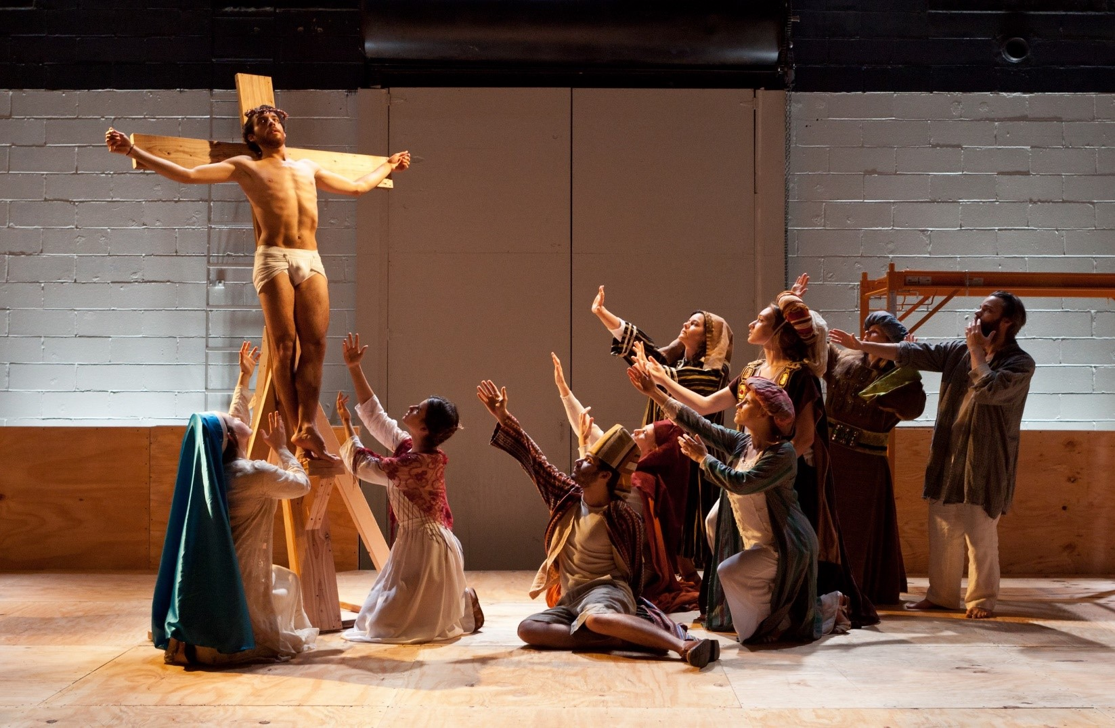
Breakfast at hotel. Around 10:00 a.m. transfer by private bus with English speaking driver from Prague to Oberammergau via Munich. Please make sure to take an overnight bag with you as we will be driving to Hotel in Munich to leave our suitcases - distance 239 miles / 381 km – approximately 5-6 hours. Arrive Munich, drop off your luggage at the Sheraton Arabela Hotel, continue trip to Oberammergau – 78 miles, approximately 90 minutes. Arrive Oberammergau, check-in at hotel. Free evening.
Oberammergau
JUNE 2022

Day 11 – June 26, 2022 – Oberammergau / Munich
Breakfast at hotel. Free morning. Lunch on your own. 11:45 a.m. check-out. 12:00 noon – our bus will pick you up and drop you off at the theater at 12:30 p.m. The hotel will also give you tickets to the Oberammergau Play/Museum. Free Time. From 13:00 admission to the theater.
13:30 – 16:00 Passion Play 1st part 16:30 – 18:30 during the break: dinner (3-course menu.) One drink will be included
Hints: The shops in Oberammergau are open until 20.00. In Oberammergau theater and the center can be reached within a few minutes on foot. Parking is available in front of the village; a shuttle bus is available and runs throughout.
19:00 Beginning of the second half of the play, lasting until 21:30.
Our bus will pick you up at the theater and drop you off in Munich in Arabella Sheraton for 2 nights. Overnight in Hotel. Arrive Munich at around midnight.
Day 12 – June 27, 2022 – Munich Breakfast at hotel. 10:30 a.m. begin our four hour tour followed by lunch at a typical Bavarian Inn in Munich. Free evening for shopping.
Day 13 – June 28, 2022 – Munich / Return Breakfast at hotel. Check-out before 12:00 noon. Transfer to airport for return flight. Enjoy your trip.
Price per person twin / double occupancy: USD4,378.00; single supplement: USD1,379.00

BUDAPEST PRICE INCLUDES:
3 nights 4* hotel Radisson Blu Beke 4* with breakfast; 16 June Transfer airport / hotel – English speaking guide, panoramic sightseeing tour / private 2 hour cruise with 3 course dinner with ¼ bottle of wine, 1 bottle mineral water; June 17 – full day city tour with lunch at a local restaurant; June 18 – transfer hotel / port / hotel for full day tour to Danube Bend or if water does not permit, half day visit to Godolo. June 19 – Transfer out from Budapest to Vienna. Porterage in/out one suitcase per person.
VIENNA PRICE INCLUDES:
3 nights 4* hotel Mercure Biedermeier with breakfast; June 19 – lunch at local restaurant no drinks, followed by walking city tour; June 20 – Half day morning city tour by bus plus visit to Schonbrunn Castle; June 21 – Full day tour to Wachau Valley with visit to Melk Abbey and boat ride, and lunch no drinks; June 22 – bus from Vienna to Prague. Porterage in/out at hotel – one suitcase per person.
PRAGUE PRICE INCLUDES:
3 nights 4* Hotel Leonardo with breakfast; porterage at hotel in/out; half day Prague city-tour with English speaking guide and private transfer (4 hours), entry to Prague Castle; full day tour Cesky Krumlov (private transfer, English speaking guide, entry to Krumlov castle), lunch at a local restaurant no drinks; full day tour to Karlovy Vary (private transfer, English speaking guide, entry to Jan Moser museum0), lunch at a local restaurant no drinks; private transfer Prague / Munich / Oberammergau with English speaking driver guide.

OBERAMMERGAU – MUNICH PRICE INCLUDES:
One night 4* hotel in Oberammergau with breakfast; 2 nights Hotel Arabela Sheraton Munich with breakfast; ticket for Oberammergau Passion play on June 26; dinner no drinks on June 26 during break of Oberammergau; transfer from Oberammergau Passion Play theater to Arabella Sheraton Hotel Munich by private bus, four hour sightseeing tour of Munich and lunch at typical Bavarian Inn in Munich, transfer from hotel in Munich to Munich airport.
Payment conditions:
90 days prior to arrival – 50% of the total amount 60 days prior to arrival – balance of payment.
Cancellation: until 60 days prior to arrival – free cancellation except for Oberammergau which is non-refundable) 59-30 days prior to arrival – 30% of total package 29-15 days prior to arrival – 50% of total package 14-0 days – 100% of total package
ENJOY YOUR TRIP.

