G: 15-day Lhasa, Everest Base Camp & Mt. Kailash Tour

Trip Overview
Mt Kailash Tour is designed for those who are looking for in-deep exploration in main tourists attractions in Tibet with Western Tibet Mt. Kailash for about 2 weeks. Located in the Ngari Region of Tibet, Mt. Kailash and Lake Mansarova are famous as Sacred Mountain and Holy Lake respectively. Both have often been chosen as a sacrificial center for Hindu, Buddhist, and Bonist pilgrims. Their spiritual aura and paradisiacal scenery also entice ordinary visitors.

Highlights:
- Potala Palace: Winter palace of the Dalai Lama
- Jokhang Temple : Spiritual Center for Buddhists in Tibet
- Sera Monastery: One of the “great three” Gelug monasteries of Tibet, the hot attraction is monks debate.
- Drepung Monstery: Drepung used to be a seat of central government until the 5th Dalai Lama built Potala Palace.
- Tashilunpo monastery: The seat of the Panchen Lama.
- Mt. Everest: The highest mountain in the world.
- Mt.Kailaish: the holist place and central of the world recognized by Hindu, Buddhist, and Bonist pilgrims
- Lake Mansarova: the resource of River Brahmaputra, one of the three holy lakes in Tibet.

Outline Itinerary
B=Breakfast D=Dinner
Day Place & Transport Today’s Activities Meals Accommodation

Day 1 Arrive in Lhasa Arrive in Lhasa, airport/train station to
hotel transfer
Potala Palace, Johkang Monastery,
- Economy Hotel

Day 2 Lhasa
Barkor Street, local Tibetan teahouse and welcome dinner
B, D Economy Hotel

Day 3 Lhasa Drepung Monastery，Sera Monastery B Economy Hotel

Day 4 Lhasa -Gyangtse - Shigatse
Yamdrok Lake, Karola Glacier, Pelkor Monastery & Kumbum Stupa, far view of Gyantse Fortress

B Economy Hotel

Day 5 Shigatse - Tingri Tashi Lhunpo Monastery B Tingri Hotel

Day 6 Tingri - Rongbu
Monastery
Far view of Himalaya, Rongpuk
Monastery -
Rongbuk Guest House or Local Tent

Day 7 Everest Base Camp -
Saga
Everest Base Camp - Guest house

------------------------------------------------------------------------------------------------------------------------------------------------------
China Prime Tour
Tel: (0086-773)2823718 Fax (0086-773 ) 2812318 Email: info@chinaprimetour.com www.chinaprimetour.com

Day 8 Saga - Darchen Drive from Saga to Darchen - Guest house

Day 9 Darchen - Drirapuk Trekking day one (Outer circuit):
Darchen to Drirapuk(11km)
Drirapuk - Dzultripuk Trekking day two: Drirapuk to
Day 10
Dzultripuk(22km)
Dzultripuk - Darchen Trek day three: Dzultripuk to Day 11 Darchen(11km)
- Camping or guest house
- Camping or guesthouse
- Camping or guest house

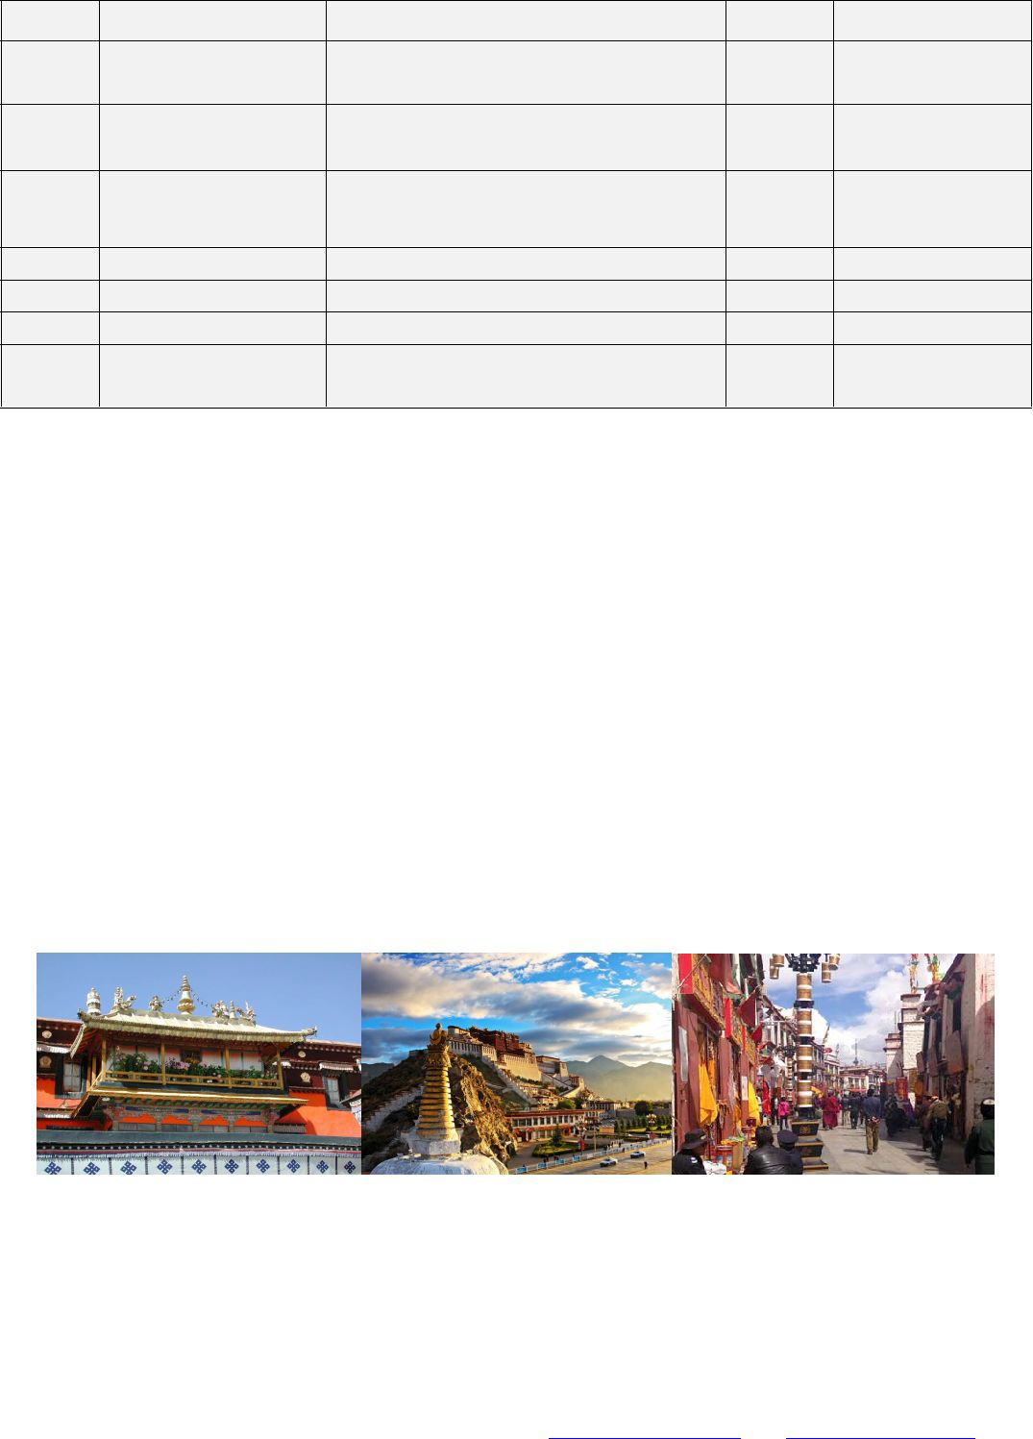
Day 12 Darchen - Saga Drive from Darchen to Saga (530 Km) Guest house Day 13 Saga - Shigatse Drive from Saga to Shigatse - Economy Hotel Day 14 Shigatse - Lhasa Drive from Shigatse to Lhasa B Economy Hotel
Day 15 Lhasa Leave Lhasa for your next destination, Tibet tour ends.
B -

Detailed Itinerary
Day 1 Arrive in Lhasa by plane or by train
You are warmly welcomed to Tibet by saying Tashi Delek at the Train station/airport by our professional employee and send you to reserved hotel in Lhasa. Then have a good rest to acclimatize the high altitude in the afternoon.

Meals included: ——
Hotel: Lhasa YAK Hotel（or other similar Hotel）

Day 2 Lhasa City, Potala Place and Barkhor Street (B, D)
The tour will begin from UNESCO World Heritage site - Potala Palace, which is also the winter palace of Dalai Lama. It's situated at 12,139 feet above sea level. It's a 13-story high building that contains over 1,000 rooms, various statues, stupas, murals and artifacts.
Then continue to Jokhang Temple, another UNESCO World Heritage site. It’s a spiritual center for Buddhists in Tibet. Next to the temple there is Bakhor Street, filled with pilgrims and street vendors, selling traditional Tibetan items such as prayer wheels and jewelry.

Meals included: Breakfast & Dinner
Hotel: Lhasa YAK Hotel （or other similar Hotel）

Day 3 Monasteries in Lhasa, Drepung and Sera (B)
In the morning, you are going to visit Drepung monastery which was one of the “three greet” Gelug

------------------------------------------------------------------------------------------------------------------------------------------------------
China Prime Tour
Tel: (0086-773)2823718 Fax (0086-773 ) 2812318 Email: info@chinaprimetour.com www.chinaprimetour.com

monasteries of Tibet and was founded in 1416. Ganden palace is used as Dalai Lama’s palace in the Drepung before moving to the Potala palace.
Afternoon, Sera Monastery---It was one of the “three great” Gelug monasteries of Tibet and was founded in 1419. The highlight is the Monks debate at around 3 - 5 in the afternoon.

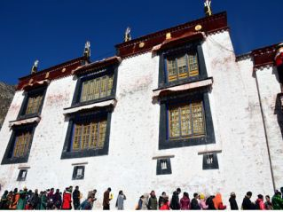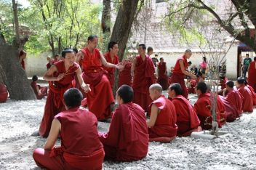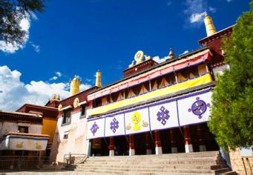
Meals included: Breakfast
Hotel: Lhasa YAK Hotel （or other similar Hotel）

Day 4 Lhasa – Yamdrok Lake – Shigatse (370km, 10 hours’ driving)
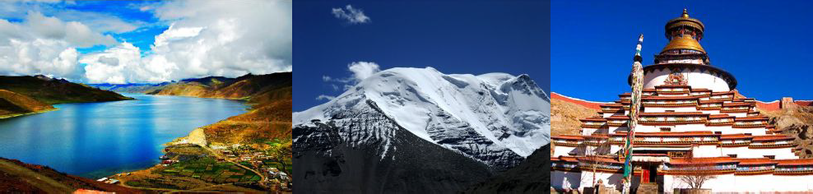
Passing by the green farmland of Nyangchu Valley, Yamdrok Lake, Karola Glacier roadside at 4960m, we move westwards to Tibet's traditional town, Gyantse. The most important attraction for today is Yamdrok Lake, which is shaped like coiling scorpion in deep blue. And we will also visit Pelkor Monastery & Kumbum Stupa, which has a 35m-high chorten (stupa) with its white layers trimmed with decorative stripes and its crown-like golden dome. Today, we drive to Shigatse, which is the second biggest city of Lhasa.
Overnight in Shigatse Meals included: Breakfast
Hotel: Tsangba Hotel（or other similar Hotel）

Day 5 Shigatse - Tingri (290km, 10 hours’ driving)

In Shigatse, you will visit the famous

Tashi Lhunpo Monastery
where you can see the well

preserved largest statue of Jampa (future god) in the world. The monastery itself is abiding place for the successive Penchen Lamas. Then forwards to world highest pass Gyatso-la pass with 5200 m above sea level, and then drive to Tingri, the entrance of Himalayan Nature Reserve.
Meals included: Breakfast
Hotel: 2 star Hotel or Guest House

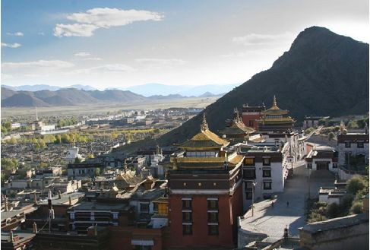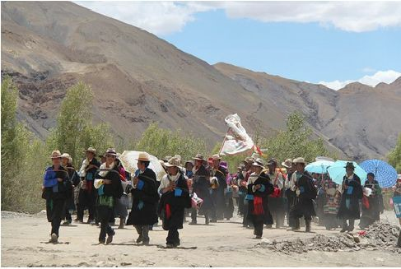

Day 6 Tingri to Rongbuk Monastery and Everest Base Camp (90km, 3 hours’ driving)
There is 2-3hours’ driving from Tingri to Rongpuk Monastery along 90km new winding road in the mountains. On the way from Tingri to E.B.C, you can enjoy the stunning mountain scenery; pass the wild grassland, the torrent and soaring mountains. If it is in clear weather, you can see the panorama of Himalaya range and among mountains you can see 4 mountains which are 8000m high and more to enjoy like Mt. Lhotse (8516m), Mt. Everest (8848m), Mt. Qowowuyag (8201m) and Mt. Mayalu (8463m), and even majestic view of golden summit of Mt. Everest at sunset.

Meals included: Breakfast
Hotel: Rongpuk Monastery (Guest House or local Tibetan Tent)
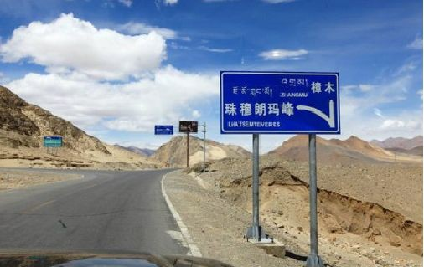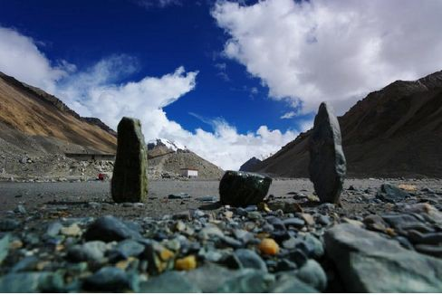

Day 7 Rongpuk Monastery - Everest Base Camp - Saga (460km, 13 hours’ driving)
We need to take the old tingri road to Saga County. From the old Tingri, you can see the Mt. Everest and Mt. Shishapangma, which is 8012 meters high and ranks the 14th among the highest peaks in the world. The road condition worsens from old Tingri and runs parallel to the Himalayan ranges and Nepalian sides called Anapurna ranges. The main road passes through the desolate plain of Digur tang, with its enormous sand dunes and the closely neighboring snow peaks of Shishapangma and Langtang to the south. Leaving the bum-chu basin, it then descends into the depression of Pelkhu tso Lake (4600m), a cobalt blue lake. Today we drive to Saga, a small town 69km from the Phelgu tso.

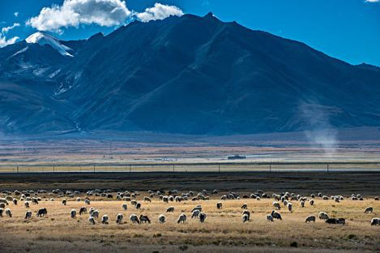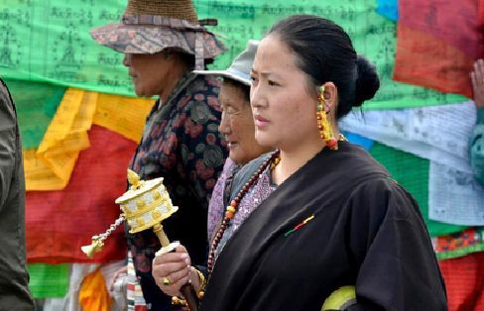

Meals included: ——
Hotel: Saga Local Guest House

Day 8 Saga – Lake Manasarova – Darchen (550km, 14 hours’ driving)
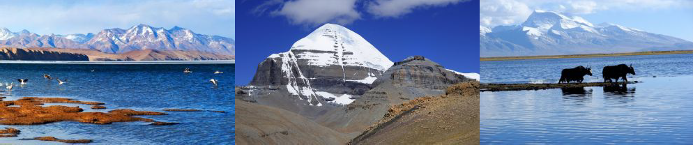
Move towards Drongpa County, the region around the sources of Brahmaputra River, which is about 167km from Saga town. At about 50km from today’s destination Darchen, we will make a small detour to Lake Manasarovar, the holy lake of Tibetan and Hinduism. You can relax around the lake shore and experience the natural beauty of the lake. In the summer time, flocks of swans gather on the lake, bringing grace and life to the area. You can also see so many Tibetans and Hindus praying and circling around the lake shore, and snow-capped mountains, attracting hundreds and thousands of tourists from all over the world. In late afternoon, we will reach Tarchen, a small town at the foot of Mt. Kailash. Tour guide will assist tourists to arrange trekking yaks and porters and make some preparation for your following 3 days’ trekking around Mt. Kailash.
Overnight at local guesthouse in Darchen Town Meals included: ——
Hotel: Local Guest House

Day 9 Trek Day One: Darchen – Drirapuk (20km, 6.5 hours)
Traditionally pilgrims undertake 52 km long trekking circuiting around Mt. Kailash. The trekking commences at Darchen (4574m) and goes across the Dolma-la pass on the second day of the three day walk. After leaving Darchen by environment-friendly bus (8 km, 40minutes), we get to a village called Sarshung, where porters are waiting for their clients. After two hours, we come upon a grassy plain populated by nomads. For this turn in the valley it is another two hours at least before reaching Drirapuk (4920m). You need to camp or can rest in monastery's guest house made from cement with a few good facilities than others in Drirapuk. At the opposite side of Drirapuk, there

you can see small monastery with its guest house little cleaner than others. Stay overnight at the tent guesthouse of monastery
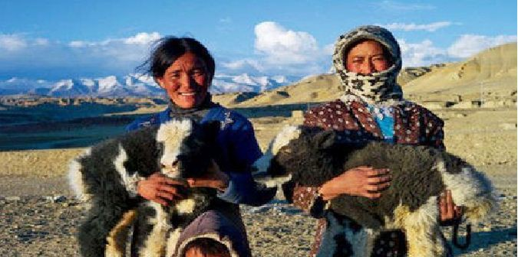
Meals included: —— Hotel: Local Guest House

Day 10 Trek day two: Drirapuk – Dzultripuk (18km, 7-8hours)
The second day is the hardest and toughest circuit with the Dolma-la pass lying 6.4km ahead but 762m above Drirapuk. The peak of Dolma-la pass is about 5630m above sea level, so it is better to set off early in the morning as the sun rays break over the ridges above. After taking a rest at the peak of Dolma-la pass, you will descend staircase to Lhachu valley floor and take about one hour from the pass. From here there is still four hours’ trekking with no shelters on the way to today's final destination. It is better to walk on the right side of the river and finally you get to Dzultripuk (with miracle cave of milarepa). It is advisable to get there before other groups because limited numbers of rooms are available there in Dzultripuk. Take a good rest in the guest room and prepare for next morning's departure.
Stay overnight at the tent guesthouse of monastery Meals included: ——
Hotel: Local Guest House
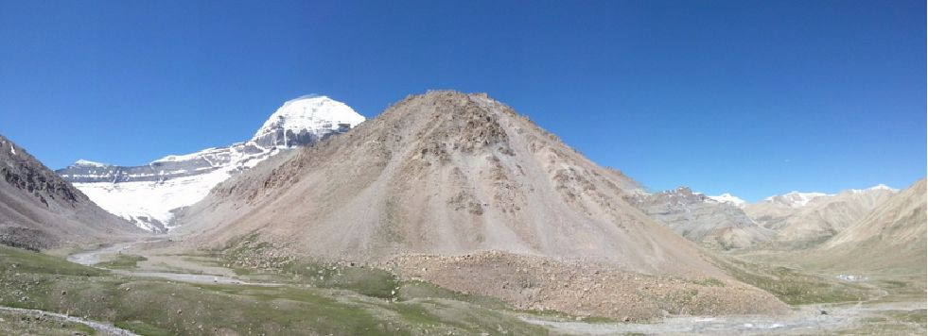

Day 11 Trek day three: Dzultripuk – Darchen (14km, 3-4hours)
Today, you will go through Milarepa's cave, where the temple and shrines have been built around. Then you walk back to Darchen is easy and the exit from the valley can be reached within three hours. At the ending point of the valley, the driver will come to pick you up and take you back to Darchen.
Stay overnight at the local guesthouse at Darchen Meals included: ——
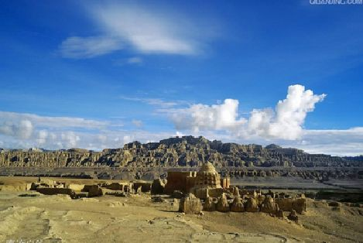
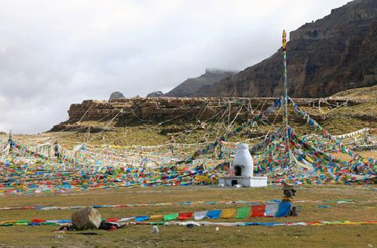
Hotel: Local Guest House

Day 12 Drive from Darchen to Saga (530Km, 14 hours)
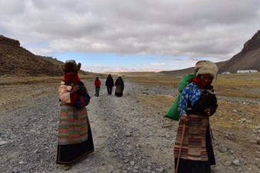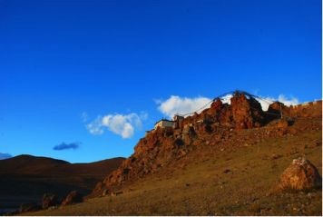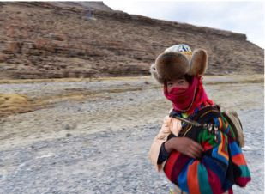Drive from Darchen to Saga. Meals included: —— Hotel: Local Guest House

Day 13-14 Saga – Shigatse –Lhasa (750km, 2 days)
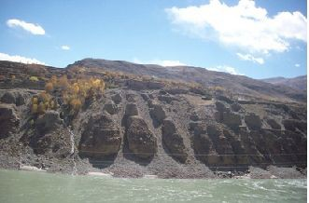
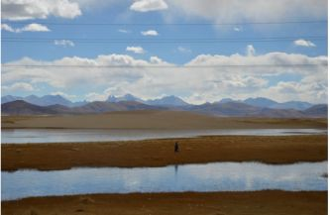
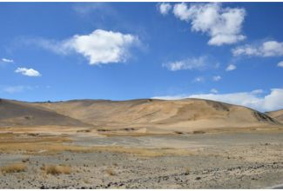
Drive back to Lhasa via Shigatse.

Day 15 Depart from Lhasa (B) Transfer to Lhasa airport or train station. Service ends.
Meals included: Breakfast

Services Included
- All necessary travel permits for Tibet (excluding Chinese visa);
- Professional Tibetan English speaking tour guide;
- Admission fee of all tourist sites listed in above itinerary;
- Tourist bus/minibus with local driver for transportation between airport/train station and Hotel at designated period of time;
- Tour Transfers with 4WD or Mini Van or Tourist Bus according to Group Size and seasons;
- Accommodation of 5 nights (3 star hotel) with daily breakfast in major cities: Lhasa/Shigatse/Old tingri; Basic guest house in remote area or while trekking;
- Environmental bus between Rongbuk Monastery and EBC;
- Welcome Tibetan dinner;
- Oxygen bottles provided during the tour days in Tibet.

Services Excluded
- China Visa;
- Lunches and Dinners;
- Breakfast at Rongpuk Saga and Darchen is not included;
- Porters, trekking animals ( Yaks) during the trekking;
- Tips to guide and driver;
- Insurance;
- Other personal expense;
- Any air tickets/ train tickets.

Important Notes:
- Our free airport--Hotel transfer are based on bus transfers on below timings: Lhasa airport--hotel: 12:20 noon, 4:00 pm
Hotel--Lhasa airport: 07:30 am; 11:00 am
If you miss the above timing, or if your flight cannot match the above time, or if your flight delay, or if you dont want to wait for other people, or if you prefer your own private transfer, we can arrange the following for you at extra cost:
500 Yuan/per taxi with guide for airport--hotel or vise verse (all year);
650 Yuan/per 5 seats Chinese business van with guide for airport--hotel or vise verse(all year except July--Oct)
750 Yuan/per 5 seats Chinese business van with guide for airport--hotel or vise verse (July--Oct)
--please note transfers include tour guide is per government requirement.

- Lhasa train station--hotel in Lhasa transfer is free on tour date
If you miss the above timing, or if your train cannot match the above time, or if your train delay,

or if you dont want to wait for other people, or if you prefer your own private transfer, we can arrange the following for you at extra cost:
350 Yuan/per taxi with guide for train station--hotel or vise verse (all year);
480 Yuan/per 5 seats Chinese business van with guide for train station --hotel or vise verse(all year except July--Oct)
580 Yuan/per 5 seats Chinese business van with guide for train station --hotel or vise verse (July--Oct)
--please note transfers include tour guide is per government requirement.

- We can upgrade your hotel with extra cost.

Tashi Delek & Enjoy Tibet and Tibetan culture!

