- GREECE family Vacations

- 10 Days - 09 Nights Athens - Mykonos - Santorini
The most perfect island hopping combination!

- 5 Days – 4 Nights Athens
Travel in Athens, the capital of Greece!
3 Days – 2 Nights Athens
Discover Athens on a fast mode trip!

- 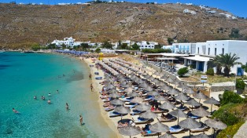7 Days-6 Nights (3 nights Athens-3 nights Mykonos)
Meet Athens & the wind island of Mykonos!
7 Days - 6 Nights Athens & Mainland (Olympia, Delphi, Meteora)
A week in Greece! Athens & Countryside!
6 Days - 5 Nights Athens & Classical Tour (Mainland)
A unique trip, getting know Athens, Olympia & Delphi!

ACTIVITY TOURS
- 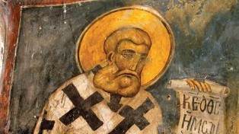Steps of St. Paul
Follow the route of St.Paul in Greece!

- Santorini Volcano Tour
Visiting the volcano island of the ancient times!

WEDDINGS – HONEYMOONS
Weddings - Honeymoon

Weddings - Honeymoon
The most important and harmony way of a couple releationship! Discover the best packages for making a wedding trip, or plan a honeymoon 08 Days | 07 Nights Honeymoon trip!
2 Nights Athens, 03 Nights Cruise & 02 Nights Santorini

- Create the perfect wedding plan!
Let us "design" on travelling style the wedding scenario of your best day in Life!
ISLAND HOPPING

- 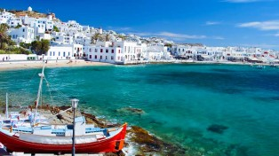08 Days/07 Nights (Athens - Mykonos - Santorini)
Magical Trip!

- 07 Days | 06 Nights Athens - Paros
Meet Athens & Paros! 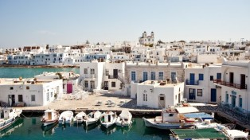

- 7 Days-6 Nights (3 nights Athens-3 nights Mykonos)
Meet Athens & the wind island of Mykonos!
8 Days - 7 Nights (3 Nights Athens -2 Nights Rhodos-2 nights Kos)
The Dodecannese breeze!
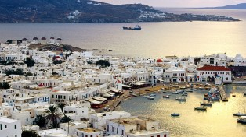07 Days | 06 Nights Athens - Mykonos - Santorini
A Pure Image of Greece!

