CLIENT LUSITANO CLUB OF CALIFORNIA
DATE 1-10 OCTOBER 2018
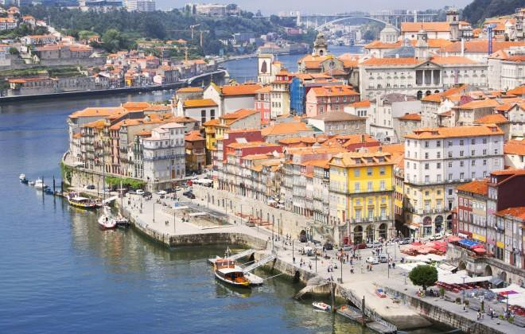
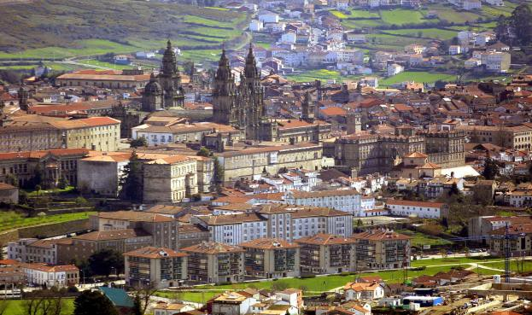
PORTUGAL & SPAIN
1ST DAY – 1 OCTOBER 2018 PORTO
Arrival Porto. Meet and Great at Porto Airport. Transfer from Airport to Hotel, in Porto.
Porto - Capital and gateway to the north of Portugal, Porto is both the city that provided a nation with a name and a fortified wine known world-wide: port. With its splendid geographical location on the mouth of the river Douro and an architectural heritage of exceptional quality, the historic centre of Porto was declared UNESCO World Heritage in 1996.
Check In. Dinner and Overnight .

2ND DAY – 2 OCTOBER 2018
PORTO – ILHAVO – AVEIRO – VISEU (+/- 180 km)

Breakfast at hotel. Check out hotel in Porto and departure in direction to Ílhavo - formerly called Illabum which is believed to have been originally settled by the Greeks. Visit the Vista Alegre Factory that for 170 years has been producing world famous porcelain. The factory features a museum, stores and an interesting complex of industrial buildings dotted along the banks of the river providing a truly worthy stop off on any tour of the region. After lunch, departure to Aveiro
- is intersected by canals, genuine streets of water, along which can be seen gliding the brightly coloured boats known as barcos moliceiros. In the afternoon, we suggest the group to do 2 activities: Ria Waterways on a Moliceiro boat and do a Pastry Workshop of “ovos moles” (typical pastry). Departure in direction to Viseu, that still retains a medieval feel to what was once a walled centre and has been an important crossroads since Roman times. Arrival Hotel in Viseu. Check In. Dinner and Overnight .

3RD DAY – 3 OCTOBER 2018
VISEU – CIUDAD RODRIGO - SALAMANCA (+/- 200 km)
Breakfast at hotel. Viseu Sightseeing tour in the morning. Check Out Hotel and departure Portugal in direction Spain.
Our first stop will be to Ciudad Rodrigo - which has Historic-Artistic Site status, is a famous fortified town situated in the west of the province of Salamanca. Its walls enclose a rich heritage of civic and religious buildings, the most important of which are the Cathedral and the Castle. Panoramic visit and free time. Further on , departure in direction to Salamanca.
Check In hotel in Salamanca. Dinner and Overnight .

4TH DAY – 4 OCTOBER 2018
SALAMANCA – ZAMORA –SANTIAGO DE COMPOSTELA (+/- 450 km)

Breakfast at hotel. Sightseeing tour in the morning. Check out hotel and departure in direction to Zamora.
Stop and panoramic visit of the city of Zamora , preserves in its old town an important legacy of Romanesque art, which has earned it the declaration of Historic-Artistic site. Set on the banks of the River Duero and right on the Via de la Plata (Silver Road) route, its medieval importance has left a mark in the shape of walls, palaces and churches. Departure in direction to Santiago de Compostela, through Via de la Plata - the longest of the pilgrim routes in Spain, starting from Seville in Andalucia, and running northwards through the provinces of Extremadura and Castilla y Leon to Salamanca and Zamora. The day will end in Santiago de Compostela - The final stop on the epic Camino de Santiago pilgrimage trail.
Check In Hotel in Santiago de Compostela. Dinner and Overnight .

5TH DAY – 5 OCTOBER 2018 SANTIAGO DE COMPOSTELA

Breakfast at hotel.
Morning visit to Santiago de Compostela. Take a city tour of this legendary pilgrimage town and visit sites such as Plaza del Obradoiro and the imposing Cathedral, said to be burial site of one of the apostles of Jesus. You will have the afternoon free to explore on your own.
Dinner and Overnight at hotel.

6TH DAY – 6 OCTOBER 2018
SANTIAGO - PONTEVEDRA - VIGO – BAIONA – MONÇÃO - VALENÇA – PONTE LIMA (+/- 250 km)

Breakfast at hotel. Check out hotel and departure in direction to Pontevedra, a city with a long maritime and trading tradition, boasts one of the largest and most elegant historic quarters in the whole of Galicia. Situated on the edge of the estuary of the same name, the old town extends in a network of streets and squares and contains major civic and religious buildings. Panoramic city tour. Our next stop will be in Vigo - a historic and cultured city or a gritty industrial port. Home to Europe's largest fishing fleet, this is an axis of commerce in northern Spain. Free time to have a coffee. Departure Vigo in direction to the magestic Baiona, from where the discovery of America was announced to the world. Leaving Spain , and returning to Portugal. Our first stop will be Monção - Further on, in direction to Monção - once an important fortification along the border with Spain. The town’s big claim to fame is its fine vinho verde, with signs touting Monção as the cradle of the refreshing Alvarinho wine. Valença do Minho – breath the air of this atmospheric fort village above the picturesque River Minho. Brief stop. Departure in direction to Ponte de Lima - photogenic town by the sweet and mellow Rio Lima, the small historic centre dotted with cafes and vast riverside gardens and greenways. Check In hotel in Ponte de Lima. Free time. Dinner and Overnight .

7TH DAY – 7 OCTOBER 2018
PONTE LIMA – VIANA CASTELO – PÓVOA VARZIM - GUIMARÃES – DOURO VALLEY (+/- 240 km)

Breakfast at hotel. Sightseeing & panoramic tour during morning.
Check out hotel and departure in direction to Viana do Castelo - the jewel of the Costa Verde, Viana do Castelo is blessed with both an appealing medieval centre and lovely beaches just outside the city – we highlight the Ofir beach. Next stop will be Póvoa de Varzim, a city that sits in a sandy coastal plain, a cuspate foreland, halfway between the Minho and Douro rivers. Departure in direction to Guimarães – the historic town centre is listed as UNESCO World Heritage Site since 2001, in recognition for being an "exceptionally well-preserved and authentic example of the evolution of a medieval settlement into a modern town" in Europe. Departing Guimarães and head onto Douro Valley - the oldest demarcated wine region in the world.
Check In hotel in the Douro Valley area. Free time. Dinner and Overnight .

8TH DAY – 8 OCTOBER 2018 DOURO VALLEY

Breakfast at hotel.
Morning Visit, wine tasting and lunch at Quinta da Pacheca – Wine tasting, visit and lunch. At Quinta da Pacheca, set onto majestic Douro Valley is possible to discover all the richness of Douro Valley Region. Guided on the estate you will discover our history and winemaking process. Afternoon cruise in river Douro. By the end of the day, return to hotel. Free time.
Dinner and Overnight .

9TH DAY – 9 OCTOBER 2018
DOURO VALLEY – VILA REAL - PORTO (+/- 130 km)

Breakfast at hotel. Check out hotel.
Return to the Departure in direction to Vila Real.
Visit Palace and Gardens de Casa de Mateus - built in the first half of the 18th century by António José Botelho Mourão, 3rd Morgado de Mateus. This replaced the former family house which had stood on the site since the beginning of the 17th century. In 1910, it was classified as a National Monument. Lunch at a local restaurant. Departure in direction to Porto.
Check In hotel in Porto. Free time. Dinner and Overnight .

10TH DAY – 10 OCTOBER PORTO
Breakfast at hotel. Free morning to enjoy te city. Transfer from hotel in Porto to Porto Airport.
QUOTATION - PRICE PER PERSON, MINIMUM 20 PAX
Price per person - Double/Twin room in HB basis: 2.642,00 €uros = USD3366.00
Single supplement in HB Basis: 588,00 €uros = USD749.00
*please note that most hotels do not have available extra bed for adults only for children under 12 y.o.

Inclusions:
English speaking guide during the whole Itinerary
Transport by air conditioned bus, as per detailed itinerary (bus with 53 seats)
Accommodation in 4* OR 5* hotels (depending the city) on half board bases (breakfast and dinner) – with the exception of arrival day. Accommodation is only in BB basis. - Suppleent for dinner, per person, from € 35,00 -
Dinner at hotels can be Buffet or Set Menu and include beverages Porterage at hotels (in & out)
Lunch in local restaurants: 01xÍlhavo, 01xCiudad Rodrigo, 01xZamora, 01xSantiago de Compostela, 01xMonção, 01xGuimarães, 01xQuinta da Pacheca, 01xVila Real
Lunch: 03 course menu (starter, main course, dessert) and beverages (01 per pax) ; same menu for the whole group. Exception are pax with food restrictions (example: in a group of 40 pax, maximum 10%, total 4 pax). If the number is superior, the menu will be subject to additional charges.
Entrance fees at below monuments: Guimarães: Castle, Santiago de Compostela: Catedral, Viana do Castelo: Catedral do Monte de Santa Luzia, Ria de Aveiro: Ria Waterways on a Moliceiro boat, Pastry Workshop of “ovos moles”, Casa de Mateus (visita Palace and Gardens)

Exclusions:
Personal expenses and gratuities; Accommodation City tax , All other items not mentioned in the “Inclusions” item

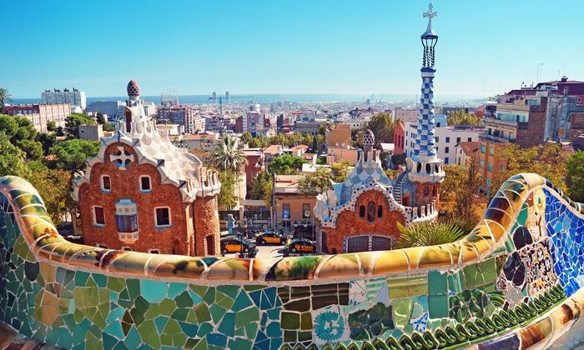
BARCELONA
11ST DAY – 11ST OCTOBER PORTO > BARCELONA

Breakfast at hotel. Free morning to enjoy te city.
By the end of the morning, departure in direction to the Airport
- We suggest flights:
- TP 1947 OPOLIS 1430 1530
- TP 1036 LISBCN 1635 1925
Arrival Barcelona. Transfer Airport to Hotel. Check In hotel in Barcelona. Dinner and Overnight.

12TH DAY – 12OCTOBER
Breakfast in the hotel . Departure for a morning sightseeing tour. As a highlight, admire the exterior of Gaudi’s unfinished masterpiece, the breathtakingly Holy Family Cathedral, known locally as La Sagrada Familia. Free time for lunch. In the afternoon, visit Parc Guell is a UNESCO World Heritage Site and is considered to one of Gaudi’s most artistic works, Barcelona top attraction and must-see. Stop by the Barrio Gotico, the gothic quarter is the medieval city of Barcelona which is the oldest area. Continue the Modernisme was a Catalan cultural movement, it is most famous for its architectural expression in particular the many works of Antoni Gaudi. Return the Hotel. Dinner and Overnight at hotel

13TH DAY – 13 OCTOBER
Morning Sightseeing tour (04 hours), 09h00-13h00
Visit La Pedrera is one of the most imaginative and creative works that Gaudi has accomplished. It was declared a World Heritage Site. After that, view the Las Ramblas shopping street, Catalonia Square,
Columbus Monument and impressive 1992 Summer Olympic site. Enjoy half free day to explore in Barcelona. Free afternoon . Dinner and Overnight at hotel.

14TH DAY – 14 OCTOBER
Transfer from hotel in Barcelona to Barcelona Airport. Group will take flight back home.

QUOTATION - PRICE PER PERSON, MINIMUM 10 PAX ---- 4* HOTEL
Price per person - Double/Twin room in HB basis: 853,00 €uros = USD1087.00
Single supplement in HB Basis: 471,00 €uros = USD600.00
*please note that most hotels do not have available extra bed for adults only for children under 12 y.o.

Inclusions:
English speaking guide & Transport by air conditioned bus, as per detailed itinerary;
Accommodation in 4* on half board bases (breakfast and dinner) ; Dinner at hotel can be Buffet or Set Menu and include beverages Porterage at hotel : Lunch while touring , local restaurants
Entrance fees at below monuments: Barcelona: Sagrada Familia, Park Güell, and Pedrera in Barcelona (excluding eventual photo rights)

Exclusions:
Personal expenses and gratuities Accommodation city tax
Flight ticket Porto to Barcelona
All other items not mentioned in the “Inclusions” item

