

# Johannesburg & Botswana Tour – 9 nights / 10 days

-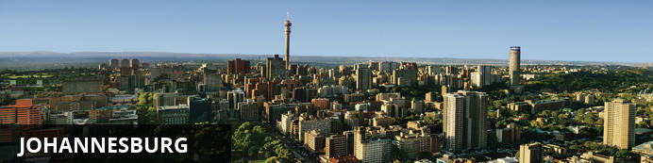

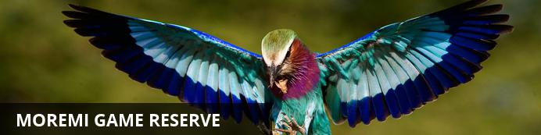

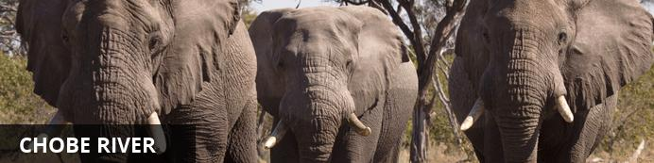

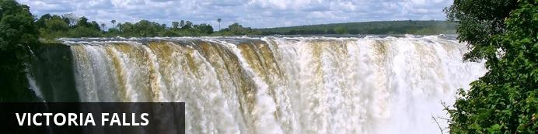

# Johannesburg & Botswana Tour

*Johannesburg - Moremi Game Reserve - Chobe River - Victoria Falls*  
*10 Days / 9 Nights- 2 Persons*

*Date of Issue: 09 June 2014*  
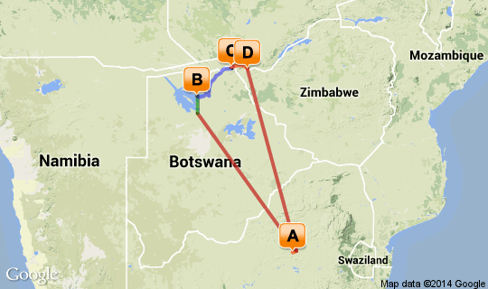

# [Click here to view your Digital Itinerary](http://wetu.com/Itinerary/VI/417495A4-D975-E992-927B-80ACF3EDFB3C)

**Overview**

|  |  |  |  |  |
| --- | --- | --- | --- | --- |
| **Destination** | **Accommodation** | **Nights** | **Basis** | **Room Type** |
| Johannesburg | Sunnyside Park Hotel | 2 | B&B | 1x Double Room |
| Moremi Game Reserve | Camp Xakanaxa | 3 | FI | 1x Double Room |
| Chobe River | Chobe Game Lodge | 2 | FI | 1x Double Room |
| Victoria Falls | [The Zambezi Sun Hotel](http://wetu.com/iBrochure/3688_1481) | 2 | B&B | 1x Double Room |

## Day 1: Sunnyside Park Hotel, Johannesburg

### Johannesburg

Johannesburg is one of Africa’s biggest and most vibrant cities. It is the economic capital of Africa and the gateway to Southern Africa. Although not as famous as other South African destinations, there is plenty to do in Johannesburg and nearby Pretoria. The old city is a multi-cultural mixture of traditional medicine shops, Chinese restaurants, taxi ranks and ultra modern skyscrapers. There are excellent museums, art galleries and organised tours of historical and political interest.

### Day Notes

Meet and Greet on arrival into OR Tambo airport, Johannesburg and transfer to your hotel.   
Remainder of the afternoon at leisure, with dinner in the hotel

### Overnight: Sunnyside Park Hotel

The Sunnyside Park Hotel combines the charm and grace of a bygone era with the amenities of the 21st centuary to offer you a hotel that perfectly melds romantic dreams of a time when things were simpler. The Sunnyside offers all the facilities needed to compete in a fast-paced world. Originally built in 1895, this Victorian-style hotel has been completely refurbished and will ensure that your every desire is catered for.

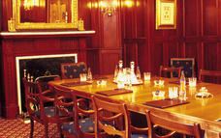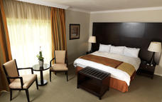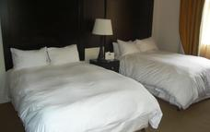

### Included - Bed & Breakfast

## Day 2: Sunnyside Park Hotel, Johannesburg

### Activities

Soweto Day Tour

#### Soweto Day Tour

A Soweto Day Tours takes in the highlights of this iconic township including Nelson Mandela’s former home and the Hector Pieterson museum (he was one of the school children who was shot in the 1976 Soweto Uprising).  
You will get close to Soweto Culture, meeting the people, trying local foods and maybe even some Omqombothi (our traditional beer) at a shebeen. This tour is one of a kind, the smell of pavement cooked meals and the buzz in the streets of people going about their daily chores. Come and experience township life, the humanity, hospitality and warmth of the people, the "Ubuntu" as it is known in South Africa.

### Included - Bed & Breakfast

## Day 3: Camp Xakanaxa, Moremi Game Reserve

### Moremi Game Reserve

The amazing foresight of Chief Moremi created one of the world's most famous reserves, conserving part of the Okavango Delta and the plains to its east. The reserve covers more than 4871 square kilometres of pristine wilderness, and the varied terrain includes savannah, winding waterways, and thick forest.

### Day Notes

Transfer to the airport where your guide will assist with check-in for your flight to Maun. (Main luggage may be left securely at the airport for later collection).  
On arrival at Maun, after clearing customs and immigration, you will be met by a representative from Desert & Delta who will take you through formalities and lead you to the small private aircraft used for accessing the lodges.  
Time of departure will be advised on confirmation of booking.  
After a short flight you will land at the lodge airstrip and be transferred to the lodge.

### Overnight: Camp Xakanaxa

Xakanaxa Camp has 12 rooms, accommodating 24 people and is set in the Moremi Game Reserve which makes up almost one-third of the entire Okavango Delta. With the Khwai River flowing directly past the camp, it is ideally placed for an authentic year round Delta land and water safari experience. Sensational safari and birding activities, the spectacular location, excellent cuisine and luxury accommodation combine to ensure a truly memorable stay in Botswana.

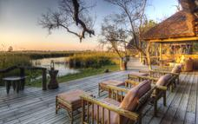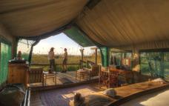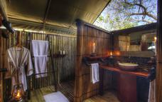

### Included Fully Inclusive

## Day 4: Camp Xakanaxa, Moremi Game Reserve

### Day Notes

Game drives and other activities at the lodge  
**Activities Include:**   
Game drives in open Land Rovers. (Four 10 seater Land Rovers are available. However only 6/8 guests are accommodated per vehicle) Water game viewing in mokoros in conjunction with powerboat exploration of the Okavango. This activity is of a 30-minute duration and is done in conjunction with a powerboat exploration of the Okavango. (Four Mokoro each seating two guests) Power boating available year round (Three x 8-seater boats)

### Included- Fully Inclusive

## Day 5: Camp Xakanaxa, Moremi Game Reserve

### Included- Fully Inclusive

## Day 6: Chobe Game Lodge, Chobe River

### Chobe River

The Chobe River forms the northern boundary of the Chobe National Park, renowned for its reliable and diverse game viewing. Safaris are conducted both by boat and on land. This section of the park is best known for its elephant and hippo populations but the waters attract all manner of game including large herds of buffalo and the lions that prey on them.

### Day Notes

Fly from the lodge to Kasane where you will be met on arrival by staff from Chobe Game Lodge.

The lodge accommodates up to 94 guests in absolute luxury. Rooms are river-facing, and include minibars, en-suite bathrooms, tea and coffee making facilities as well as private terraces. In addition, four exclusive suites have their own plunge pools and separate lounges.

There are three safari activities on offer every day. Stays at Chobe Game Lodge are fully inclusive, so you are welcome to do as little or as much as you please.

### Overnight: Chobe Game Lodge

Counter-balancing the wilderness are restful, air conditioned, en-suite lodgings. Graceful high arches, quarry tiled floors and barrel vaulted ceilings create an atmosphere of cool tranquillity. Other facilities include a large swimming pool with terrace, a riverside boma area, and a fully equipped conference room, a business centre for those guests needing to keep in touch, a stylish bar with an outside terrace overlooking the Chobe River and a cigar bar with a full sized billiard table. Meals are catered for at the terrace restaurant overlooking the Chobe River.

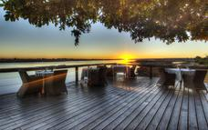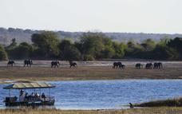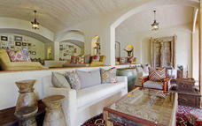

### Included - Fully Inclusive

## Day 7: Chobe Game Lodge, Chobe River

### Included - Fully Inclusive

## Day 8: The Zambezi Sun Hotel, Victoria Falls

### Victoria Falls

One of the original natural wonders of the world, the Victoria Falls is a World Heritage Site and an extremely popular tourism attraction. Known locally as ‘The Smoke that Thunders’ this spectacle is accessible from both Zambia and Zimbabwe and it is an ideal place to combine a game viewing and water sports. There is excellent fishing, a terrifying bungee jump and arguably the best commercial white water rafting in the world.

### Day Notes

Fly from the lodge to Kasane where you will be met on arrival by staff from Chobe Game Lodge.

### Overnight: The Zambezi Sun Hotel [View iBrochure](http://wetu.com/iBrochure/3688_1481)

The Zambezi Sun, features adobe-style architecture. Simple finishes highlight bright mosaics and fabrics and the intoxicating environment is characterised by ethnic wall stencils, timber and plaster ceilings, Zambian artworks and accessories. It is constructed in a series of eight buildings, consisting of the guest rooms, a central pavilion of restaurants and a fabulous convention centre.   
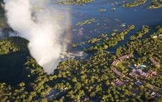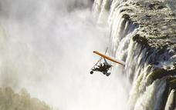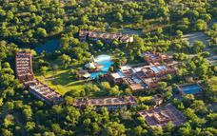

### Included -Bed & Breakfast

## Day 9: The Zambezi Sun Hotel, Victoria Falls

### Day Notes

This day is at leisure to pursue some of the local visitor options. Highly recommended is a walk across the famous railway bridge linking Zambia with Zimbabwe, and built by Cecil Rhodes in the late 1800s. While on the Zimbabwean side, a visit to the Victoria Falls Hotel will reveal the colonial splendour of the settlement era.  
In the late afternoon you will be transferred to the jetty of The African Queen riverboat for the sunset cruise above the Falls.   
For dinner tonight (own account) a table at the neighbouring hotel (Royal Livingstone) is recommended.

### Included- Bed & Breakfast

## Day 10: Departure

### Day Notes

Transfer from your hotel to Livingstone Airport for your flight to OR Tambo.

End of Services.