MADRID-TOLEDO-CORDOBA-SEVILLE-GRANADA-VALENCIA-BARCELONA

**$2995 LAND ONLY**

**LAND ONLY**

**Land**

LAND ONLY

MARCH 29 - APRIL 9, 2017

**BOOK NOW!W!**

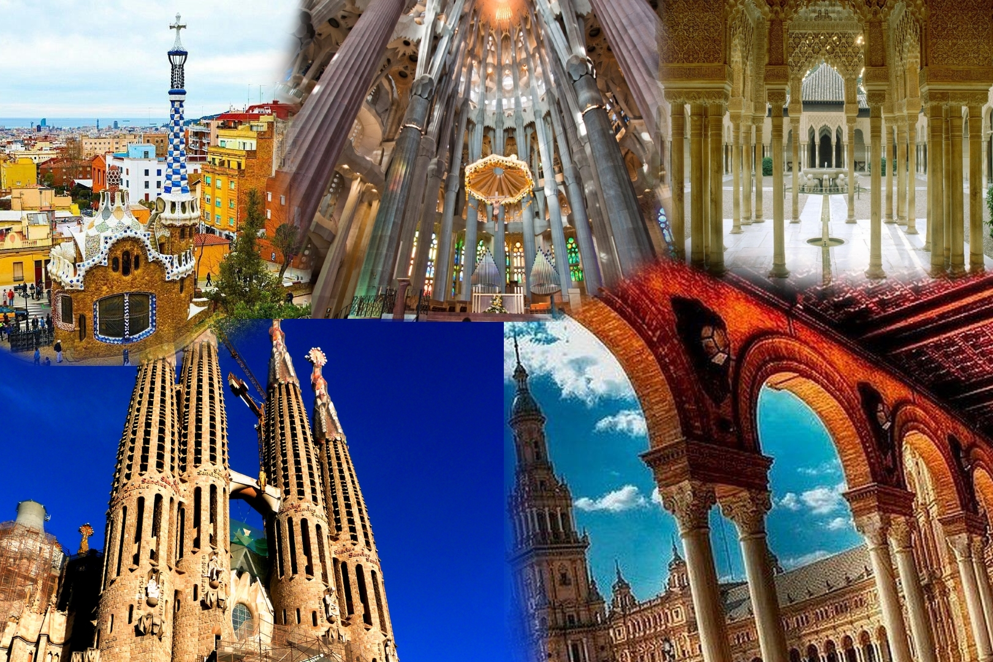

Included Features:

Sightseeing Highlights:

* BUFFET BREAKFAST DAILY
* WELCOME DRINKS
* 5 DINNERS WITH WINE
* 1 GYPSY FLAMENCO DINNER SHOW
* 1 SPECIALITY PAELLA DINNER
* 1 FARMHOUSE LUNCH

* **GUIDED CITY TOUR IN MADRID, TOLEDO, SEVILLE, CORDOBA, GRANADA, AND BARCELONA**
* **VISIT PRADO MUSEUM, THE HAPSBURGS PALACE - EL ESCORIAL, THE CIVIL WAR MONUMENT - THE VALLEY OF THE FALLEN, CóRDOBA – THE CATHEDRAL/MOSQUE, ALCAZABA CASTLE, GUADIX AND TROGLODITE HOUSES, LAS RAMBLAS**
* WHISPER TECHNOLOGY ENHANCED TOURING

**BEST OF EUROPE TOURS & CRUISES**



**4 * HOTELS-CENTRALLY LOCATED:**

* **3 NIGHTS MADRID**
* **2 NIGHTS SEVILLE**
* **2 NIGHTS GRANADA**
* **1 NIGHT VALENCIA**
* **3 NIGHT BARCELONA**
* WHISPER TECHNOLOGY ENHANCED TOURING